Name M.Haris
ID No 15307
Course Environmental Science
DEP MIC 4th semester

Q NO , 2
Answer
Air Pollution
As the presence of one are more pollutants in the local or in the region in such quantity or such duration which effect animals, plants and human beings directly.
Air Pollutants
All those substance which contribute in air pollution are known as pollutants. They include carbon monoxide Co. Sulphur dioxide SO2. TOXIC organics nitrogen oxides and volatile organic compounds
Source of Air pollution
; Winds and Air currents
Can mobilize pollutants from the ground and transport them over large areas
Volcanic activities
Volcanic eruptions emit a series of toxic gases including sulfur chlorine . as well as particulate matter as particles but are usually restricted to localized areas
Wild fires
A large destructive fire that spreads quickly over woodland or brush
Sources of Co
Volcanic eruption , seed germination , electric discharge in the atmosphere , industries of iron ,steel , petroleum . Burning of forests etc.
Effect on Human
It forms carboxyhemoglobin with hemoglobin by replacing oxygen from it
Co + Hbo2 HbCo + o2
This reduce the oxygen carrying capacity of hemoglobin and finally leads to death . Co binds to hemoglobin 320 times tightly than o2 . 100 ppm concentration of co in atmosphere cause headache and shortness of breath .
Q No 3
Answer
Environmental science
Derived from French word environ means surrounding or enveloping.
Environmental science is a multidisciplinary science which combines physics , chemistry , biology ,medical health science , life science , agriculture science , forestry , public health engineering etc.
Environmental science is the study structure and function of our life supporting environment and to understand causes , effects and solutions of different environmental problems .
Scope of environmental science
The scope of environmental studies is very wide and it deals with many areas likes.
- conservation of natural resources
- ecological aspects
- pollution of the surrounding natural resources
- controlling the pollution
- social issue connected to it
- impacts of human population on the environment
Evolution
The need for a multidisciplinary approach to analyse complex environmental problem
The arrival of substantive environmental laws requiring specific environmental protocols of investigation
The growing public awareness of a need for action in addressing environmental problems .

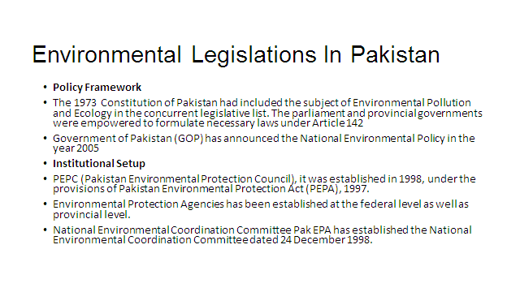

Q NO 1
Answer
Population
The total number of a person’s inhabiting a country, city , or any district or area .
Population Theories
- Cornucopian
A cornucopian is someone who believes
That continued progress and provision of material items for mankind can be met by advances in technology
- Bogue
The population grows only in response to the earth ability to support a larger population.
Over time, society naturally limits or increases its population
Theory of demographic regulation.
- Boserup
Population growth has enabled agricultural development to occur
People will find ways to increase the production of food by increasing work force, machinery , fertilizers, etc.
Fertility to land will be maintained when population is low .
Change in technology helped in developing high yield crops .
- Club of Rome
Founded in April 1968 by Aurelio peccei, an Italian scholar and industrialist and Alexander King a Scottish scientist
Published the book the limits to growth in 1972
If present growth trends in the word continue , the limits to growth on this planet will be reached some time in the next 100 years
The result will be sudden and uncontrollable decline in both population and industrial capacity .

Q NO 1 , Part B
Answer
Main Components of population growth
The main components of population growth are Birth rate , Death rate and migration .
Birth rate is the number of live births per thousand persons in a year.
Death rate is the number of deaths per thousand persons in a year.
Migration is define as the difference between the number of people moving into area and the number of people moving out .
Peoples are migrate from one country to another .

