ID#16076 SECTION: “A” PAPER: FINAL
SUBJECT: ARCJITECTURE AND TOWN PLANNING
SUBMITTED TO: MAM’M ALINA BABAR
Q1: Point out slump In Peshawar. What step do you recommend to improve livelihood of people living in these slump? While suggesting slump improvement keep the current economic and political situation of the government in mind as well as pay carefully attention to the context.
ANS1: following are the slum area in Peshawar region.
1)Changarhabad
2)Nothia
3)Umerkhel
4)Kacha garhaye
5)Chamkani
6)Hyder colony
7)Hazar khani
8)Mohala Rahim abad
9)Akhun abad
10)Shah dhand
11)Afghan colony
12)Kakshal
13)Mohala pir hidayat ullah
14)Hassan garhi
15)Tahkal paya
16)Subhan abad
17)Taj Abad
18)Nasir bagh
19)Sofaid deri
20)Gujar camp near university camp
Taj Abad: come in town 3 area all is connects to Peshawar ring road to a metalled road it a distance of 1 kilometer it the south it the north this area connect to canal road and GT road. This are is sarrounding by agricultural land and this area can be easly categorise as urban-rural fringe. Extensive house construction can be seen on this agricultural land. This area is not planned properly and is divide into street slash lanes where major land considerd a mohalla there are total 18 major lanes in tajabad. And taj abad is a notified katchi abadi. It consist of 2000 slump houses. And they have so faulty arragment of design.
These areas are very dangerous have no safety. There hospital are so away. And slump are double over the past 15 year. All streets of Tajabad Lane 10 are unpaved and undulating. The area has a very poor drainage system and almost all the study area is inundated during the rainy season and water remains standing for days in streets, thereby making the population prone to water borne diseases.
There are few private health clinics in the area but there is no public health facility operating here. No urban transport system exists in the area. People use their own vehicles or rent private vehicles, usually a taxi or rickshaw.
Upgradation of slump:
I think that government give a small hospital without hospital so difficult to live. That good for Taj Abad people and government collect nominal charges from them. education is very important for there better future and also for Pakistan future. I suggest to government make a primary school there. Government supply a drinking water for Taj Abad and they have nominal charges. Slump will be reduce when government make a bus terminal near the slump and this is the very important point decrease a slump. These all thing done on low cost. Double road is best but economy problem of Peshawar
Q2: Explain the structure and pattern of Islamabad master plan. Also mention what could have been done during the planning stage to make this master plane better or mention what are the wrong in town planning by criticizing it?
ANS: Islamabad is divided into 8 zones.
- Administrative zone
- Diplomatic enclave zone
- Residential area

- Educational sector
- Industrial sector
- Commercial areas
- Rural areas green areas.
Islamabad urban pattern are multiple nuclei theory. In Pakistan so many town planning are multiple nuclei theory.
The map look like form.
There nodes are on the center.
There are so many linkages. And they are nucleated urban farm. Core facilities in the center.
Islamabad is natural determinant and also man-made determinant city.
The vision was definitely futuristic. Cleanly mapped streets with sectors that had everything you would ever need and thus there would be nothing that would require you to over go anywhere outside of your sector. It was all rather mechanical, and the approach was perhaps summed up best in that no office spaces were created apart from the secretariat, and the master plan did not include any plans for expansion. After all, Islamabad was to be a small scale center for governance, with bureaucrats, politicians and government functionaries occupying its homes for the most part.
NEGATIVE POINTS:
They have some slump but away with a small distance from islamabad.
Roads need further expansions and under passes.
There super markets are so big like centaurus they cover all area of agriculture
Entire F9 sector cover with Fatimah Jinnah park.
The water supply scheme is not sufficient for the whole Islamabad people.
There roads near to home people are disturb from traffic noise pollution.
In Islamabad have air pollution because there have so many highway which passes on Islamabad.
Positive points:
The sector were used for distinct land uses such as residental, educational, commercial and administrative.
There chances of slump create are less.
good point is that islamabad located in green valley.
They have a large parks for re-freshment.
Faisal mosque attractive mosque.
They have so many linkages which as good for CBD.
Naturaly and beutifull place for tourism.

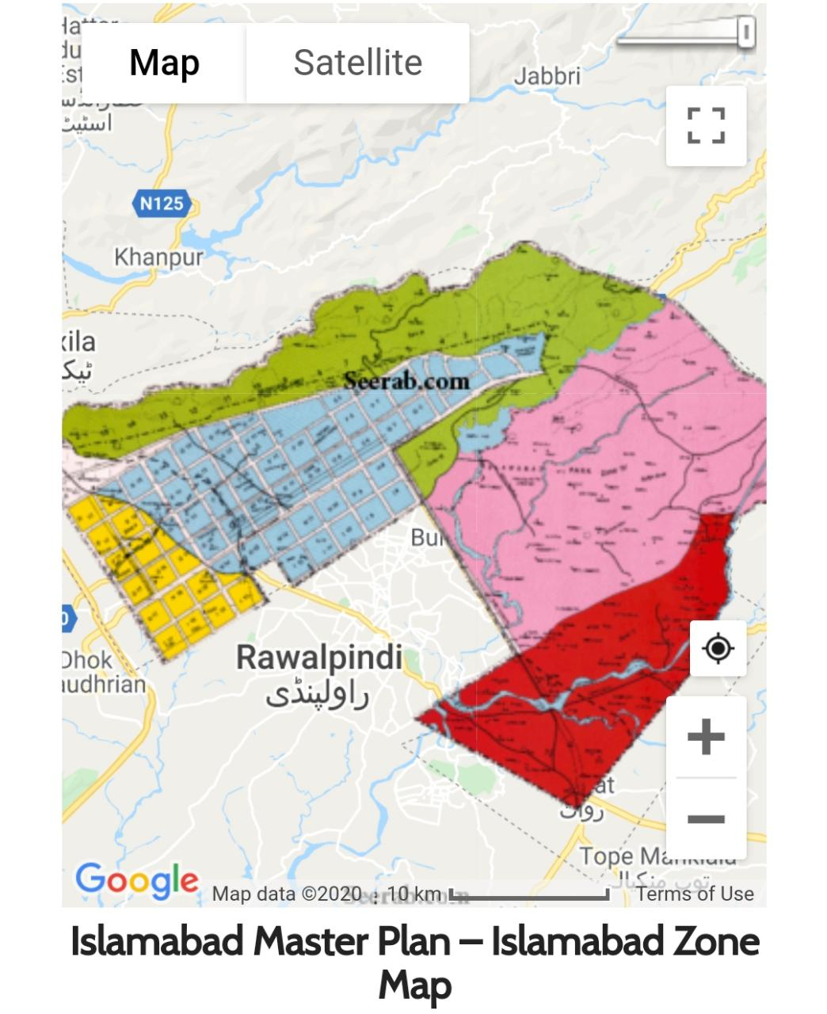
Q3: which land use model best represents Peshawar (i.e. concentric zone model, sector model, or multiple Nuclei model). After identifying model type mark sketch all the zone (I.e. CBD, residential, industrial etc.) on the map is discussed in the model additionally, explain the form of Peshawar city.
NOTE: you can use Peshawar map attach below or google map to study and understand the layout of Peshawar. Print the map on A4 page and sketch all zone of land use model on it. Or you can use paint tool or any other image editing tool to mark zones.
ANS3: I study the Peshawar map. on my mind the Peshawar come in multiple nuclei Model. Is reason is that the CBD (central buissness district) in the center like Saddar, university road, there residential area attach with CBD like Hayatabad, university houses and there industrial area away from CBD and residential area. So for this reason Peshawar come in multiple nuclei model.
Peshawar form can not be proper organized.
in hayatabad area they form like grid structure. and there city form is grid and radial.
Peshawar Map:
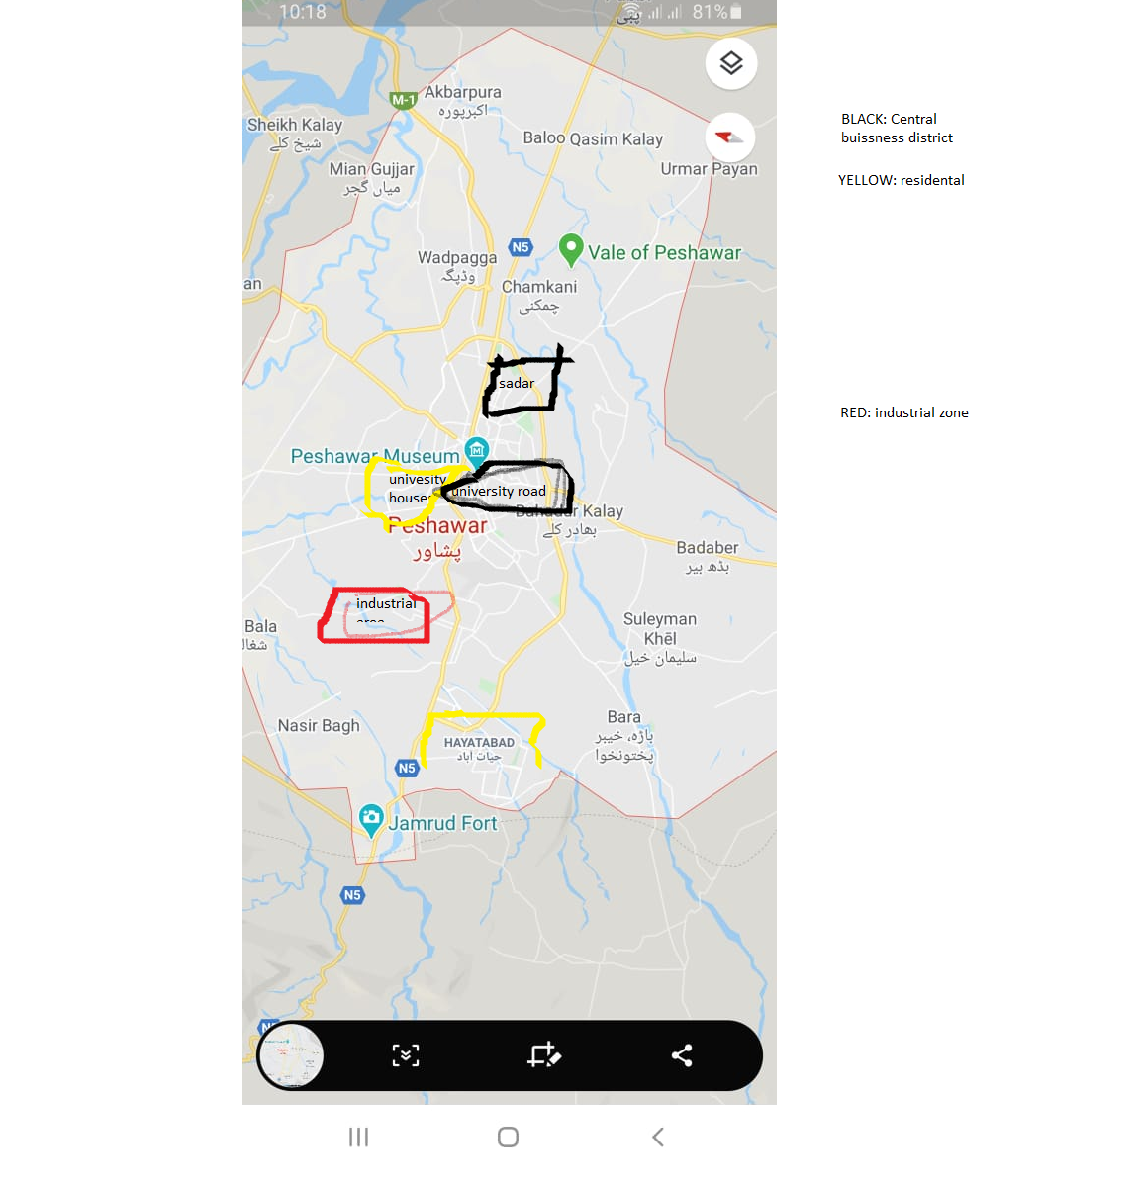
YELLOW: residential
RED: industrial
BLACK: CBD (central business district)

