NAME: MANZOOR AHMED
ID NO: 15220
DEGREE: DPT 4th
PAPER: ANATOMY
SUBMITTED TO: Dr.Arooba

QNO1.WRITE A COMPREHENSIVE NOTE ON THE BLOOD SUPPLY OF BRAIN?
ANS:-BLOOD SUPPLY OF BRAIN:-
- The entire blood supply of the brain and spinal cord depends on two sets of branches from the dorsal aorta.
- The vertebral arteries arises from the subclaivian arteries
- The internal carotid arteries are branches of the common carotid arteries.

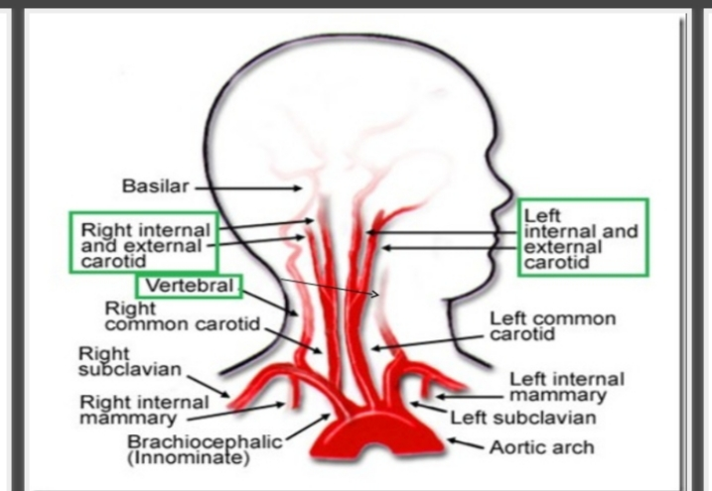
ARTERIAL SUPPLY OF BRAIN:
The arterial blood reaches the brain trough the pair of;
- Internal carotid arteries. (80% supply of telencephalon & diencephalon)
- Vertebral arteries.(20% supply to the brainstem & cerebellum along with some cortical regions)
THE INTERNAL CAROTID ARTERIES:
It arises at the point in the neck (foramen lace rum) and enters into cavernous sinus where the common carotid arteries bifurcates into external &internal carotid arteries.
- External carotid artery supplies blood to the facial muscles.
- Internal carotid artery enters the cavernous sinus through the foramen lacerum enters the subarachnoid space by piercing the arachnoid mater and lies lateral to the optic chiasma.

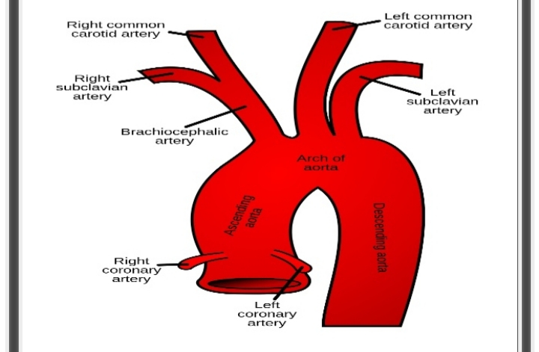

- Ophthalmic artery:
It passes into the orbit trough the optic foramen. It supplies the structure of the orbit, frontal part of the scalp and dorsum of the nose.
- Anterior choroidal artery:
It supplies the optic tract, choroid plexus of the lateral ventricle, hippocampus and some of the deep structures of the hemisphere, including the internal capsule.
- Posterior communicating artery:
It passes posteriorly inferior to the optic tract &joints the posterior cerebral artery with the middle cerebral artery.
- Anterior cerebral artery:
It passes medially above the optic nerve and then passes into the great longitudinal fissure between the frontal lobes where it joints the corresponding vessels of the opposite side by anterior communicating artery.

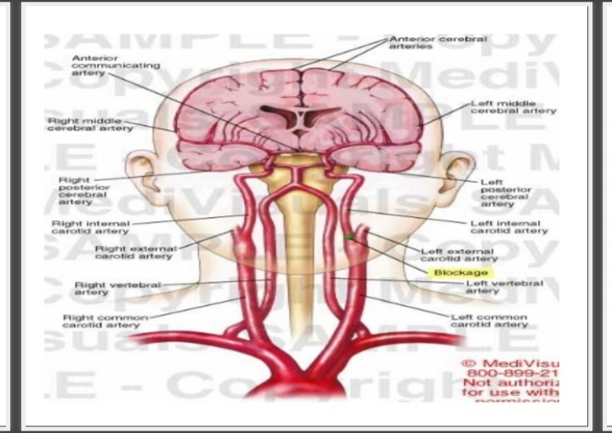

Vertebral arteries:-
- The vertebral arteries arises from the subclavian arteries and the ten medullary arteries that arises from segmental branches of the aorta provide the primary vascularization of the spinal cord.
- These medullary arteries join to form anterior and posterior spinal arteries.
- These arteries enter the cranial cavity through the foramen magnum.
- Each of it gives rise to the 3 main branches;
- 1) posterior spinal artery
- 2) anterior spinal artery
- 3) Posterior inferior cerebral artery (supplied post. &infero aspect of the cerebellum).
- BASILOR ARTERY:
Anterior and posterior vertebral arteries unite at the junction between medulla and pons to form the basilar artery.
It gives rise to the following branches;
- 1- Anterior inferior cerebral artery.
It supplies the anterior and inferior portion of the cerebellum.
- 2- Superior cerebral artery.
It supplies the superior aspect of the cerebellum.
- 3- Pontine arteries.
It supplies pons.
- 4- Labyrinthine arteries.
It supplies the inner ear.
- 5- Posterior cerebral artery.
It curves around the midbrain to supply the visual cortex of the occipital lobe and the infer-o-medial aspect of the temporal lobe.

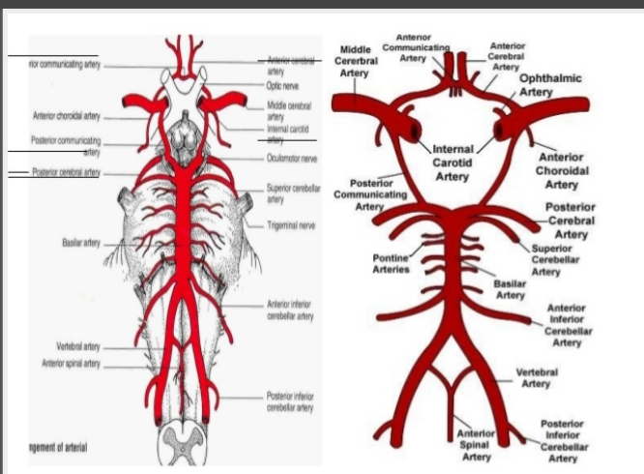

QNO 2. WHICH TYPE OF STROKE IS COMMON? WRITE A COMPLETE NOTE ON ISCHEMIC STROKE.
ANS:-The most common type of stroke is ischemic stroke, accounting for almost 80% of all strokes, is caused by a clot or other blockage within an artery leading to the brain.
ISCHEMIC STROKE:-
- The blood supply is blocked by a blood clot or clump of fat. This damages your brain cells and they begin to die.
- Ischemic stroke affects about 9 out of every 10 people who have a stroke. It’s most common in people over the age of 65, although can happen at any age.

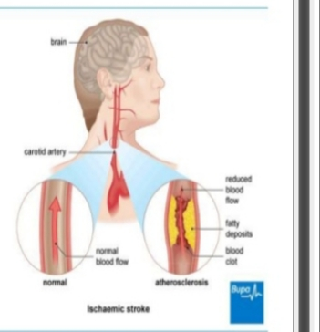

TWO TYPES
1 ARTERIAL THROMBOSIS:-
- Also called thrombotic stroke or cerebral thrombosis.
- This is when a blood clot forms in an artery that supplies your brain and blocks the blood supply.
2 CEREBRAL EMBOLISM:-
- Also known as embolic stroke.
- This is when a blood clot forms somewhere else in your body and travels to your brain and blocks the blood supply. The clot usually forms in your heart or one of the large arteries that supplies your brain.

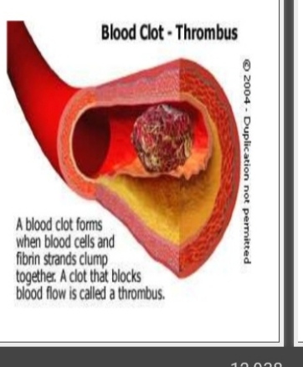

RISK FACTORS
NON-MODIFIABLE RISK FACTORS
- Age
- Gender
- Race, ethnicity
- Heredity
MODIFIABLE RISK FACTORS
- Hypertension
- Cardiac disease
- Smoking
- Alcohol
- Cholesterol
- Illicit drug use
- Migraines
- Diabetes mellitus
- Oral contraceptives

Signs & symptoms
- A good way to recognize if you’re with has had a stroke is to use the “FAST” TEST.
- The exact symptoms depend on where in your brain the blood supply has been blocked.
- This is because different areas of your brain control different function and they all receive blood through different arteries.
- A transient neurologic attack that lasts <24 hours (most last<1 hour) and is determined to be of ischemic etiology.
ANTERIOR CEREBRAL ARTERY
- Contralateral paresis and Sensory loss in the leg.
- Cognitive or personality changes.
MIDDLE CEREBRAL ARTERY
- Pneumonic: “changes”
- Contralateral paresis and sensory loss in face and the arm.
- Aphasia.
- Neglect.
BASILAR ARTERY
- Coma
- Apnea
- Visual symptoms
- Drops attacks
- Dysphagia

DIAGNOSIS
- You will have your blood pressure measured and an electrocardiogram (ECG) to record the rhythm and electrical activity of your heart.
- Echocardiogram (ECHO) of your heart if embolic stroke is suspected.
- You may then have tests to measure the levels of cholesterol and sugar in your blood.

TREATMENT
MEDICINES
- ALTEPLASE is a medicine (iv tPA-Tissue plasminogen Activator) used to break up blood clots, and will help restore the blood flow to your brain. You need to have it within four and a half hours of your symptoms starting for it to be effective.
- Intra-arterial thrombolysis:
Can be used within 6 hours of a major stroke from middle cerebral artery occlusion if such patients are not suitable candidates for alteplase.
SURGERY
- This may involve an operation called carotid endarterectomy to remove blood clots and fatty deposits from one of the carotid arteries in your neck. The surgery may help to reduce risk of having another stroke but isn’t suitable for everyone.

QNO 3.WHAT DO YOU KNOW ABOUT THE THALAMIC NUCLEI OF BRAIN?
ANS:-THALAMUS:-
- The thalamus is a midline symmetrical structure of two halves, situated between the cerebral cortex and the midbrain.
THALAMIC NUCLEI OF BRAIN:-
- Based on their connection with the cerebral cortex, the thalamic nuclei are divided into:
- SPECIFIC NUCLEI
- NON SPECIFIC NUCLEI

SPECIFIC NUCLEI:-
- Have well- define sensory and motor functions
- Have highly organized point-to-point connection with sensory & motor regions of cerebral cortex
- Lie within the ventral group of the lateral nuclear group.
NON-SPECIFIC NUCLEI:-
- Receive less functionally distinct afferent input.
- Connect with wider area of cortex, including associative and limbic regions
- Include nuclei of the dorsal tier of lateral group, and whole of the anterior and medial group.

ANTERIOR NUCLEAR GROUPS
Anterior nuclear group control of instinctive drivers, emotional aspect of behavior and in memory.
- 3 parts:
- Anteroventral
- Anteromedial
- Anterodorsal
MIDIAL NUCLEAR GROUP
Integrates emotion, thought, and judgment.

LATERAL NUCLEAR GROUP dorsal tier
- Lateral dorsal
- Lateral posterior
- Pulvinar
LATERAL NUCLEAR GROUP ventral tier
- Ventral anterior
- Ventral lateral
- Ventral posterior:
- (VPL)
- (VPM)
4. Lateral geniculate
5. Medial geniculate

VENTRAL ANTERIOR NUCLEUS
Influence motor activity
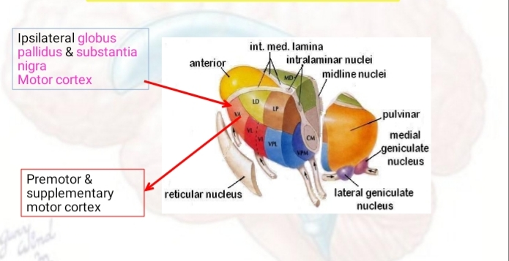

VENTRAL LATERAL NUCLEUS
Influence motor activity

VENTRAL POSTERIOR NUCLEUS
Chief sensory relay station
LATERAL GENICULATE BODY
Part of visual pathway
MEDIAL GENICULATE BODY
Part of the auditory pathway

MIDLINE NUCLEI
- Located between medial nuclear group and the ependymal of 3rd ventricle.
- Important in visceral functions

INTRALAMINAR NUCLEI
- Located within the internal medullary lamina
- Main nuclei:
- Centromedian & parafascicular
- Function as activator of the cerebral cortical mantle

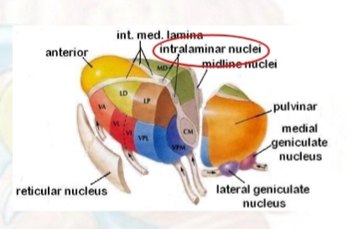

QNO 4. WRITE NOTE ON THE DESCENDING TRACTS OF SPINAL CORD?
ANS:-DESCENDING TRACT OF SPINAL CORD:-
The descending tracts are the pathways by which motor signals are sent from the brain to lower motor neurons. The lower motor neurons then directly innervate muscles to produce movement.
The motor tracts can be functionally divided into two major groups:
Corticospinal tract
Origin
The corticospinal tract originates in the motor cortex, which is located in the precentral gyrus of the brain’s cerebral cortex. Depending on where the neurons originate within the gyrus, they will supply different regions of the body. For example, the foot and leg are controlled by neurons which originate in the inner, medial part of the gyrus; whereas the arms, hands, face, tongue, trunk, etc., are controlled by neurons which originate from the outer, lateral surface. This layout is often represented as a little cartoonish person with body parts proportional to the input they receive from their corresponding areas within the motor cortex. It is referred to as the homunculus. The sensory information received from the body by the somatosensory cortex is often depicted with a similar figure.
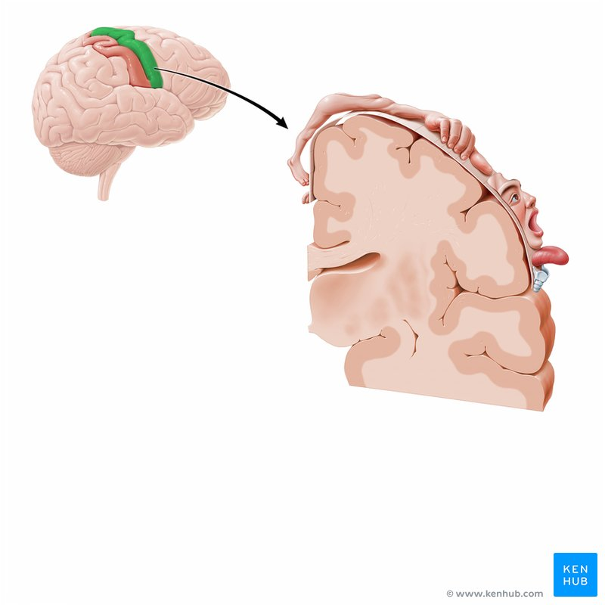

Corticobulbar tract
Overview
The corticobulbar (a.k.a. corticonulcear) tract is responsible for influencing the motor nuclei of a number of cranial nerves (CN), including the:
- oculomotor (III)
- trochlear (IV)
- mandibular component of the trigeminal (V3)
- abducens (VI)
- facial (VII)
- glossopharyngeal (IX)
- vagus (X)
- spinal accessory (XI)
- hypoglossal (XII) nerves
UMNs descending from the cortex to the CN nuclei are considered part of the corticobulbar tract; whereas LMNs are considered as part of the CNs themselves, with their cell bodies in the CN nuclei and their axons projecting to the muscles of the face, head, and neck.
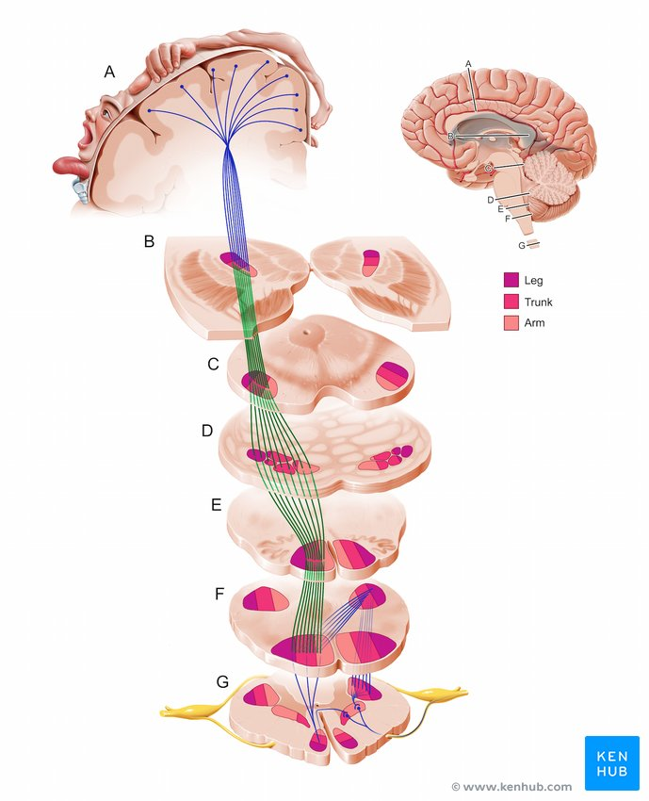

Rubrospinal tract
The rubrospinal tract is primarily concerned with the control of the flexor muscles: the neurons in this tract function to facilitate flexion and inhibit extension.
The tract originates in the red nucleus of the midbrain. Its axons cross the midline within the midbrain at the ventral tegmental decussation and descend in the contralateral spinal cord in all levels. The dorsal part of red nucleus receives input from the region of the sensorimotor cortex dedicated to the upper limb, and supplies the cervical spinal segments; the ventral part of the red nucleus receives input from the region of the sensorimotor cortex dedicated to the lower limb, and supplies the lumbosacral spinal segments.
The axonal fibers of the rubrospinal tract terminate on interneurons which in turn project to neurons in the ventral horn of the spinal cord.

Tectospinal tract
The tectospinal tract is believed to play a role in modulating head movements in response to visual and auditory stimuli. Originating from neurons deep within the superior colliculus, the axons in the tectospinal tract cross via the dorsal tegmental decussation, project to the spinal cord, and terminate in the upper cervical spinal levels. Although the tectum receives input from many cortical regions, the visual cortex provides the most highly organized input to the tectum.
Reticulospinal tract

Origin
The axons which form the reticulospinal tract arise from neurons in the pons and medulla. This tract has three different components.

First component
The first component of the reticulospinal tract plays a role in motor functions. It has two components: the lateral bulboreticulospinal tract originating in the medulla, and the medial pontoreticulospinal tract originating in the pons. These components inhibit and facilitate extensor spinal reflexes respectively, ultimately assisting with posture and balance.
Fibers of the lateral reticulospinal pathway arise in the nucleus reticularis gigantocellularis of the medulla and project bilaterally along the full length of the spinal cord. The medial reticulospinal pathway arises from the nucleus pontis caudalis and the nucleus points oralis, two distinct clusters of nuclei in the medial pontine reticular formation. These fibers project ipsilaterally along the entire length of the spinal cord. Both the lateral and medial reticulospinal tracts receive input from several cortical areas in both hemispheres.

Second component
The second component of the reticulospinal tract modulates autonomic functions. The fibers in this pathway originate from the ventrolateral medulla and project to the intermediolateral (IML) nucleus within the thoracolumbar spinal cord, where they excite sympathetic ganglionic neurons in the viscera.

Third component
The third component of the reticulospinal tract plays a role in modulating pain impulses. This pathway begins with enkephalinergic neurons in the midbrain periaqueductal gray (PAG). Their axons project to serotonergic neurons in the nucleus raphe magnus of the medulla, which project to the dorsal horn of the spinal cord. In the dorsal horn, they synapse with enkephalinergic interneurons, which act on primary afferent pain fibers to regulate pain impulses ascending the spinal cord via the spinothalamic tract.

Vestibulospinal tract
The vestibulospinal tract has lateral and medial components.

Lateral vestibulospinal tract
The lateral vestibulospinal tract increases extensor muscle tone, mediating posture and balance. The lateral vestibular tract originates from neurons in the lateral vestibular nucleus located at the pontine-medullary border in the brainstem. The lateral vestibular nucleus receives inhibitory signals from the cerebellum and excitatory signals from the vestibular apparatus.
The fibers originating in the lateral vestibular nucleus span the entire length of the spinal cord, synapsing on interneurons within the cord. These interneurons activate motor neurons in the spinal cord, innervating extensor muscles of the trunk and ipsilateral limbs. Like many other nuclei and tracts, the lateral vestibular nucleus is arranged somatotopically: input to the lumbosacral cord originates in the dorsal and caudal regions of the lateral vestibular nucleus, whereas input to the cervical cord originates in the more rostral and ventral areas of the lateral vestibular nucleus.

Medial vestibulospinal tract
The medial vestibulospinal tract is considered a component of the MLF. As part of the MLF, the medial vestibulospinal tract originates from both the ipsilateral and contralateral medial vestibular nuclei in the pons and medulla.
The axonal fibers in this tract follow the ventral funiculus of the cervical spinal cord to synapse in the ipsilateral ventral horn; regulating the activity of motor neurons. The major role of this tract is to adjust the position and maintain stability of the head in response to changes in posture, such as those occurring during movement of the rest of the body.

QNO 5. WRITE A NOTE ON THE AUTONOMIC SYSTEM. DIFFERENTIATE BETWEEN SYMPATHETIC AND PARASYMPATHETIC NERVOUS SYSTEM.
ANS:-AUTONOMIC NERVOUS SYSTEM:-
Autonomic nervous system, in vertebrates, the part of the nervous system that controls and regulates the internal organs without any conscious recognition or effort by the organism. The autonomic nervous system comprises two antagonistic sets of nerves, the sympathetic and parasympathetic nervous systems. The sympathetic nervous system connects the internal organs to the brain by spinal nerves. When stimulated, these nerves prepare the organism for stress by increasing the heart rate, increasing blood flow to the muscles, and decreasing blood flow to the skin. The nerve fibres of the parasympathetic nervous system are the cranial nerves, primarily the vagus nerve, and the lumbar spinal nerves. When stimulated, these nerves increase digestive secretions and reduce the heartbeat.
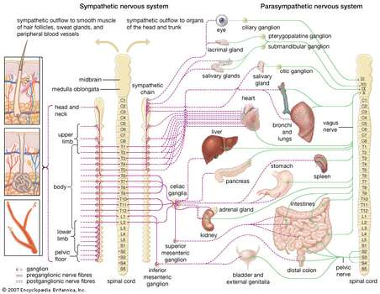

Difference between Sympathetic And Parasympathetic Nervous System:-
The sympathetic nervous system prepares the body for the “fight or flight” response during any potential danger. On the other hand, the parasympathetic nervous system inhibits the body from overworking and restores the body to a calm and composed state. The difference between the sympathetic and parasympathetic nervous system are differentiated based on the way the body responds to environmental stimuli.
The major difference between sympathetic and parasympathetic nervous system are summarized below:
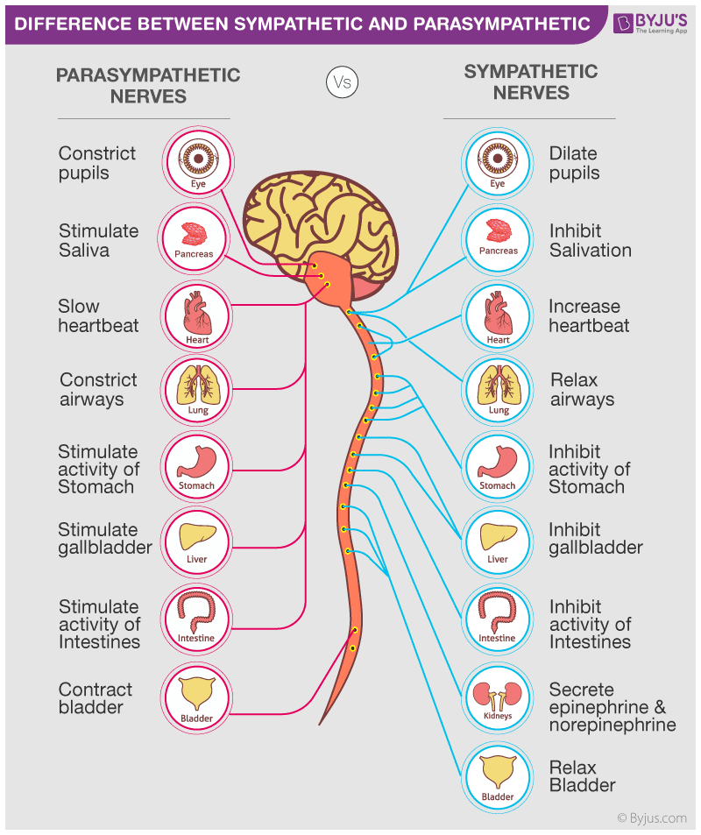
Sympathetic nervous system | Parasympathetic nervous system
Involved in the fight or flight response. | Involved in maintaining homeostasis and also, permits the rest and digest response.
The sympathetic system prepares the body for any potential danger. | The parasympathetic system aims to bring the body to a state of calm.
Sympathetic system has shorter neuron pathways, hence a faster response time. | Has comparatively longer neuron pathways, hence a slower response time.
Increases heartbeat, muscles tense up. | Reduces heartbeat, muscles relaxes.
The pupil dilates to let in more light. | The pupil contracts.

