AISHA IHSAN
ID NO: 16250
BS RADIOLOGY
2ND SEMESTER
SECTION A
PHYSIOLOGY FINAL TERM ASSIGNMENT
NOTE: Attempt all questions.
Q1: How stimulus of smell moves from nostril to brain? Make a diagram as well.
ANS: Sense of smell is called olfaction.
- Nose is the responsible organ for smell.
- Nose contains mucus membrane, having smell receptors connected with olfactory nerve.
- The nasal cavity is lined with mucus membrane that have smell receptors connected to the olfactory nerve.
- Olfactory bulb is present at the back of the nose.
- The axons of the olfactory neurons extend from the basal surface of the epithelium, through an olfactory foramen in the cribriform plate of the ethmoid bone, and into the olfactory bulb, located on the ventral surface of the frontal lobe.
- Collectively the axons that pass through the cribriform plate are called the olfactory nerve.
- They receives the information from axons of olfactory receptor and transfer them the brain.
- Sense of smell is called chemical senses because they detect the chemicals or odor.
- These neurons are capable of detecting thousands of odor.
- Vaporized odor molecules present in the air reach the nostrils by active transport and dissolve in the mucus.
- Below the mucus, is olfactory epithelium.
- They are also called olfactory receptors. They detect the odor.
- The olfactory receptors through neurons transmit the information to the olfactory bulb.
- From the olfactory bulbs, the sensation are carried through olfactory tract to olfaction area in the temporal lobe of cerebral cortex.
- These brain centers work on the odor and access the memories to remind us about the events related with these olfactory sensation.

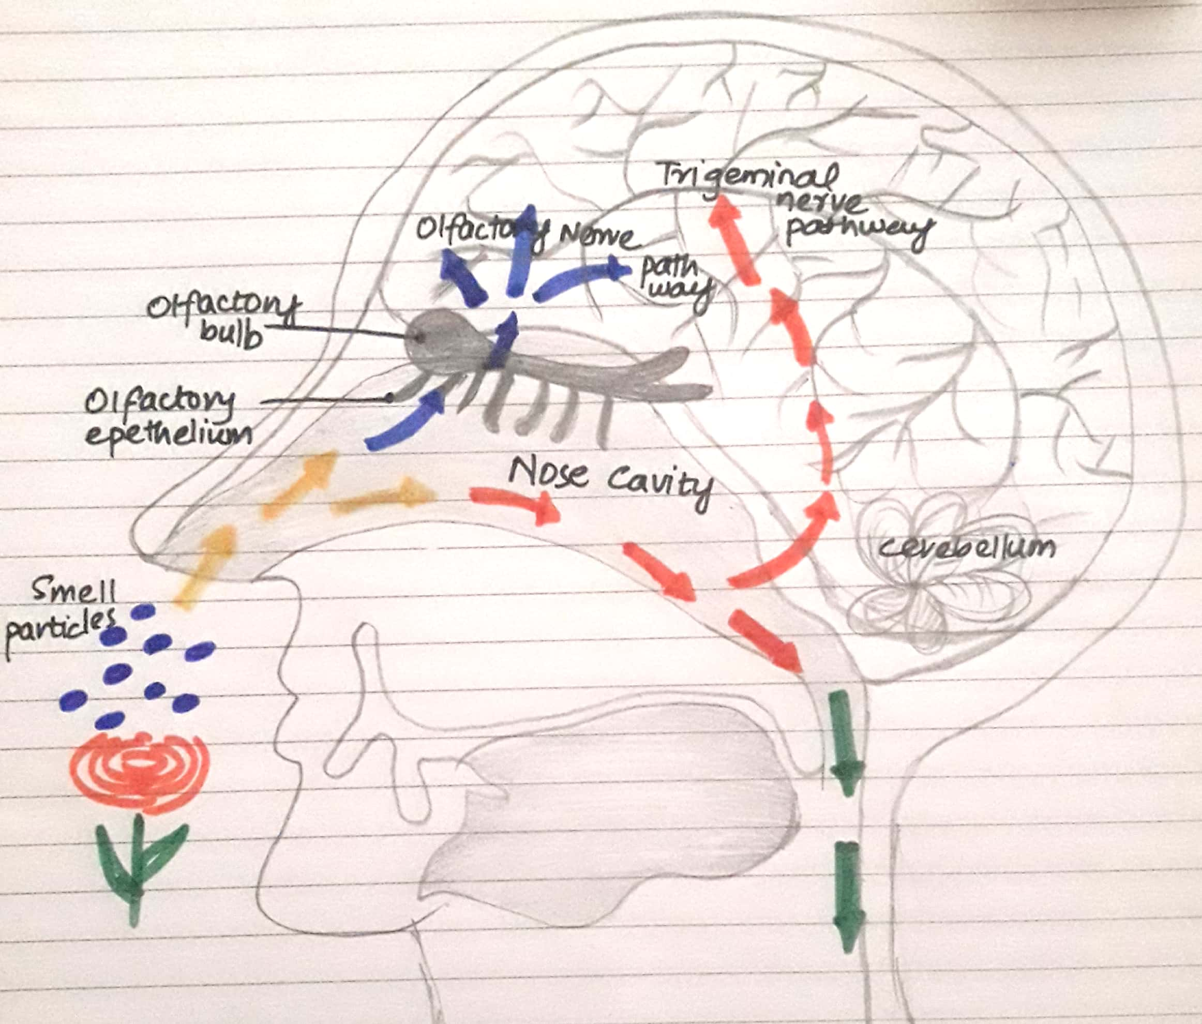
Q2 (A): What is the difference between Hemostasis, hematopoiesis and homeostasis?
ANS: Difference between hemostasis, hematopoiesis and homeostasis
HEMOSTASIS
Hemostasis is a process to prevent and stop bleeding, meaning to keep blood in the damaged blood vessels. It is the first stage of wound healing. This involves the coagulation, blood changing from fluid to a gel. It occurs in three stages.
- vasoconstriction
- platelet plug formation
- Coagulation of blood.

HEAMATOPOIESIS
The process of formation of blood cell like red blood cells, white blood cells and platelets is known as hematopoiesis. Cells responsible to do the function of hematopoiesis are first seen in yolk sac of third week of embryo.
Hematopoietic tissue: The sites where the cells are made is called hematopoietic tissue. They are bone marrow, liver and spleen.

HOMEOSTASIS
Homeostasis is the state of steady internal, physical and chemical conditions maintained by living systems. This is the condition of optimal functioning for the organisms.
For example:
- Regulation of blood sugar through insulin.
- Regulation of temperature by hypothalamus
- Regulation of blood pressure through sensors in the walls of artery.
- The PH balance by the lungs.

Q2 (b): What is Erythroblastosis fetalis?
ANS: When a women is pregnant it’s possible that her baby blood type will be incompatible with her own. This can cause a condition known aserythroblastosis fetalis, where the mother’s white blood cells attack the baby’s red blood cells as would any foreign invaders. It is also known as hemolytic disease of the new born.
Symptoms: Babies who experiences erythroblastosis fetalis symptoms may appear swollen, pale, or jaundice after birth. Also includes fluid in the spaces of
- Abdomen
- Heart
- Lungs
Causes: There are two main cause of erythroblastosis fetalis
- Rh incompatibility
- ABO incompatibility
Q3 (A): What is immunity? Explain different types of immunity.
ANS: IMMUNITY: It is the capability of multicellular organisms to resist harmful microorganisms from entering their cells.
Or
The state of being resistant to reinfection with a pathogen.
It is done by the immune system which is the complex network of lymphoid organs such as bone marrow, thymus and spleen.
Susceptibility: Lack of immunity is called susceptibility.
Immunity is divided into two types:
- Innate immunity
- Acquired immunity

- Innate immunity: it is also called native r natural immunity. The innate immunity system is what we are born with and it is nonspecific. All antigens are attacked pretty much equally. It is genetically based and we pass it on to our off springs. It is present from birth and is inherited from mother to off springs through placenta.
It is of three types:
- Species immunity
- Racial immunity
- Individual immunity
- Species immunity: If one specie is resistant to certain infection and the other species is susceptible to the same infection then it is called as species immunity. Anatomic, physiological and metabolic differences between species determine species immunity.
For example: birds are resistant to anthrax but humans are susceptible. It is simply they have high temperature than humans.
- Racial immunity: If one race is susceptible while other is resistant to the same infection, then it is called racial immunity. It is determined by difference in socio-economic status, habitat, culture feeding habitats.
For example: Certain Africans are more resistant to malaria and yellow fever where are Asian’s and Americans are susceptible to same infection.
- Individual immunity: if one individual of certain race or cast is resistant while other individuals of same cast and race are susceptible to certain infection than it is called individual immunity. It is determined by health status, nutritional status illness, personal hygiene etc.
For example: individual with genetic deficiency of glucose- 6 phosphate dehydrogenase are resistant to malaria.
- Acquired or developed immunity: immunity which is developed later in life after microbial infection in host is called as acquired immunity.
Acquired immunity is provided by certain antibodies and T- lymphocytes. There are two types of acquired immunity.
- Active immunity: if host itself produces antibodies. It is called active immunity.it is of two types: artificial active immunity and natural active immunity.
- Artificial active immunity: immunity provided by vaccination.
- Natural active immunity: immunity provided by natural infection.
- Passive immunity: if host does not produce antibodies itself but antibodies produced in other host provides immunity, than it is called natural immunity. It is of two types:
- Natural passive immunity: Ig G antibody produced in the mother cross placenta and protects fetus up to 6 month old age.
- Artificial passive immunity: if performed antibody are injected into host for immunity. For example; antibodies in mother’s milk provide a baby with temporary immunity.
Q3 (b): What is the difference between antigen and antibody?
ANS: a. ANTIGEN: Antigen is a harmful substance which enters the body which causes the body to make antibodies as a response to fight off diseases.
For example: An antigen is a common cold virus causes the body to make antibodies which help the person from getting sick.
Antigen may be exogenous and endogenous.
Exogenous: Those antigens that have entered the body from outside.
For example: inhalation, ingestion, injection.
Endogenous: That have been generated within the cell as a normal metabolism.
b. ANTIBODY: It is also known as immunoglobulin. It is a blood protein produced in response to and counteracting a specific antigen. Antibodies combine chemically with substances which the body recognize as alien, such as bacteria, viruses and foreign substances in the blood.

Q4 (A): Write down different functions of antibody.
ANS: FUNCTIONS OF ANTIBODIES
- Specific binding of the corresponding antigen: Antibody hyper variable region and antigenic determinants of the three dimensional structure must be consistent in order to bind the antibody and the antigen binding is highly specific.
- Neutralization of infectivity or toxins: Antibodies are secreted into the blood and mucosa, where they can block the infectivity of pathogens, inactivate or neutralize foreign substances such as toxins.
- Phagocytosis: antibodies facilitate phagocytosis of foreign substances by a process called opsonization. Inside the phagocyte the pathogen becomes the target of various destructive processes that include oxidative damage, enzymatic digestion.
- Tanscytosis: some antibodies can move across epithelial layers through a process called transcytosis

Q4 (B): Write the difference between primary and secondary response to an antigen.
ANS: Difference between primary and secondary response
Primary response to antigen: It is reaction of immune system when it contacts an antigen for the first time.
- Appearance: It appears in lymph nodes and spleen.
- Antibody peak: the antibody level reaches its peak in 7-10 days.
- Responding cells: naive B and T cells.
- Antibodies: both thymus dependent and independent.
- Lag phase: long 4-7 days
- Amount of antibody: few antibodies are produced.
- Antibody level: declines to the point where it may be detectable.
Secondary response to antigen: it is the reaction of immune system when it contacts an antigen for the second and subsequent times.
- Appearance: appears mainly in bone marrow and then in lymph nodes and spleen.
- Antibody peak: the antibody level reaches its peak in 3-5 days.
- Responding cells: memory B cells.
- Antibodies: only thymus dependent
- Lag phase: short 1-4 days
- Amount of antibody: 100-1000 times more antibodies are produced in this type of response.
- Antibody level: the antibody level tends to remain high for longer

Q5: Write the difference between cell mediated and antibody mediated immunity.
ANS: DIFFERENCE BETWEEN CELL MEDIATED AND ANTIBODY MEDIATED IMMUNITY
CELL MEDIATED IMMUNITY: It is the second line of defence.
- Lymphocytes: it is associated with T- Lymphocytes and is responsible for destroying the pathogens or microorganisms which have invaded the cells without producing antibodies.
- Include: T-lymphocytes, helper T cells, natural killer cells and macrophages.
- Main defence: it is the main defence against intracellular bacteria.
- Mechanism: mycobacterium tuberculosis enters the body. Ingested by macrophage. Bacterium is broken down into fragments. The antigen protein complex interact with an antigen specific receptors on surface of helper T- lymphocyte. T lymphocytes works by identifying viruses and microorganisms, thus destroying them by the cell lysis or phagocytosis or pinocytosis.
- Delay but permanent action: they show delay though permanent action against any pathogens.
- Organ transplant rejection; they are involved in rejection of organ transplant after a certain time as they show delayed response.

ANTIBODY MEDIATED IMMUNITY: It is the 3rd line of defence.
- Lymphocytes: it is associated with B-lymphocytes and is responsible for destroying the pathogens by producing antibodies against them.
- Include: B-lymphocytes, T-lymphocytes and macrophages.
- Mechanism: after processing by macrophages, fragments of antigen appear on surface of macrophage. These antigen binds to specific receptors on surface of helper T- cells. These factors activate the B -cells capable of producing antibodies specific for that antigen. The activated B- cell proliferates and differentiates to form many plasma cells that secrete large amount of immunoglobulins.
- Quick action: antibody mediated show quick and rapid action against antigens.
- Graft rejection: it is involved in early stage of graft rejections due to the formation of antibodies against any foreign particles.

The End

