ASSIGNMENT # 03

SUBMITTED TO
ENGR.NADEEM ULLAH

SUBMITTED BY
M AFAQ KHAN

STUDENT ID

7700
SECTION

B

SUBJECT

WASTE WATER TREATEMENT

SOIL PIPES
Our Soil and Waste systems are manufactured in the UK by FloPlast in one of Europe’s most technologically advanced factories. The result is a high-quality soil & waste pipes and fittings that are tough and durable, yet lightweight and simple to install.
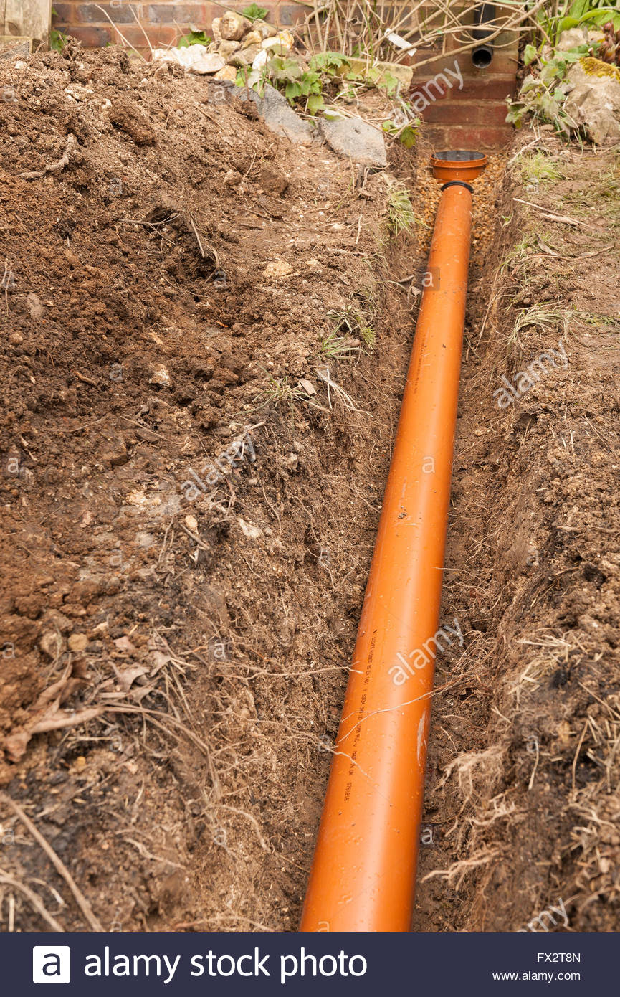
ANTI-SYPHON PIPES
The size of anti-siphonage pipes merits careful consideration, but no hard and fast rule can be laid down. For a single fitting the sectional area of the anti-siphonage pipe (A, fig. 196) need not be much more than half that of the waste-pipe.
as a rule, are not, and drain-air will therefore pass through the soil-pipes and through the anti-siphonage pipes connected with them. The main anti-siphonage pipe is generally connected to the upper continuation of the waste-pipe above the highest fitting; this economises piping, and is quite as effective as carrying it up independently to the same height as the waste-pipe vent.
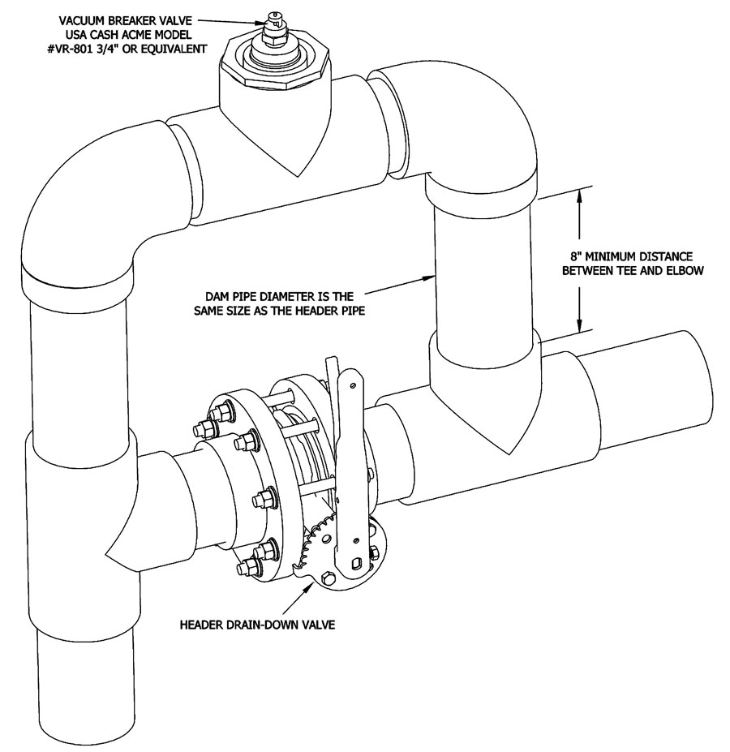

SANITARY FIXTURES
Sanitary fixtures are installed in different areas. Bathtubs, washstands, shower sumps, traps, and bidets are installed in bathrooms, washrooms, and shower rooms. Toilet bowls, lavatory pans, and urinals of various types, whether equipped with flush tanks or taps, are installed in lavatories. Washers, sinks and drains are installed in kitchens.

SANITARY TRAPS
A trap is a device which is used to prevent sewer gases from entering the buildings. The traps are located below or within a plumbing fixture and retains small amount of water. The retaining water creates a water seal which stops foul gases going back to the building from drain pipes. Therefore all plumbing fixtures such as sinks, washbasins, bathtubs and toilets etc. are equipped with traps. This article tells you the features of traps, various types of traps and water seal.

CROSS CONNECTION
A connection in a plumbing installation through which water may possibly pass to or come in contact with another part (as a water inlet in a bathtub that may at timesbe below the water level of the tub.

BACK SYPHONAGE CONTROL
Back siphonage is one type of backflow. Back siphonage—The flowing back of used, contaminated, or polluted water from a plumbing fixture or vessel into a potable water supply because of negative pressure in the pipe. Branch—Any part of the piping system other than the main, riser, or stack.

