Name hayan ullah
I-D 15305
Discipline BS radiology
Viva assignment
Radiological positioning
Instructor mam Atoofah azmat
case. 1
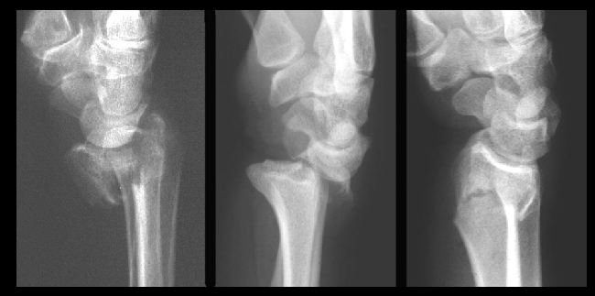

ANSWER
Pathology
In the above radiograph the pathology is detected is radiocarpal fracture/dislocation or we also say the distal radius fracture.
This fraction is in the wrist area,and here the carpal and radius bone form a joint.
Radiological finding
The following are the radiological finding of the above radiograph.
- Distal radius fracture
- Radius bone dislocation
- Carpel fracture
- Lunate dislocation
- Capitate pathologies

CASE-2
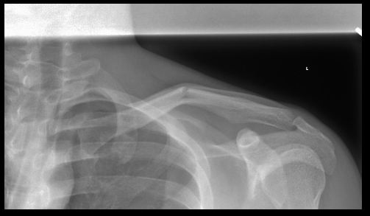

PATHOLOGY
In the above radiograph the pathology detected is fracture of clavicle/collar bone.
This fraction can occur at any part of the collar bone
But mostly it occur at the mid-shift or near the junction of the outer and middle third.
This fracture is caused due to direct below the shoulder outstretched arm and fall onto the shoulder.
Radiological finding
The following are the radiological finding in the radiograph.
- Clavicle fracture
- Shoulder dislocation
- Ribs fracture
- Coraco-clavicular distance
- Proximal humerus
- Vertebral fracture
- Gleno-humeral joint

CASE 3
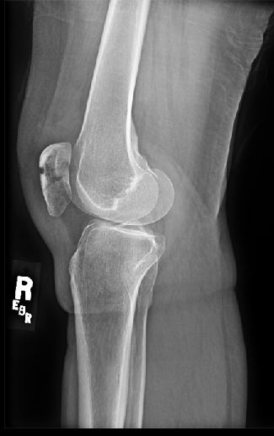

PATHOLOGY
The pathology detected in the above radiograph is dislocation of patella
Dislocation of joint between the tibia fibula and femur and there is a slight fracture on distal femur.
Above radiograph shows lateral view of knee
There is a slight fracture of patella and distal femur bone lesion identified in radiograph.
ACL ligament got splits because of the fracture or high pressure/force.
In this pathology the knee gets swelled it causes pain to the pressure.
Knee surgery will be performed in this case.

Radiological finding
The following are the radiological finding of the radiograph.
- Infrapatellar fat pad
- The length of the tibial tubercle
- Patellofemoral joint
- Posterior supra-patellar fat pad
- Tibia tubercle
- Distal femur fracture
- Proximal tibia
- Femoral condyles.

CASE 4
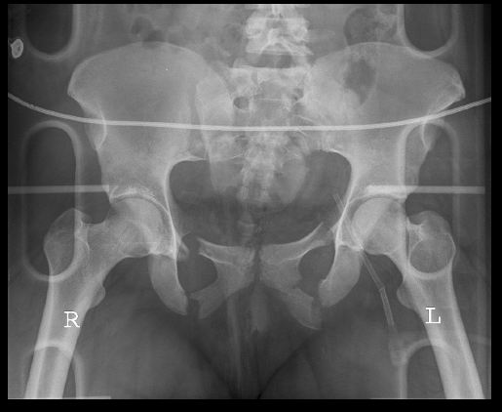

PATHOLOGY
The pathology detected in the given radiograph is pubic rami fracture
It is the most common fracture of the pelvis about 40% of the pelvis fracture is pubic rami fracture.
This type of fracture is more likely to occur due to high energy event stress and also possible due to collision.
Radiological finding
- The following radiological finding should be seen on radiograph
- Pubic rami fracture
- Pubic rami and ischium fracture
- Complex pelvic fracture
- Open book fracture
- Femoral neck fracture
- Hip dislocation (antero-inferior)
- Hip dislocation (posterior)
- acetabular fracture

