Iqra National university
Department of DPT
Final term exam (Anatomy)
Student : Marwa zeb (15335)
Instructor :MAM Arooba

Q) what do you know about the thalamic nuclei of brain
Thalamic nuclei of brain ;
Ans) Thalamus derives from a Greek word means inner chamber .
Near the center of the brain.
It is a part of diencephalon.
Largest component of the diencephalon (80%).
Diencephalon includes the following function.
Subthalamus
Hypothalamus
Epitheliums
Thalamus (including the metathalamus)

Location and Relation ;
Thalamus medially lies in the cerebrum.
Laterally; interior capsule and basal ganglia.
Bounded medially:3 ventricle.
Ventrally continuous with subthalamus .
Thalamus nuclear groups
Anterior ; nuclear groups
Anterior thalamic nuclei
Medial; nuclear groups
Dorso medial nucleus
Lateral; nuclear groups . Dividend into

DORSAL TIERS
lateral dorsal nuclei
Lateral posterior nuclei
Pulvinar
Nuclear groups ;
VENTRAL TIRERS

ventral anterior nucleus
Ventral lateral nucleus
Ventral posterior nucleus
Ventral posteromedial nucleus
ventral posterolateral nucleus
OTHER NUCLEI
Interlaminar ; nuclei
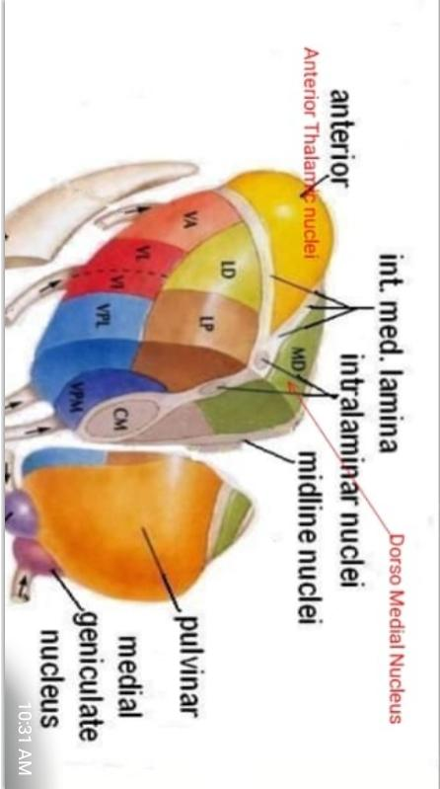
Reticular; nucleus
Midline ; nuclei
Medial Geniculate; body
Lateral Geniculate; body

Lateral nuclei group ;

Lateral dorsal nucleus ;

Part of limbic system
Hippocampus
cingulate gyrus

Lateral posterior nucleus ;
Sensory association cortex of parietal lobe

Pulvinar;
sensory association
Cortices of parietal
Temporal and occipital lobes

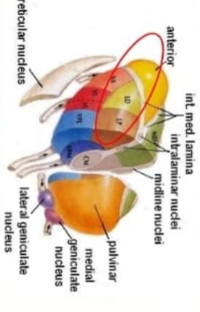

Lateral nuclear group : ventral Tier

Ventral anterior
Ventral lateral
Ventral posterior
(VPL)
(VPM)
lateral geniculate
Medial geniculate

Anterior nuclear groups ;
Functionally part of the limbic system .involuntary control of instinctive drives .emotional aspect of behavior and in memory
3 PARTA
anteroventral
Anteromedial
anterodorsal
Medial nuclear groups ;
Integrates emotion, thought, and Lateraldorsal
Lateral posterior
Pulvinar

Functions of the thalamus ;
Receives and analyzes all the sensory information from the body ( except olfactory).
Having extensive connection with the basal ganglia and the motor cortices it played a pivotal role in voluntary motor activity.
Connection with the limbic system make it important in the control of mood , emotional and sexual behavior and memory.

Thalamic lesions ;
Cerebrovascular lesions or tumors of thalamus lead to:
Loss of sensation in the contractual side of face by body following by distressing discomfort and burning and diffuse pain in the anesthetic area.
Thalamic syndrome :abnormal voluntary movements with hemisensory disturbances.

Blood supply ;
Posterior communicating artery.
Para median thalamic. Sub thalamic Inferolateral arteries.
Posterior choroidal arteries.

Q2 . Which type of stroke is common ? Write a complete note on Ischemic stroke .

A.COMMON TYPE OF STROKE :
Ischemic stroke is the most common type of stroke , according for almost 80% of all strokes is caused by a clot or other blockage within an artery leading to the brain.
ISCHEMIC STROKE :
Ischemic stroke is one of the three type of stroke . It’s also called as brain ischemia or cerebral ischemia. This type of stroke is caused by a blockage in an artery that supplies blood to the brain. The blockage reduced the blood flow and oxygen to the brain , leading to damage or death of brain cells .
SYMPTOMS :
Certain symptoms are common across most ischemic stroke , including :
. Vision problem like blindness in one eye or double vision
. Dizziness and confusion
. Loss of coordination
. Weakness or paralysis in your limbs , which may be on one or both sides , depending on the affected artery.
. Drooping of face on one side
CAUSES :
Ischemic stroke is caused by a fatty buildup happens when plaque breaks off from an artery and travels to the brain . Plaque can also build up in the arteries that supplies blood to the brain and narrow those arteries enough to cause ischemic stroke .
Ischemic stroke also caused when an artery that supplies blood to the brain is blocked by a blood clot or fatty build up called plaque . This blockage can appear at the neck or in the skull.
RISK FACTORS :
High blood pressure
High cholesterol
Atrial fibrillation
Sickle cell anemia
Clotting disorders
Congenital heart defects
Atherosclerosis
Smoking and diabetes
DIAGNOSED :
Doctor might perform a blood sugar test or usually use a physical exam and family history to diagnose ischemic stroke .
Cranial CT scan can also diagnosed ischemic stroke from other tissue .
TREATMENT :
Restore breathing , heartrate and blood pressure to normal .
Tissue plasminogen activator ( tPA) also called alteplase .

Q5 : Write a note on Autonomic Nervous System ? Difference between sympathetic and parasympathetic Nervous System .
A.AUTONOMIC NERVOUS SYSTEM :
The autonomic nervous system is the part of the nervous system that supplies the internal organs. Including blood vessels , stomach , liver, kidney lungs and heart and salivary and digestive gland .
Autonomic nervous system receive information about the body and external environment . It responds by stimulating body process, usually through sympathetic division or trough the parasympathetic division .
FUNCTION OF AUTONOMIC NERVOUS SYSTEM :
The autonomic nervous system control internal body processes such as :
• Blood pressure
• Heart and breathing rates
• Body temperature
• Digestion and metabolism ( thus affecting body weight )
• Balance of water and electrolytes ( such as sodium and calcium )
• The production of body fluids (saliva , sweat and tears)
• Urination
CAUSES :
Common causes of autonomic nervous system :
Diabetes , parkinson’ s disease , spinal cord disorders , disorder of neuromuscular junction , injury to neck , including that due to surgery .
SYMPTOMS :
Constipation
Orthostatic hypotension
Urine retention
Dizziness and light- headedness
Decrease blood pressure
TREATMENT :
Electrocardiography
Sweat test
A doctor’s evaluation
TYES OF AUTONOMIC NERVOUS SYSTEM :
There are two types of autonomic nervous system:
1.Sympathetic nervous system
2.Parasympathetic nervous system .

DIFFERENCE BETWEEN SYMPATHETIC AND PARASYMPATHETIC NERVOUS SYSTEM :

SYMPATHETIC NERVOUS SYSTEM :

•One of the main part or autonomic nervous system that control the body’s ‘fight or flight’ responses .
• Sympathetic nervous system prepare the body for emergency situation .
• It responsible for producing rapid and total metabolization to avoid danger .
• It’s preganglionic fibres arise from thoracic and lumber segments of spinal cord .
• It secretes adrenaline or noradrenaline at their synapse .
• Preganglionic fibres are shorter and postganglionic fibres are longer.
• Sympathetic nervous system increase the heart rate .
• Overall effect is excitatory .

PARASYMPATHEYIC NERVOUS SYSTEM :

• One major part of the autonomic nervous system that control the ‘ rest and digestion ‘ function of the body .
• Parasympathetic nervous system maintain conserving functions when the body is at rest .
• It restore the organism to its normal position .
• It’s preganglionic fibre arise from the midbrain and sacral ligaments of spinal cord
• postganglionic fibres of parasympathetic nervous system secretes acetylcholine .
• Preganglionic fibres are longer and postganglionic fibres are shorter .
• Parasympathetic nervous system does the opposite that of decrease the heart rate .
• Overall effect is inhibitory .

Q4) write a comprehensive note on blood supply of brain?

Blood supply of brain ;
Ans: The brain receive arterial supply from two pairs of vessels vertebral and internal carotid arteries which are interconnected in the cranial cavity to produce arterial circle of Willi’s.
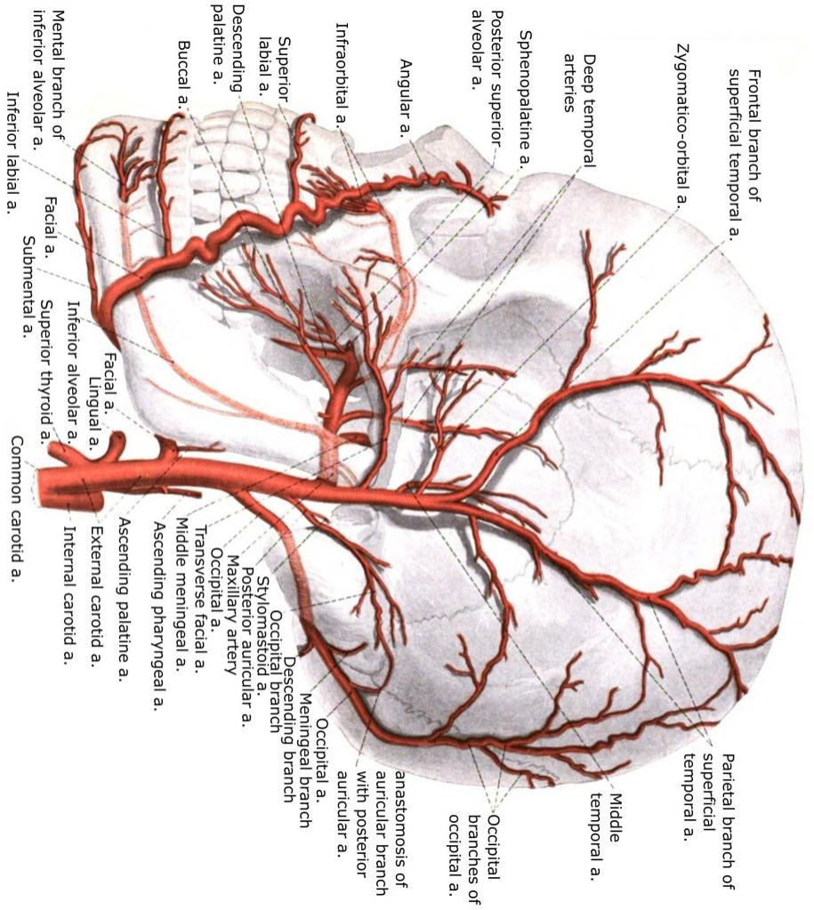
Internal carotid Artery;
The most important running up the side of neck is called common carotid artery it splits into two branches, one of the branch is called the external carotid artery which supplies bloood to the neck and face the other branch of common carotid artery which supplies to the brain with oxygenated blood, is the internal carotid artery the internal carotid artery again is the branch of common carotid artery that supply to the brain oxygenated blood. Each side of the neck and head, has one internal carotid artery supplying blood to the brain. There have a grand total of two internal carotid artery.

The interior cerebral Artery;
As the internal carotid artery enters to brain, it gives off branch called the anterior cerebral Artery. The anterior cerebral Artery is the branch of interior carotid artery supplying the anterior or front portion of brain with oxygenated blood. This Artery also important because it provides another avenue by which brain can be supplied with blood just in case another passage way is closed off.

Posterior Cerebral Artery;
Another artery entering to brain is called the posterior Cerebral Artery which supplies the posterior or structure at the rear of brain with oxygenated blood. There is one posterior artery on each side of body.furthermore each posterior artery connect to the internal carotid artery on the same side of brain in order to complete a very special structure in the brain.

The Circle of Willi’s:
The important of blood supply to brain explain why there are so many pathways for oxygenated blood. As the internal carotid artery enters to head it gives off a branch to one side called the interior cerebral Artery the anterior cerebral Artery will then connect to the anterior cerebral Artery on the other side of head therefore by extension to the internal carotid artery on the other side of head as well as we also Know that the posterior Cerebral arteries will also connect to the internal carotid artery through small vessels

Q5?
Descending spinal tracts

Originate from the cerebral cortex and brain stem

Concerned with;

Control of movements

Spinal autonomic functions

Spinal reflexes and equilibrium

Muscle tone

Modulation of sensory transmission to higher centers

Motor or descending tracts of the spinal cord

Name ; lateral corticospinal

Location; lateral column

Function; muscle of the limbs hand and feet

Name; Anterior corticospinal

Location; Anterior column

Function; Muscles of the axial skeleton

Name; Rubrospinal

Location; lateral column

Function ; skeletal muscle of the limbs hands and feet

Name; Tectospinal

Location; Anterior column

function; skeletal muscle of the hand and eyes in response to visual stimili

Name ;Vestibulospinal

Location; Anterior column

Function; muscle of maintaining balance in response to head movement

Name; Lateral reticulospinal

Location; Anterior column

Function; facilitates flexor reflexes inhibits extensor reflexes

Name; Medial reticulospinal

Location; Anterior column

Function; facilitates extendor reflexes inhibit flexor reflexes

The motor pathway are divided into two group

Direct pathway

(Voluntary motion pathway)

The pyramidal tracts

Indirect pathway

(Postural pathway)

The extra pyramidal tracts
S imlicate primarily in Action selection that is the decision of which several possible behaviora to execute at a given time.

PYRIMAIDAL SYSTEM

. Components’

. Corticospinal track

. Corticobulbar track

CORTICOSPINAL TRACK DIVISION

- Lateral corticospinal track

Made up of corticospinal fibres that have crossed in medulla . Supply all levels of spinal cord.

- Anterior corticospinal track

Made up of corticospinal fibres that cross near level of synapse with LMNs supply nech and upper limbs .

CORTICOSPINAL TRACK FUNCTIONS :

Add speed to conscious movements especially to hand.

Provide a high degree of motor control .

CORTICOBULBAR TRACK:

.Innervates the head

. Leave reticular formation and syanpse in cranial nerve nuclei .

. Synapse with lower motor neurons .

EXTRAPYRAMIDAL SYSTEM :

Includes descending motor tracks that do not pass through medullary pyramids or corticobulbar tracks includes:

. Rubrospinal track

. Vestibulospinal track

. Reticulospinal tracks

Tectospinal

RUBROSPINAL TRACK

Begins in red nucleus

Decussates in mid brain

Descends in lateral funiculus

Control the tone of limb flexor muscles being excitatory to motor neuron of these muscles .

VESTIBULOSPINAL TRACK

Originates in vestibular nuclei

Receive major input from vestibular nerve

Descends in anterior funiculus

Synapse with LMNs to extensor muscles

RETICULOSPINAL TRACK :

Originates in various regions of reticular formation

Descends in anterior portion of lateral funiculus

Thought to mediate larger movements of trunk and limbs

Origin : Pontine an Medullary reticular formation

Medial ( pontine ) reticulospine track descends ipsilaterally

Lateral ( medullary ) reticulospinal track descends bilaterally

Both tracks located in the ventral funiculus .

TECTOSPINAL TRACK

Mediates reflex movements of head and neck in response to visual stimuli.

ORIGIN : Superior colliculus

Descend in fissure , terminate mainly in cervical segments .
Desending autonomic fibers

The higher centers associated with the control of autonomic activity and situated mainly in the hypothalamus
The fibers run in the reticulospinal tracts
Terminate on the autonomic neuron in the lateral horn of throcic and upper lumberand sacral segments levels of the spinal cord

Decending tract lesions

Pyramidal tract lesions ..

Loss of fine skilled movements
Babinski sign presented
Cremasteric reflex absent
Signs contralateral ispilateral or bilateral dependent or levels of lesions

Extra pyramidal tract

Paralysis
Not muscle wasting other than that due to disuse
Hyperreflexia develops or several days
Clasp knife rigidity

