Name, faheema yousafzai.
I’d number 16990.
Computer assignment no, 1.
Different types of transmission media.
Transmission media is a pathway that carries the information from sender to receiver. We use different types of cables or waves to transmit data. Data is transmitted normally through electrical or electromagnetic signals..

Transmission Media & Types
In network communications, a transmission medium is a physical connection or an interface between the transmitter and the receiver. There are two major categories of transmission media, namely guided and wireless (or unguided). Let us take a walk through the types of transmission media and connectors in detail in this lesson.
Let's first take a closer look at the different types of guided transmission media one at a time.

1. Twisted Pair Cable
Twisted pair cables have been around for a long time. They were mainly invented for voice transmissions. Twisted pair is a widely used medium in networking because it's lighter, cheaper, more flexible, easy to install, and provides greater speeds than coaxial cables. There are two types of twisted pair cables: the unshielded twisted pair (UTP) and the shielded twisted pair (STP). Let's take a closer look at each of them.
The unshielded twisted pair cable has 4 pairs of copper wires that are present inside a plastic sheath. These wires are twisted to protect them from interference. The only protection available for a UTP cable is a plastic sheath that is thin in size.

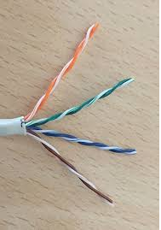
Unshielded Twisted Pair Cable

The shielded twisted pair cable is widely used in high-speed networks. The major difference between UTP and shielded twisted pair is that STP makes use of a metallic shield to wrap the wires. This metallic shield prevents interference to a better extent than UTP. These STP cables come with numbering; the higher the numbering, the better the interference prevention. As an example: most computer networks must go with CAT 3 or CAT 5, and nothing less than this.

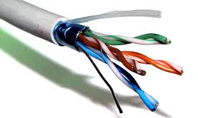
Shielded Twisted Pair Cable

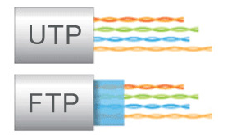
UTP and STP Difference

2. Coaxial Cables
The coaxial cables have a central copper conductor, surrounded by an insulating layer, a conducting shield, and the outermost plastic sheath. Thus, there are three insulation layers for the inner copper cable. There are two basic modes of data transmission in coaxial cables: baseband mode that has dedicated bandwidth, and broadband mode that has distributed cable bandwidth.
Cable TV and analog televisions mainly use coaxial cables. Coaxial cables have better resistance to cross talk than twisted pair cables. The coaxial cables are used for long distance communication. The most widely used types of coaxial cables are RG-59 and RG-6 (RG stands for 'radio guide'). RG-59 has lesser shielding and is suitable for short cable lengths and cable TV connections.
RG-6 has better insulation than RG-59 and is used for satellite TV and digital signal transmissions for better strength and longer distances.

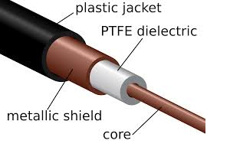
Coaxial Cable

There are many advantages to coaxial cables, including the following:
- High bandwidth
- Easy and cheap installation
- Better immunity from noise
- Better scaling
However, there are also a number of disadvantages to coaxial cables, which include the following:
- They're more prone to lightning strikes.
- They cover less distance than fiber optic cables.
- They carry less bandwidth than both fiber optic and twisted pair cables.
Now let's move onto a different type of guided transmission media.

3. Optical Fibers
Optical fibers use light waves for transmission. Crosstalk, EMI, and attenuation aren't issues with optical fibers. These cables are well-suited for voice, data, and video transmissions. Optical fibers are the most secure of all the cable media. Installation and maintenance are difficult and costly. Fiber optic cables have greater transmission speed, high bandwidth, and the signal can travel longer distances when compared to coaxial and twisted pair cables. Though the cost of optical fiber cable is less compared to co-axial and twisted pair cables, the additional optical components needed for installation make fiber optic the costliest of all the cables.

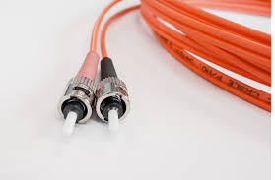
Optical Fiber Cable

The advantages of optical fibers include the following:
- There is zero interference and covers major cities and countries.
- They have high speed and high bandwidth.
- They're highly secure.
There also are a number of disadvantages, including the following:
- Installation and maintenance are difficult.
- Cabling is costly.
- Retrofitting an existing network is difficult, since optical fibers are incompatible with many types of electronic networking equipment.
There are two modes of operation for optical fibers. First there's single-mode fiber, which uses a single beam of light and allows communication over great distances with better transfer speed. Then there is multimode fiber, which uses multiple light beams inside a single fiber cable, has a reduced length and travel speed, and has a larger bandwidth, but signal strength is weakened.

4. Wireless or Unguided Transmission Media
The features of wireless/unguided transmission media are that the signal gets broadcast without any guided medium through the air and is less secure. There are three types of wireless transmission media:
- Radio wave
- Infrared
- Microwave
The advantages of unguided transmission media include the following:
- They are useful in wireless remote accessing methods.
- Networks can be expanded without disturbing the current users.
The disadvantages include:
- Potential security issues.
- They have limited speed compared to guided transmission media.
Characteristics…..
Each of them has its own characteristics like transmission speed, effect of noise, physical appearance, cost etc. Wireless or Unguided Media or Unbound Transmission Media: Unbound transmission media are the ways of transmitting data without using any cable
Basic purpose of transmission media…….
The main functionality of the transmission media is to carry the information in the form of bits through LAN(Local Area Network). It is a physical path between transmitter and receiver in data communication. In a copper-based network, the bits in the form of electrical signals.

Advantages of twisted pair cable
Twisted pair cable are the oldest and most popular cables all over the world. This is due to the many advantages that they offer −
- Trained personnel easily available due to shallow learning curve
- Can be used for both analog and digital transmissions
- Least expensive for short distances
- Entire network does not go down if a part of network is damaged

Disadvantages of twisted pair cable
With its many advantages, twisted pair cables offer some disadvantages too −
- Signal cannot travel long distances without repeaters
- High error rate for distances greater than 100m
- Very thin and hence breaks easily
- Not suitable for broadband

Advantages of Coaxial Cables
These are the advantages of coaxial cables −
- Excellent noise immunity
- Signals can travel longer distances at higher speeds, e.g. 1 to 2 Gbps for 1 Km cable
- Can be used for both analog and digital signals
- Inexpensive as compared to fibre optic cables
- Easy to install and maintain

Disadvantages of Coaxial Cables
These are some of the disadvantages of coaxial cables −
- Expensive as compared to twisted pair cables
- Not compatible with twisted pair cables

Advantages of Optical Fibre
Optical fibre is fast replacing copper wires because of these advantages that it offers −
- High bandwidth
- Immune to electromagnetic interference
- Suitable for industrial and noisy areas
- Signals carrying data can travel long distances without weakening

Disadvantages of Optical Fibre
Despite long segment lengths and high bandwidth, using optical fibre may not be a viable option for every one due to these disadvantages −
- Optical fibre cables are expensive
- Sophisticated technology required for manufacturing, installing and maintaining optical fibre cables
- Light waves are unidirectional, so two frequencies are required for full duplex transmission

Advantages of Radio Wave
These are some of the advantages of radio wave transmissions −
- Inexpensive mode of information exchange
- No land needs to be acquired for laying cables
- Installation and maintenance of devices is cheap

Disadvantages of Radio Wave
These are some of the disadvantages of radio wave transmissions −
- Insecure communication medium
- Prone to weather changes like rain, thunderstorms, etc.

