SEHAM UD DIN
13125
FINAL TERM
MARKETING MANAGEMENT
SUBMITTED TO SIR SHAHZEB ANWAR.
Question 1:
- Discuss different steps of Marketing Research along with it benefits and limitations.
Ans: Marketing research:
The process of gathering, analysing and interpreting information about a market, about a product or service to be offered for sale in that market, and about the past, present and potential customers for the product or service; research into the characteristics, spending habits, location and needs of your business's target market, the industry as a whole, and the particular competitors you face. Accurate and thorough information is the foundation of all successful business ventures because it provides a wealth of information about prospective and existing customers, the competition, and the industry in general. It allows business owners to determine the feasibility of a business before committing substantial resources to the venture. The information collected during the marketing research process can be used to create a new marketing plan or analyse the current one to determine if changes are needed.
STEPS IN MARKETING RESEARCH:
Marketing research involves a scientific approach to decision making. A step-by-step method is used to collect accurate and meaningful data that will improve the quality of the decision-making process.
1 Identify and Define the Problem:
The most important part of the marketing research process is defining the problem. In order to do any research and collect data, you have to know what you are trying to learn from the research. In marketing research, defining the problem you need to solve will determine what information you need and how you can get that information. This will help your organization clarify the overarching problem or opportunity, such as how to best address the loss of market share or how to launch a new product to a specific demographic.
Develop questions that will allow you to define your problem (or opportunity), and examine all potential causes so that the research can be whittled down to the information you actually need to solve that problem or determine what action to take regarding an opportunity. Oftentimes, these are questions about who your target market or ideal buyer persona is (for example: “What does our ideal customer look like?”). These might include questions about demographics, what their occupation is, what they like to do in their spare time—anything to help you get a clearer picture of who your ideal buyer persona is. Consider as many variables and potential causes as possible.
2 Develop Your Marketing Research Plan:
After you’ve examined all potential causes of the problem and have used those questions to boil down exactly what you’re trying to solve, it’s time to build the research plan. Your research plan can be overwhelming to create because it can include any method that will help you answer the research problem or explore an opportunity identified in step one. It identifies which research questions must be answered, how and when the data will be gathered, and how the data will be analysed. The strength of the research design has a major impact on the success or failure of the research process.
3 Collect Relevant Data and Information:
In marketing research, most of the data collect will be quantitative (numbers or data) versus qualitative, which is descriptive and observational. Ideally, we need to gather a mix of the two types of data. For example, you might run an A/B test on your website to see if a new pricing tier would bring in more business. In that research study, one might also interview several customers about whether or not the new pricing tier would appeal to them. This way, you’re receiving hard data and qualitative data that provide more color and insight.
When collecting data, it should be valid and unbiased. one should never ask a research interviewee, “You think that we should offer a higher pricing tier with additional services, correct?” This type of question is clearly designed to influence the way the person responds. Try asking both open-ended and closed-ended questions (for instance, a multiple-choice question asking what income range best describes you
4 Analyse Data and Report Findings:
Now that once gathered all of the information needed, it’s time for the: analysing the data. Although one piece of information or data might jump out, it’s important to look for trends as opposed to specific pieces of information. As analysing the data, one shouldn’t try to find patterns based on someone assumptions prior to collecting the data.
Sometimes, it’s important to write up a summary of the study, including the process that being followed, the results, conclusions, and what steps recommended taking based on those results. Even if one doesn’t need a formal marketing research report, it must make sure that it reviewed the study and results so that it can articulate the recommended course of action. Sharing the charts and data collected is pointless if it doesn’t lead to action.

5 Analyse the Data:
Once the information has been collected, it should be organized in a meaningful way so that it can be interpreted and analysed by decision makers.
When large amounts of information are collected, computers and statistical programs aid the analysis process.
If numerical data are collected, researchers can calculate the percentage of responses or average responses to each question.
Numerical data make comparisons much easier.
Non-numerical data are collected through open-ended questions and are more difficult to analyse.
6 Report and Present the Data:
The final stage in the marketing research process is that of interpreting the information and drawing conclusion for use in managerial decision. The research report should clearly and effectively communicate the research findings and need not include complicated statement about the technical aspect of the study and research methods.

Often the management is not interested in details of research design and statistical analysis, but instead, in the concrete findings of the research. If need be, the researcher may bring out his appropriate recommendations or suggestions in the matter. Researchers must make the presentation technically accurate, understandable, and useful. The report likely will include tables, charts, and graphs to summarize the data collected.
Benefits of Marketing Research
Businesses need information to make marketing decisions. Marketing research often is the main source of data for decision makers. Marketing research can benefit a business in several ways.
1 it helps businesses strengthen their position. Knowledge is power. Use market research to gain a better perspective and understanding of your market or target audience and ensure that your firm stays ahead of the competition.
2 It minimises any investment risk. This is a simple but vitally important and often business critical consideration. Spending what is often only a small proportion of your investment on researching and testing the market, product, concept or idea makes sound business sense.
3 It identifies potential threats and opportunities. Both primary research (fieldwork) and secondary research (desk research) can be utilised as an insurance policy against both obvious dangers on the road ahead. Coupling this with some qualitative research for deeper probing can highlight certain opportunities or warning signs that may otherwise have been missed.
4 Marketing research guides a company’s communication with consumers.
Good research enables companies to create more effective and targeted marketing campaigns. Companies may advertise during a football game if market research indicates that the target market frequently watches televised sporting events.
5 It helps to discover your’s and your competitor’s strengths and weaknesses. It’s vitally important to adopt an ‘eye’s wide open’ approach to any market research project which is why it’s often advised to work with a market research agency to ensure completely unbiased reporting. Use research findings to adapt and learn from your own weaknesses whilst capitalising on your new-found knowledge from competitor analysis to take advantage and forge ahead of the pack.
6 Marketing research helps companies track their progress.
Ongoing marketing research allows a company to make comparisons against data previously collected. For example, if a company is trying to increase its market share among women, it can track customer demographics through a survey to determine if this market has grown. If not, the research could indicate that a new marketing strategy is needed.
Limitations of Marketing Research:
1. Effect of Extraneous Factors:
Extraneous means external and uncontrollable factors. In most of the cases, the extraneous factors affect marketing research results adversely. Due to impact of such factors, the net impact cannot be estimated. For example, if marketer wants to study the impact of 10% price rise on demand and he raises price by 10%.
As a result, demand falls by 20%. Here, decrease in demand cannot be fully attributed to price hike only. Demand might have been affected by other factors like introduction of new superior product, attractive offer of competitors, availability of powerful substitutes, etc., over and above price rise. Whatever degree of precaution is taken, one cannot eliminate effect of such factors completely, and as a result, marketing research cannot serve the purpose.
2 Gathering and processing data can be very expensive and time consuming.
As mentioned above, many organizations have to hire marketing research specialists to research and collect data or to conduct extensive(broad) surveys. The entire research process, including the planning, collecting, and analysis stages,

3 Time Gap Makes Research Irrelevant:
Systematic marketing research project needs more time. It takes weeks, months, even years. When marketing research is carried on to investigate or solve the problem, final outcomes are available after considerable time. When outcomes are made available, situations might have been changed thoroughly or problem for which research was made might have been solved automatically. Decision-maker needs information in time. But, practically, it is not possible. Sometimes, time, money, and efforts contribute nothing.
4 Cost Consideration:
To conduct marketing research systematically is a luxury. A firm needs money for research design, data collection, data analysis, interpretation, and report preparation. Statisticians and computer experts charge heavy fees. When research is conducted regularly, a company has to maintain a separate well-equipped marketing research department. Marketing research has become costlier. So, it is difficult for medium and small companies to afford.
5 Marketing research does not guarantee success.
Marketing research can identify opportunities and make predictions, but it is not an exact science. The ultimate decisions are made by management. Marketing research is not fool proof, but it does give a business a fighting chance to succeed in the marketplace.

Question 2:
- Discuss different level of Products and Services.

Ans: According to Philip Kotler, who is an economist and a marketing guru, a product is more than a tangible ‘thing’. A product meets the needs of a consumer and in addition to a tangible value this product also has an abstract value. For this reason Philip Kotler states that there are five product levels that can be identified and developed. In order to shape this abstract value, Philip Kotler uses five product levels in which a product is located or seen from the perception of the consumer. These 5 Product Levels indicate the value that consumers attach to a product. The customer will only be satisfied when the specified value is identical or higher than the expected value

different levels of products.

1 core benefit:
This is the basic product and the focus is on the purpose for which the product is intended. The more important benefits the product provides, the more that customers need the product. A key element is the uniqueness of the core product. This will benefit the product positioning within a market and effect the possible competition.
For example, the core benefit of a hotel is to provide somewhere to rest or sleep when away from home.

2. Generic Product:
The generic product is a basic version of the product made up of only those features necessary for it to function.
In our hotel example, this could mean a bed, towels, a bathroom, a mirror, and a wardrobe.
3 Expected product:
The expected product is the set of features that the customers expect when they buy the product
In our hotel example, this would include clean sheets, some clean towels, Wi-fi, and a clean bathroom.
4 augmented product:
The augmented product refers to any product variations, extra features, or services that help differentiate the product from its competitors.
In our hotel example, this could be the inclusion of a concierge service or a free map of the town in every room.
5. Potential Product
The potential product includes all augmentations and transformations the product might undergo in the future. In simple language, this means that to continue to surprise and delight customers the product must be augmented.

In our hotel, this could mean a different gift placed in the room each time a customer stays. For example, it could be some chocolates on one occasion, and some luxury water on another. By continuing to augment its product in this way the hotel will continue to delight and surprise the customer.
Five Levels of Service:
1. Unacceptable
This may be a kind term for some of the more terrible examples of customer service, but it encompasses any service that is unacceptable for any reason.
2. Basic
Minimum standards and commodity.
3. Good
This category contains what customers would call “satisfactory” service.
4. World Class
Taking a big jump from satisfactory, in the eyes of the customer your company is superior to others in the industry.
5. Trademark
At the top of the game. You set the benchmarks for the industry.

Question 3:
What is BCG Matrix? Explain with examples.

Ans: The BCG Matrix is a well-known management model for analyzing a company's product portfolio. 'BCG' stands for Boston Consulting Group, a well-known consultancy company that developed the BCG matrix in the 1970s. The general purpose of the analysis is to help understand, which brands the firm should invest in and which ones should be divested.

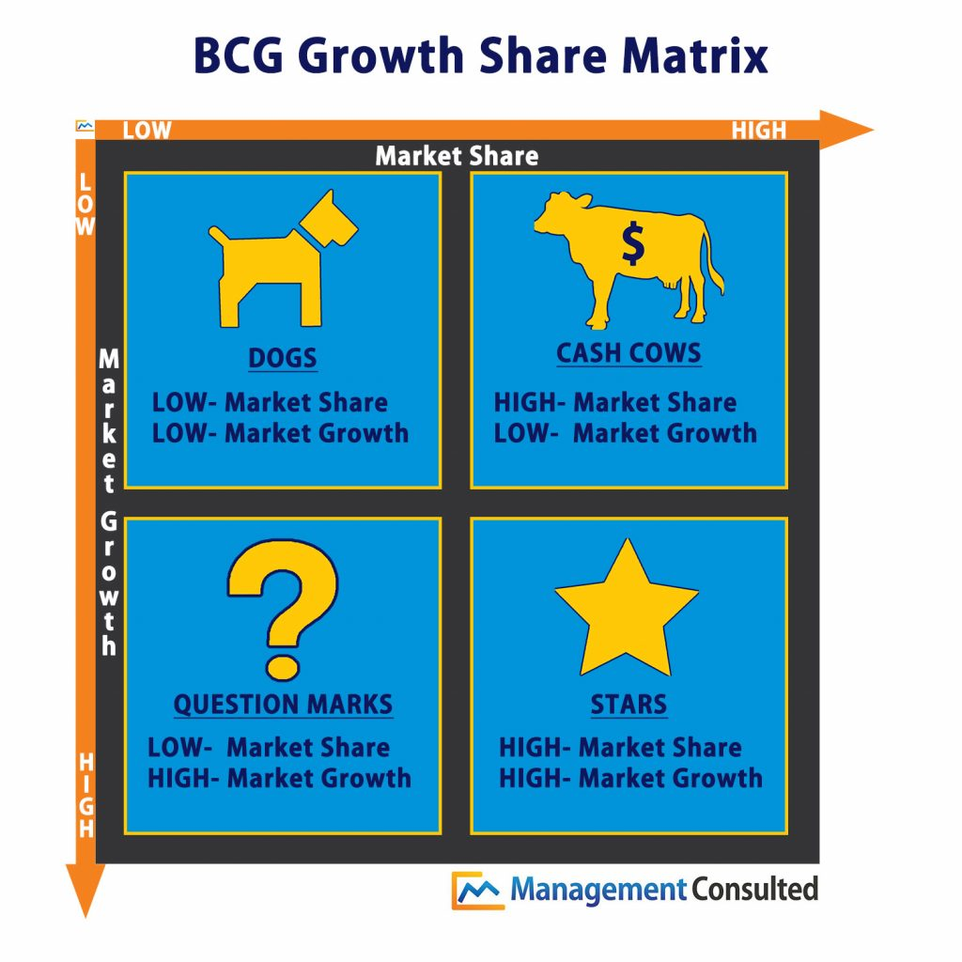

In the BCG matrix, market growth and market share of the products (or service) of a company are compared to each other. This allows a company to determine whether they should invest in a product or whether they should de-invest, or even stop the product altogether.
The dogs in the BCG Matrix are products at the end of the product lifecycle, or products that have had to compete against the competition. The margins are low, the market share is low and the market barely grows or even shrinks. The company will no longer invest in marketing. Many companies will choose not to produce the product at all. An example that can be considered as a ‘Dog’ in the BCG Matrix is the plasma TV from Philips.
The cash cows in the BCG Matrix are the products that have been on the market for some time. They have ended up in the so-called maturity stage of the product lifecycle. A product that can be classified as a cash cow in the BCG Matrix generally has a high market share, a reasonable margin, and limited growth or a slight decrease. The costs are low. The production line is largely recouped, and there is a limited investment in marketing. With cash cows it is important that you as a company optimize the profit. So go see how you can, for example, optimize processes and thus reduce costs. An example of a product that can be classified as a ‘Cash Cow’ is the Philips energy-saving lamp.
The question marks in the BCG Matrix are the products of which the future is not entirely certain. The market growth is high, but the market share low. The company must make the choice: invest in marketing, and try to make the product a 'Star', or let the product flow down to become a ‘Dog’, or in other words stop investing and even stop the product in the future. The strategy for products that have been designated as a question mark must either be focused on growth (to turn the product into a star) or on cost savings (to turn the product into a cash cow). An example that can be considered as a ‘Question mark’ in the BCG Matrix is the tablet from Philips. The market is growing very fast, but it takes a fortune in marketing to gain a large market share in this. The question mark is sometimes referred to as 'problem child' in other explanations about the BCG matrix.
The stars in the BCG Matrix are products at the start of the product lifecycle. The growth and market share are high. Because the product is at the start of the product lifecycle, the margins are usually also high. A lot is being invested in marketing. It is important for a company to have stars. Here you can earn big money. To get stars, for example, a company must invest in product development. If you have a star as a company, the strategy for this product must be aimed at gaining as much market share as possible. An example of a product that can be classified as 'Star' in the BCG Matrix is the LED lamp from Philips.

