Name: Kamgar khan
ID 12808
Final Term Assignment
Submitted to Zaigham abbass
Subject: Project Management
Date: June 24, 2020.
Iqra National University

Question no: 1
Please share ten key learning outcomes from this subject. What is the practical implementation of this subject?
(10 Marks)
Answer:
Project Management is the processes and activities to identify, define, combine, unify, and Coordinate the various processes and project management activities within the Project Management Process Groups.
The ten important learning outcomes along with its practical implementation are given in bullets.
1. Cost Efficiency. We can use it in our daily life because it’s one of the routine activity
2. Scope if there is no scope of anything its useless.
3. Time is the most important thing in life as well as in project.
4. Planning: Planning is the base to anything
5. Implementation of strategy is one of the hectic stage of project.
6. Monitoring is the managerial job and difficult to manage
7. Projects can be easily accomplished when divided in programs
8. Work break Down structure is the skeleton of project
9. Quality is important aspect of projects and can come from consistency
10. Evaluation of project is the important stage. How to evaluate the project and evaluation actually measure by the outcomes of project.
Practical Implementation of Project Management:
When the projects, programs and processes of any organization are managed in a systematic manner in order to align them with the strategic goals of the company, it is known as organizational project management. It can be said that structurally it is a combination of project management, program management and profile management. If the devised strategies do not translate through different projects, then the company will be in trouble. One has to implement organizational project management so that it can respond to any kind of organizational change efficiently.
Managing Change Efficiently:
A change in a company usually occurs when it is making a transition from the current state to any desired future state. One has to plan the implementing strategy in a way that there is least resistance from the employees and their work and that the costs are kept to a minimum. Some ways to approach the change management are:
Identifying the area of change and the problems that change would cause. See how the changes would affect the project and process and rank it based on its impact. Envisioning how you would want the change to act in the future. It should be ensured that the change should not disrupt the current state too much and the process of change should be felt the least, irrespective of what the impact of the change would be. The team especially should not feel any sort of anxiety brought by the change. Once the nature of the change has been studied properly, the change should be implemented in a systematic and methodical manner. A planning process should be designed, all the available and required resources should be allocated and one person should be appointed to overlook the transition. He should be accountable for all the developments that the project is seeing and should ensure that everything goes on smoothly. There are some tools that can assist the manager during the transition. Some of the change management tools are:
Communication: The biggest tool change management tools is communication and it comes as no surprise that it considered as one of the most efficient tools. Communicate well and the change will be handled very smoothly.
Manager Training: The managers of the team should be given appropriate training so that he can guide this team efficiently through the change.
Employee Training: It is not only the manager who needs the training. The employees should also be trained so that they can deal with the change and processes well without relying too much on the manager at all times.
Data: Collect as much data as possible that will help with the organizational project management. Take help of the tools that will help you analyze it and reach conclusive results.
Way Forward:
It’s true that change is the only constant, even in business. It is also natural for people to resist change as it makes them uncomfortable dealing with something that they are not familiar with. However, this doesn’t mean that they don’t face it altogether. After all, it is change that will bring new avenues for the businesses to explore. Implementing organizational project management efficiently will help an organization and the concerned teams deliver better results and explore new opportunities. Embracing change will do them a lot of good, thus don’t get stressed out when there is a change in progress. Use the necessary tools, plan well and implement using the various techniques and methods, you will see great results and success just around the corner!

Question no :2
What are the components of project budget, sequence of these components and explain it with relevant example?
Answer:
Components of project budget:

Cost Baseline:
The cost baseline is the approved version of the time-phased project budget, excluding any management reserves, which can only be changed through formal change control procedures and is used as a basis for comparison to actual results. It is developed as a summation of the approved budgets for the different schedule activities.
Contingency Reserve:
Duration estimates may include contingency reserves, sometimes referred to as time reserves or buffers, into the project schedule to account for schedule uncertainty. Contingency reserves are the estimated duration within the schedule baseline, which is allocated for identified risks that are accepted and for which contingent or mitigation responses are developed. Contingency reserves are associated with the “known-unknowns,” which may be estimated to account for this unknown amount of rework. The contingency reserve may be a percentage of the estimated activity duration, a fixed number of work periods, or may be developed by using quantitative analysis methods such as Monte Carlo simulation. Contingency reserves may be separated from the individual activities and aggregated into buffers.
As more precise information about the project becomes available, the contingency reserve may be used, reduced, or eliminated. Contingency should be clearly identified in schedule documentation. Estimates may also be produced for the amount of management reserve of time for the project. Management reserves are a specified amount of the project duration withheld for management control purposes and are reserved for unforeseen work that is within scope of the project. Management reserves are intended to address the “unknown-unknowns” that can affect a project. Management reserve is not included in the schedule baseline, but it is part of the overall project duration requirements. Depending on contract terms, use of management reserves may require a change to the schedule baseline.
Control Accounts:
Work Performance Information:
The calculated SV and SPI time performance indicators for WBS components, in particular the work packages and control accounts, are documented and communicated to stakeholders.
Schedule Forecasts:
Schedule forecasts are estimates or predictions of conditions and events in the project’s future based on information and knowledge available at the time of the forecast. Forecasts are updated and reissued based on work performance information provided as the project is executed. The information is based on the projects past performance and expected future performance, and includes earned value performance indicators that could affect the project in the future.

Question no: 3
What is the project quality, its purpose and project quality management processes?
Answer:
Project quality management is the process through which quality is managed and maintained throughout a project. While the context may imply that “quality” means “perfection,” in this case, is usually more about ensuring quality consistency throughout a project. However, what is exactly meant by “quality” is beholden to what the customer or stakeholder needs from the project, and therefore can be different on a per-project basis.
Modern quality management and project management are complementary. They both emphasize customer satisfaction and the underlying belief that quality leads to customer satisfaction. The main objective in project quality management is making sure that the project meets the needs it was originally created to meet nothing more, nothing less.
In other words, to ensure quality, you must meet the needs of the stakeholder. Meeting or exceeding requirements, however, is not part of project quality management. According to A Guide to the Project Management Body of Knowledge, quality is “the degree to which a set of inherent characteristics fulfill requirements.” The project manager and project management team have a special responsibility to balance quality and grade (a category or rank assigned to products or services having the same functional use but different technical characteristics).
This responsibility ensures quality expectations are met. This means that it might be possible and reasonable to have a quality, low-grade product, but it is never acceptable to have a low-quality product. At the beginning of the project, requirements are determined with the stakeholders. These requirements become the foundation for the work of the project. After that, the project manager’s job is to ensure that the work is done with no extras included. Quality is not about giving the customer extras or completing extra work. The notion of extras is often based on possibly erroneous perceptions of what you believe the customer wants. These extras add time, possible costs and other impacts to a project but do not always result in increased customer satisfaction.
different phases in project quality management.
Project quality management consists of three major processes:
1. Quality management planning: This involves identifying the quality requirements and standards for the project and product. The goal of the project quality management should be clearly shared with all stakeholders, and appropriate tasks should be delegated to those responsible.
2. Quality assurance: This involves auditing the quality requirements and quality control results to ensure appropriate quality standards are used. When standards are not met or goals are not achieved, necessary steps and corrective actions should be employed to fix these issues.
3. Quality control: This involves monitoring and recording the results of quality activities to assess performance and recommend necessary changes.
What is the definition of “quality” in “project quality management”?
The definition of quality is central to understanding these three processes. To be able to define quality, you need to be clear about the meaning of the following terms:
• Validation: assurance that the product meets the agreed-upon needs
• Precision: repeatable measures in a tight grouping
• Accuracy: closeness of a measure to the true value
• Verification: compliance with requirements
• Tolerance: range of acceptable results
The quality management planning process determines the quality standards that are applicable to the project and devising a way to satisfy them. The goal is to create a quality management plan, which documents the following:
• The way the team will implement the quality policy
• The way the quality of both the project and the product will be assured during the project
• The resources required to ensure quality
• The additional activities necessary to carry out the quality plan
Identifying these items might require updates to the project management plan or schedule, which emphasizes the evolving nature of the plan and project documents. The project manager with input from stakeholders writes the plan, like other components created during the planning phase. When planning for quality on a project follow the corporate quality policies that are in place. If a corporate quality policy does not exist, the project team should create one for the project. The project team might even need to adapt an existing policy to better suit the nature of the project. Read more about Tools and Techniques Useful in Quality Planning, Assurance and Control.

Question no 4
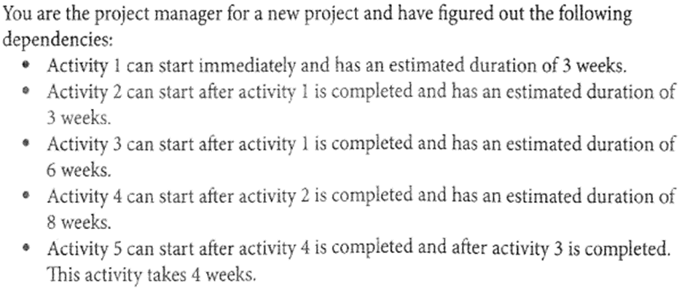
• Draw a Critical path diagram through critical path methods.
• What is the duration of critical path?
• What is the float of activity 3?
• What is the float of activity 2?
• What is the float of the path with the longest float?
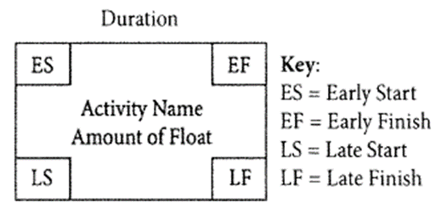

Answer:
You are the project manager for a new project and have noticed the following dependencies.
ES | Activity1-Activity 2---3weeks | EF
3week  Activity1  Activity2 |  | Activity3  6weeks  Activity4  8weeks
LS | Activity2- Activity4 4weeks | LF

