Final-Term Assignment

Course Title: Human Physiology II
Rad 2nd semester section A
Instructor: Dr. M .Shahzeb khan (PT)
Name Fizza
ID 16684
Bs Radiology 2nd semester
Sec A Marks: 50

Note:
- Attempt all questions, all questions carry equal marks.
- Answer Briefly and to the point, avoid un-necessary details

Q1: (A) How stimulus of smell moves from nostril to brain? Make a Diagram as well

Q 2: (A) What is difference between Haemostasis, Haematopoiesis and Homeostasis?
(B) What is Erythroblastosis fetalis?

Q3: (A) What is Immunity? Explain different types of immunity
(B) What is difference between Antigen and Antibody?

Q4: (A) Write down different functions of Antibody
(B) Write difference between Primary and secondary response to an antigen

Q5: Write difference between cell mediated and Antibody Mediated Immunity
Answer no 1
Smell
An act of inhaling in order to ascertion an odour is called smell
Structure
Organ for smell is nose. The inner membrane of nose is called olfactory mucosa. This membrane contain special neuron called as olfactory receptor neuron . It has many cilia which posses about 1000 various protein for each and every Odour.
Stimulus of smell moves from nostril to brain:
Like the sense of taste its chemical sense.
They are called chemical sense because they detect chemicals in the environment .
Smell begin at the back of the nose, where millions of sensory neuron like in a strip of tissue know as olfactory epithelium .In the tips of these cells contain protein which is known as receptors that bind order molecule.
People have about 450 different types of olfactory receptors and each can be activated by many different odour molecules and each odour molecules can activate several types of receptors.
- The odor molecule presents in the air reach the nostrils and dissolve in the mucus
- Here in the mucus , in the olfactory epithelium, olfactory receptors neuron are present which can detect the smell
- These neuron are able of detecting of thousand odor
- Then these neurons transmit the information to the olfactory bulbs, which are present at the back of the nose.
- Then from the these olfactory bulbs, the sensation carried through olfactory tract to olfactory area in the temporal lobe of cerebral cortex
- These brain centers perceived odor.
Answer no 2
Part A
Homeostasis:
The ability of an organisms to maintain its internal environment constant or nearly constant is known Homeostasis
Important of Homeostasis
The homeostasis is the central requirements of an organism and is necessary for normal body functions
- The organisms having better homeostatic system will survive and adopt in the changing condition
- Homeostasis contributes in the evolutionary process
Haematopoiesis:
It is the process of formation of Blood cells e.g red blood cells, white blood cells and platelets the process is know Haematopoiesis and the site where it occur is known as hemopoietic tissues.
- Development of the cells of the blood system and of their supporting structure
- The liver is the major haematopoiesis organ of the fetus but the stem cells migrate to the bone marrow.
Haemostasis:
- It is the process of the stopping of a flow of blood
- The process to prevent and stop bleeding
- It is the opposite of hemostasis
- It is the human body response to blood vessels injury and bleeding. It involves a coordinated effort between platelets and numerous blood clotting protein resulting in the formation of a blood clot and stopping of the bleed.
Stages involve in haemostasis:
Stages are as follow
- Vasoconstriction
- Platelet plug formation
- Coagulation of blood
Part (B)
Erythroblastosis fetalis:
Erythroblastosis fetalis is the disease of the fetus and the new born characterized by agglutination and phagocytosis of the fetus red blood cells
- In most instance of erythroblastosis fetalis the mother Rh negative and the father Rh positive. The baby has inherited the Rh positive antigen from the father and the mother develops anti Rh agglutination from exposure to the fetus s Rh antigen
- In turn, the mother agglutination through the placenta into the fetus.
Sign and symptoms in the fetus:
- Enlarge liver spleen , or heart
- Fluid building in the fetus abdomen seen via ultasound
Sign and symptoms in the new born:
- Anemia that creates the new born’s ( pale appearances
- Jaundice or yellow discoloration of the new born.
Answer no 3
( part A)

Immunity
The ability of a body which resists against disease or pathogens’ is called immunity
Basic type of immunity :
There are two types of immunity
Innate immunity:
It is the type of immunity which is in born and inherited from parents or antibodies obtained from mother’s milk during Lactation
Acquired immunity:
It is the type immunity which is developed during life time of an individual.
Types of Acquired immunity
There are two types
Active or natural immunity
It is a long lasting immunity developed by antibodies produced by an individual
Passive or Artificial immunity
It is a short lasting immunity in which organism itself does not produced antibodies but the antibody against specific antigen is directly injected from other source
Part ( B)
Different between Antigen and Anti bodies
Antigen
An antigen is any substance that cause your immune system to produce antibodies against it. This means your immune system doesn’t recognize the substances and is trying to fight it off. An antigen may be a substance from the environment such as chemicals, bacteria or pollen
The immune system protect the body from possibly harmful substances by recognizing and responding to antigen.
Antibodies:
Antibodies are immune system related proteins called immunoglobulins .Each antibody consists of four polypeptides two heavy chains and two light chains joined to form a Y shaped molecules. The amino acids sequences in the tip of Y varies greatly among different antibodies.
The variable region composed of 110 to 130 amino acids give the antibody its specificity for binding antigen.
Major classes
- IgM
- IgG
- IgA
- IgD
- IgE
Answer no 4
Part ( A)
Different Functions of Antibody:
Functions are as follow
- Antibodies are secreted into the blood and mucosa where they bind to and inactivated foreign substance such as pathogens and toxins
- Antibodies activate the complement system to destroy bacterial cells by lysis
- Antibodies facilitate phagocytosis of foreign substances by phagocytosic cells.
- Neutralization of infectivity
- Part (B)

Difference between primary and secondary response to an antigen:
Primary Response to an antigen:
Primary immune response occur when an antigen comes in contact to the immune system
- Responding cell is B cell and T cell
- Lag phase is longer
- It takes longer time to establish immunity
- Produced IgM but sometimes IgG also produced
Secondary response to an antigen:
The secondary immune response occur when the second time the person is exposed to the same antigen.
- Responding cell is memory cell
- Lag phase is shorter
Produced IgG antibody but sometimes small amount of IgM are produced.
Answer no 5
Q No 5 Answer

Cell mediated immunity:

The cell mediate immune system consist of T cell which originate in the bone marrow but moves to the thymus where their thymus their development is completed t cell are highly specialized cells in the blood and lymph they fight bacteria viruses fungi protozoan cancer etc .within host cells and react against foreign mater such as organ transplants there are three kind of t cell cytocxic t cells directly kill invaders helper t cell aid b cell and other t cell to do their jobs suppresor t cell suppress the activites of b cell and other t cell so they don’t overrating the cellular immune responses cells of the immune system kill cell of the body.
That have been infected with a virus or that are cancerous .this response relies on cytocxic T cell tc cells contain molecule called perforins

The antibody mediated immunity

The humoral immune system consist Of B cells which originate in the bone marrow and stay there to develops B cell can produce antibodies but need exposure to foreign antigens to do so these antigens are cell surface oligosaccharides and proteins which the cell uses as if tags
Antibodies are chemically proteins present in blood plasma and lymph they help in fighting bacteria and viruses in body fluids
All daughter cells of a B cells will be able to produce the same antibodies as the mother cell antibodies bind to certain parts of an antigen to mark it for destruction by the T cells

The body humoral or antibody mediated immune response begins in the same manner as the cell mediated response but there the macrophage are joined by b cells.
The to enter the battle .mean while the antigen presenting macrophages activate those helper t cell with receptors those T cell in turn lead the battle front with activated b cells
Antigen presenting cell

Anti fragement
Clone of plasma cells
Clone of memory b cells ..
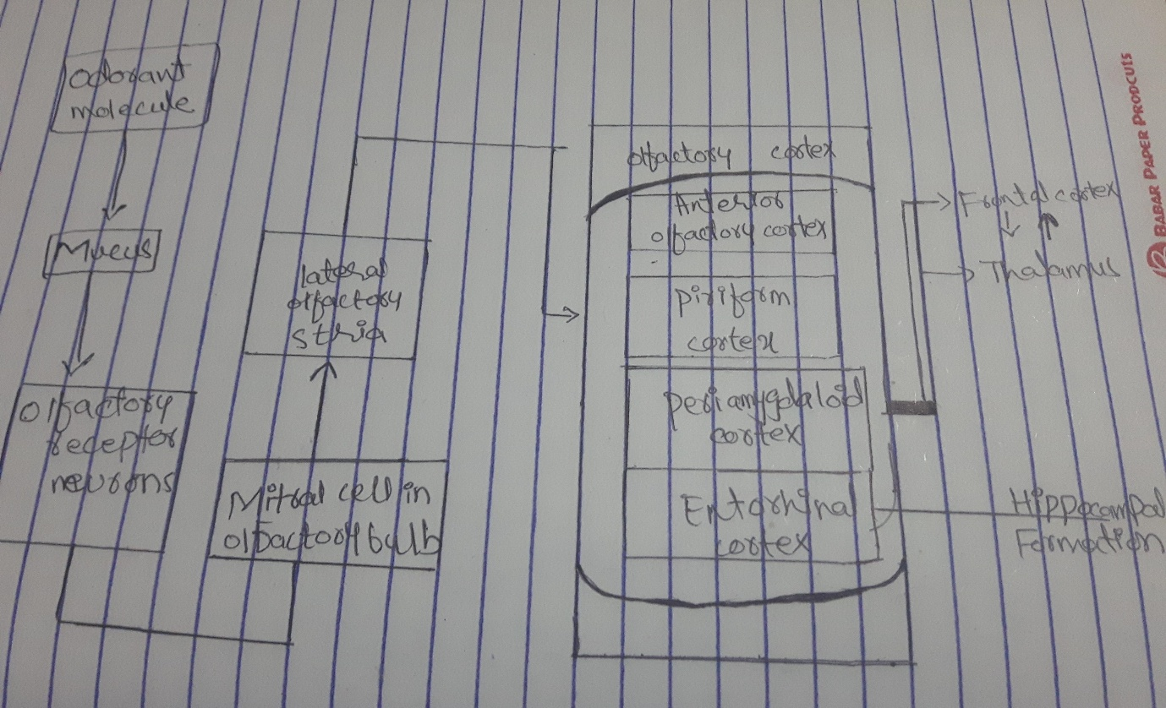
Answer no 1 diagram:

