Student ID 13103
This study illustrates the differences of the employees working in Indian sector organization i.e. Bharat Sanchar Nigam Limited and dimensions included gender (males and females) and categories (general, disabled, minorities etc). The sample of 619 respondents indicates that the discrimination exists at workplace.
Introduction:
Diversity means that individuals having differences that can be in terms of characteristics that reflects in one’s behavior i.e age, race, ethnicity, gender religion, ability etc. Diversity is when you accept that every person is unique and all have different personality.
Brief introduction of BSNL:
BSNL it’s an Indian owned telecommunications company situated in New Delhi. It began its operations on 15 September 2000. It is one of the huge company in India providing different telecom services. They have highly skilled labor i.e. employees that work in their workforce is 357,000(Bharat Sanchar Nigam Limited, 2018). Indian telecom sector play a huge and important role for the development of their country. BSNL is one of the major public sector players in the telecom sector of India. Public sector organization mainly follows the rules, regulations and the principles that are given to them by their workplace itself so therefore, they should support and promote workforce diversity that can help them in achieving their targets and goals of the businesses. BSNL telecom sector company have certain questions that needs to be answered i.e. how do employees respond to their perceptions in mind towards gender and different categories? How do their perceptions differ from one another?

Promotion of Diversity:
The public sector organizations hold an important value for any workforce diversity. Moreover the perceptions and abilities of the people perceptions still have no answer to these questions. This study found out that as compared to males females are more positive towards diversity.

Development opportunities for diverse workforce:
In any workplace all the individuals working there have different perceptions in their mind regarding diversity. Kundus (2004) elaborated that in comparison of males, females are more likely to respond positively to the organization’s work.
Organizational support for diverse workforce:
Based on the personal experiences of employees working in organizations, they had developed different attitudes and perceptions in their minds regarding the support and fairness provided by workplace. However women face more discrimination at their work as compared to males (Fine et al., 1990; Soni, 2000; Sipe et al., 2009).
Recommendations:
A diverse workplace is important for each individual and also for the company success. Organizations should be fair in recruitment and selection process for workforce diversity. Organizations should make each and every employee valued and encourage them so that they can help them to achieve their overall goals and objectives. Equity among all employees.
Conclusions:
Employer’s efforts to promote diversity and work was valued and of great importance for females as compared to males and valued least by general category employees compared with all other categories of employees. Disabled, minority and socially disadvantaged employees believed that they received no organizational support than that assumed by the other categories of employees respectively.
Being an employee/business man/student I didn’t faced discrimination but one of companion of mine got bullied by her coworker at the office. This made her working environment very uncomfortable for her and this made her in complex and her performance began lesser day by day. Due to this discrimination by her coworker she began to experience anxiety and stress when she was about to go to the same office.
Solutions for discrimination and victimization:
In order to cope up with the discrimination and victimization I can suggest that we need to focus more on our strengths and we should motivate individual to succeed in life. Speak up for our rights. And sometimes we can also take help from professionals. We need to discourage every individual for doing discrimination.

Workforce diversity:
Diversity basically means that one person is different from another. Diversity is when you accept that every person is unique and all have different personality. Workplace diversity means when you bring different people altogether. Workforce diversity comprises of different characteristics that reflects in one’s behavior i.e. age, race, ethnicity, gender religion, ability etc. The main purpose of workforce diversity is that we can identify, attract and retain the capable and most suitable persons from a group. Providing a positive and favorable environment to the individual. Satisfying the needs of customer. Diversity is important it helps us to encourages individuals at workplace to promote new knowledge and information. Ensuring fairness in an organization can also help us to promote diversity in an organization.
Dimensions of workforce diversity:
There are two main types of dimensions.
- Primary dimensions
- Secondary dimensions
Primary dimensions: the primary dimension includes differences such as your age, race, ethnicity, gender etc. These are the by-birth differences that differentiate from person to person. Primary dimensions play an important role for an individual because they can make us true human beings.
Age:
Age diversity is when you accept different age groups people within the business organization or any workplace you are working in. every organization needs to adjust them having variations in age groups.

Race:
Race diversity is when people belongs to different groups and possess some factors and living in the same state or country. It includes physical attributes such as your skin color, appearance, etc.
Ethnicity:
It is associated to the culture and, norms and values of a person.
Gender diversity:
It basically represents the equal ratio of male and female. Gender diversity means that both male and female are equal, they are paid equally for the work they do, and hiring as well.
Secondary dimensions: secondary dimensions include education, religion, beliefs; culture etc. Secondary dimensions have a huge impact on a person’s core identity.
Personality:
Personality represents a person’s likeness and dislikes. By personality it means a person’s traits and characteristics that distinguish a person from another.
Culture:
Culture is defined as attitudes, beliefs and values of a person that helps a person to build positive and form relations with others.
Conclusion:
The main advantage in workforce diversity is that when different people work together that helps them in achieving organizational goals and they can come up with the creation of new knowledge that can help them in long-run.

Some examples from the workplace of discrimination at workplace includes when an employer, supervisor or co-worker treats another employee UNFAIRLY based on religion, age, gender, cast, skin color or race. People with different background and opinions norms and values and experiences. Discrimination can be done direct, indirect, intentional or unintentional.
People diverse in the following aspects such as Thinking styles, language, Ethnicity, Religion, Perspectives, experiences, nationality, skills, job level, age, Gender Physical abilities etc.
1-Excluding potential employees during recruitment.
2-Descrimination when issuing promotion or lay-offs.
3-Paying equally qualified employees in the same position different salaries.
4-Denying certain compensation or benefits.
5-Decisions and hiring process based on a person’s race.
6-Some employees or managers may not consider the made changes “positive”. Employees who oppose workforce diversity usually reject new ideas and make the environment difficult to work.
7-Communication barriers lead to the problem for example: if the manager is giving the instruction about the certain task and message is not understood clearly the employee may make a mistakes while attempting the task without receiving the clear message.
8-Food habits: The food habits are mostly guided by one’s religion and casts. As I have experienced a lot of experiences to different cities of Pakistan, I have found that interestingly, the food habits are also influenced by the city/region as the climate influences or the climate is the major factor that decides the availability of the demanded food.
1- The top management commitment to value diversity is pre-requisite
2-Organise diversity training programs that provide diversity awareness and educate on cultural and gender differences and train them how to respond in workplace.
3- Provide a nurturing climate for employees to work.
4-GENDER biased needs to be given up. When paying salary to men and women of the same qualification, responsibilities, timing hour, skills and position. It shall be forbidden to discriminate on the basis of gender.
5-Don’t play Favorites: if you can offer certain benefits to employees, make sure these perks are being available for all the other employees too.
6-Be careful to what you say and to whom: Its easy for an off-the-cuff remark said by either. Think before you say something that might be misinterpreted. Also teach employees to conduct themselves similarly. People should not be afraid of being themselves, but they need to be careful about what is okay to say and what is better left unsaid.
7-Formailze Policy: Create and post an anti-discrimination policy. If any kind of discrimination tool place in an organization/workplace, decide if you will start with warning, counselling them, or formally terminate the accused.
8-Respond Quickly: If an employee expresses their concern or the problem at workplace discrimination, do what can be done in the shortest possible time to resolve the issue.
9-Religious Discrimination: Businesses/Organization should make reasonable accommodation of an employee’s religious beliefs, as long as doing so does not have excessive negative consequences for the employer.
10-Age discrimination: is a practice specifically prohibited by law. Employees must receive some benefits irrespective of age.

Diversity represents the multitude of individual differences and similarities that exists among people. Diversity can encompass many different human characteristics such as race, age, creed, national origin, religion, ethnicity sexual orientation. Wellner (2000)
The Dimensions of the Diversity can be explained by the four layers wheel model. The wheel shows the complication of diversity filters through which the information is processed. It leads to the assumptions about the behavior of the people around which eventually drive our own behaviors that has an impact on others.
the Four layers model is:

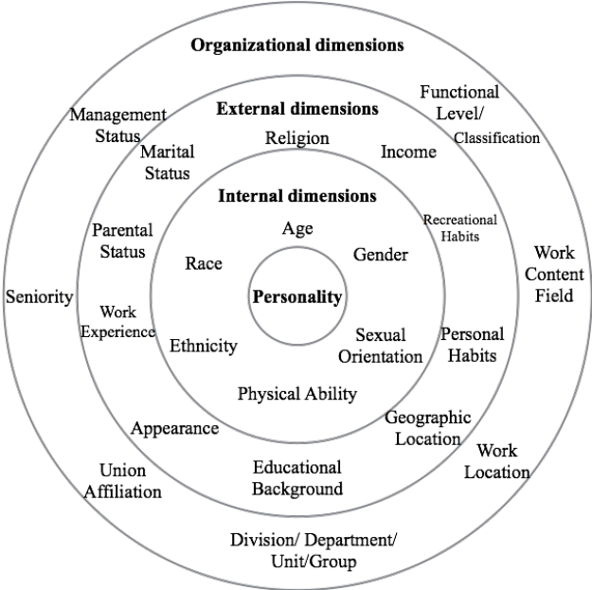
Th characteristics representing diversity illustrated in Gardenswartz & Rowes (1994) Four Layers of Diversity Model. According to Gardenswartz & Rowe (1994) the four layers of diversity are:
Organizational Dimensions
External Dimensions
Internal Dimensions
Personality
The Organizational Dimensions
It represents the outer most layer and consists of elements such as management status, union affiliation, work location, seniority, divisional department, work content, and functional level classification. The elements associated to these dimensions are items under the organization control.
The External Dimension
it represents those elements that deals with the individual’s life choices. Individual has a higher level of control over these elements comparatively to the organizational dimension. The characteristics in this layer are personal habits, recreational habit religion, educational background, work experience, appearance, marital status, geographic location, and income.
The Internal Dimension
This dimension of diversity represents that an individual has no control over these characteristics. These characteristics are assigned at birth i.e. Age, race ethnicity, gender and physical ability. Often these traits are the sources of bias and discrimination.
Personality
this is described as traits and stable characteristics of an individual that are viewed as determining particular consistencies in the manner in which that person behaves in any given situation and over time (Winstanley 2006)
The personality of an individual is influenced by the other three levels of the models. The other models they help to shape the individual’s perception, disposition and actions as the individual inter-acts with the people of its surroundings.

