Junaid Ahmad
13868
BS MLT
Submitted to mam huma
26/06/2020

Answer No 1
Hemovigilance
It is derived from two Greek words Heama means blood and Vigilans means watchful or paying special attention.
Hemovigilance is defined as a set of surveillance procedures covering whole transfusion chain from the collection of blood and its components to the follow up of its recipients, intended to collect and access information on unexpected or undesirable effects resulting from the therapeutic use of blood products.
Benefits of Hemovigilance
Hemovigilance data can be used to define priorities for blood transfusion
Improve public confidence and trust.
Improve the quality of Transfusion Service.
Understanding of frequency and range of transfusion related events.
Improve understanding of real risks/hazards of transfusion.
Limitations of Hemovigilance
Incomplete reporting
Limited details
Variation in terminology and definitions

Answer No 2
Purpose of cross match
- The main purpose of cross match is to detect ABO incompatibilities between donor and patient.
- This is carried out to prevent transfusion reaction by detecting antibodies in recipients’ serum
Major Cross match
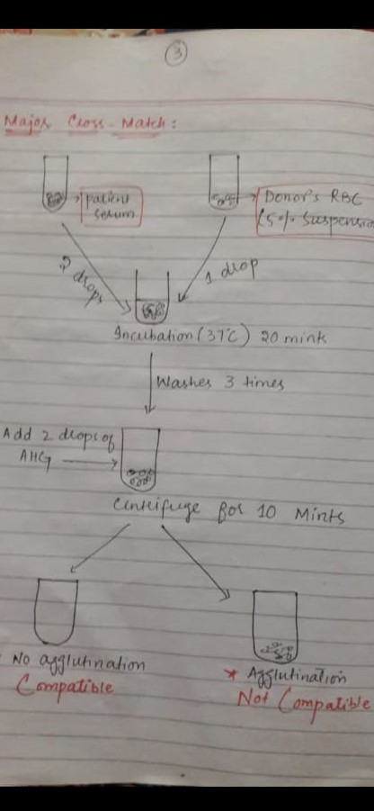

Answer no 3
Pathogenesis of HDN
The antibodies answerable for haemolysis are often naturally occurring (e.g., anti-A or anti-B antibodies) or can develop as a results of a sensitising event like pregnancy or transfusion. the foremost well recognised is rhesus alloimmunisation (Greek: allo = 'other' or 'different from') which begins with red blood cells from a rhesus-positive fetus crossing the placental barrier during pregnancy and delivery, and entering the maternal blood circulation. A Rh-positive father and a Rh-negative mother are required for this example to develop. The incompatible antigens introduced end in a primary immunologic response and stimulate the assembly of maternal antibodies. a awfully bit of fetal-maternal haemorrhage (FMH) has to occur (less than 0.1 ml) and most go unrecognised. Primary exposure also can be the results of amniocentesis, villus sampling and cordocentesis.

Answer no 4
As a chemokine receptor, it binds to the chemicals that are secreted by cells during inflammation and recruits other blood cells to the world of injury
These chemokines include
- Acute inflammation chemokines
- Chronic inflammation chemokines
- Interleukin-8

Answer No 5
Coombs reagent
- Coombs reagent made by taking blood from a human then separating the serum with auto antibodies.
- Then the serum is injected to the lab animal and the animal produces antibodies against the auto antibodies.
- Then the blood from the animal is drawn and separated to give the formed antibodies.

