Iqra National University
Department of Civil engineering
Mid Assignment

ID: 14747 Course: Pavement Material
MS CE Instructor Name: Sir Engr. Shabeer Ahmad

Q1. (1)
The phenomena given in the figure is stress strain phenomena.
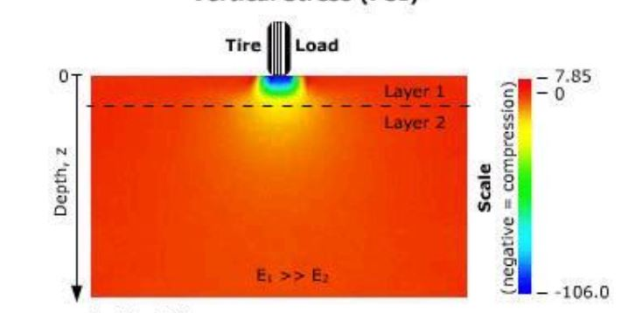
The primary function of the pavement structure is to reduce and distribute the surface stresses (contact tire pressure) to an acceptable level at the subgrade (to a level that prevents permanent deformation). A flexible pavement reduces the stresses by distributing the traffic wheel loads over greater and greater areas, through the individual layers, until the stress at the subgrade is at an acceptably low level. The traffic loads are transmitted to the subgrade by aggregate-to-aggregate particle contact. Confining pressures (lateral forces due to material weight) in the sub base and base layers increase the bearing strength of these materials. A cone of distributed loads reduces and spreads the stresses to the subgrade.

Q1 (2):
The phenomena in the given figure in the pavement layers is stress strain relationship due to traffic loading. The stresses and strain in the pavement are classified into vertical and horizontal stresses and strains based on the axis.

Vertical Stress:
It is the wheel load which is transfer to the each layer of pavement. It is a vertical line which start from the surface of wheel contact area to the last layer of the road.
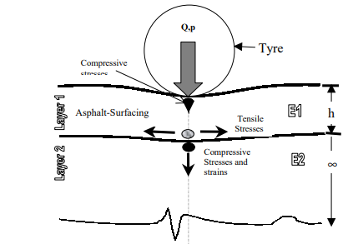

Horizontal Stress:
The stress which is not present directly under the wheel load but is the effect of horizontal normal stress on the layers called Horizontal stress.
The compression of lower layers is caused due to the vertical strain. The compression transfer to the sub layers from the adjacent top layers. Bearing capacity and strain are inversely proportional to each other i.e if bearing capacity is low more strain will be transferred to the below layers and vice versa.The vertical strain produce horizontal strain which transferred by grain to grain contact.
Typical Flexible Pavement with Granullar Base:
Four types of stresses are produced by the wheel under the layer. The location and position of the stresses induced in the layers depend on the layers and their respective properties. 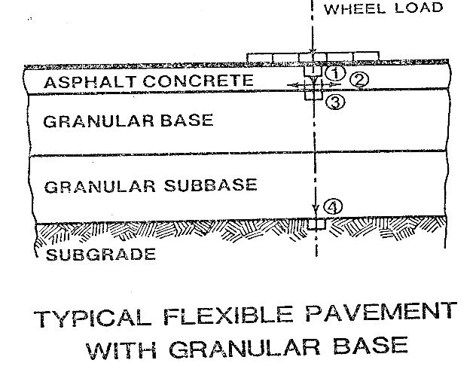
The stresses induced are:

- The first layer is asphalt concrete where compression is produced as the wheel load is adjacent to the contact area of wheel and pavement. The rutting is caused due to the compressive strain which is produced by compressive stresses.
- The fatigue or aligator cracking is produced due to the tensile stresses at the bottom of the asphalt layer.
- Rutting is produced in the third layer of granular base due to the compressive stresses and strains.
- In the fourth layer of grannular subbase compressive stresses and their strains are induced which inturns cause rutting and due to its position of being the last layer it also produces depression in the subgrade.
Typical Flexible Pavement with Stabalized Base:
The process of pulverizing the existing underlying layers and mixing into a homogenous base material durimg the recycling process called Base stabilization.
The purpos of stabilize base is to provide a transitional load bearing strata between the pavement layer and the underlying subgrade soil. Four types of stresses created by the wheel under the layers,the four layer of road having stabilized base are as under:
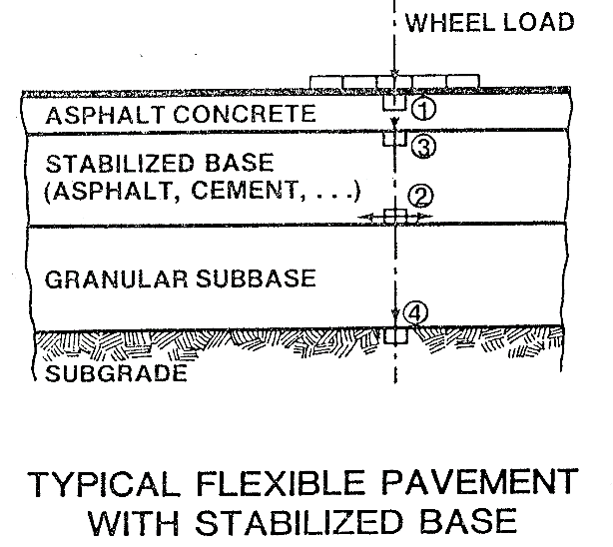
- In the first layer of asphalt concrete due to wheel load compressive stresses are produced which in turns produces copressive strains.
- In the seconde layer of stabilized base tensile strains are induced in the lower zone which causes transvese reflective cracking or fatigue craching.
- Also in the second layer of stabilized base copressive strain are produced which cause rutting
- In the fourth layer of grannular sub base compressive strain is induced which inturn causes ruttuoing and depression in the subgrade.

Q2:
(1): Steps involved in the soil investigation and preparation of Geotechnical Report:
Site investigation or Sub-Soil explorations are done for obtaining the information about subsurface conditions at the site proposed for construction. Soil exploration consists of determining the profile of the natural soil deposits at the site, taking the soil samples and determining the engineering properties of soils using laboratory tests as well as in-situ testing methods
Site investigation or sub-soil exploration is carried out stage-wise as given below:
- Site Reconnaissance
- Preliminary site exploration
- Detailed exploration
- Preparation of soil investigation report

Stages in Site Investigation:

1. Site Reconnaissance
Site reconnaissance is the first stage of site investigation. In this stage, visual inspection of the site is done and information about topographical and geological features of the site are collected. The general observations made in site reconnaissance are as follows :
- Presence of drainage ditches and dumping yards etc.
- Location of groundwater table by observing well in that site.
- Presence of springs, swamps, etc.
- High flood level marks on the bridges, high rise buildings, etc. are observed.
- Presence of vegetation and nature of the soil.
- Past records of landslides, floods, shrinkage cracks, etc. of that region.
- Study of aerial photographs of the site, blueprints of present buildings, geological maps, etc.
- Observation of deep cuts to know about the stratification of soils.
- Observation of Settlement cracks of existing structures.
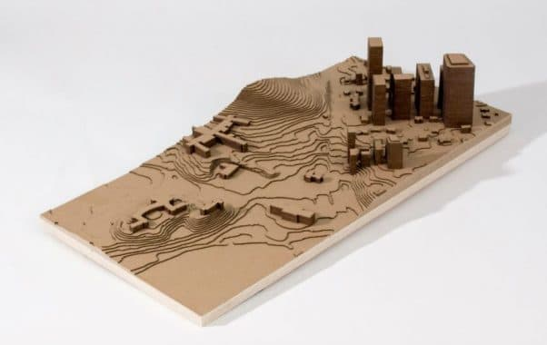
Topographical Study of Site.

2. Preliminary Site Exploration
Preliminary site exploration is carried out for small projects, light structures, highways, airfields, etc. The main objective of preliminary exploration is to obtain an approximate picture of sub-soil conditions at low cost. It is also called general site exploration.
The soil sample is collected from experimental borings and shallow test pits and simple laboratory tests such as moisture content test, density, unconfined compressive strength test, etc. are conducted. Simple field tests such as penetration methods, sounding methods, geophysical methods are performed to get the relative density of soils, strength properties, etc.
The data collected about subsoil should be sufficient enough to design and build light structures. Following are some of the general information obtained through primary site exploration.
- Approximates values of soil’s compressive strength.
- Position of the groundwater table.
- Depth and extent of soil strata.
- Soil composition.
- Depth of hard stratum from ground level.
- Engineering properties of soil ( disturbed sample)

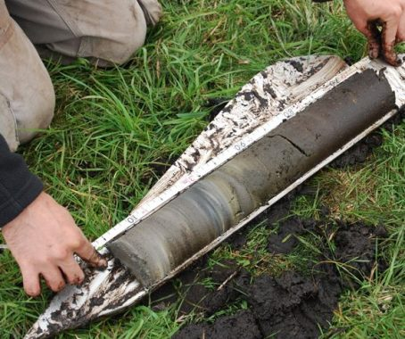

Collecting Soil Sample for Preliminary Soil Exploration

3. Detailed Site Exploration
Detailed exploration is preferred for complex projects, major engineering works, heavy structures like dams, bridges, high rise buildings, etc. A huge amount of capital is required for a detailed site exploration hence, it is not recommended for minor engineering works where the budget is limited. For such type of works, data collected through preliminary site exploration is enough.
In this stage, numerous field tests such as in-situ vane shear test, plate load test, etc. and laboratory tests such as permeability tests, compressive strength test on undistracted soil samples are conducted to get exact values of soil properties.
Different methods of site exploration which are used in both preliminary and detailed site are followed:
- Open excavation
- Borings
- Subsurface soundings
- Geographical methods

Open Excavation
A pit, eventually, can be excavated for exploring shallower depths, say of the order of 2 to 5 m, or so. Such a pit can be easily excavated at the proposed construction site, if the soil has a bit of cohesion, and the soil samples can be lifted from such different depths, besides making the easy visualization and examination of the different strata. Even undisturbed soil samples can be lifted from such a pit by a process called chunk sampling.
Boring Method
Soil samples can be lifted from deeper depths by drilling bore holes by using mechanical devices called samplers.
The process consists of
- Drilling a hole and visually examining the cuttings coming out from different depths
- Lifting the soil samples from different depths by using mechanical devices called samplers

Geographical Methods of Soil Exploration

i. Electrical resistivity method
This method is based on the measurement and recording of changes in the mean resistivity or apparent specific resistance of various soils. The test is done by driving four metal spikes to act as electrodes into the ground along a straight line at equal distances.

ii. Seismic refraction method
This method is very fast and reliable in establishing profiles of different strata, provided the deeper layers have increasingly greater density, higher velocities and greater thickness.

Q3 :

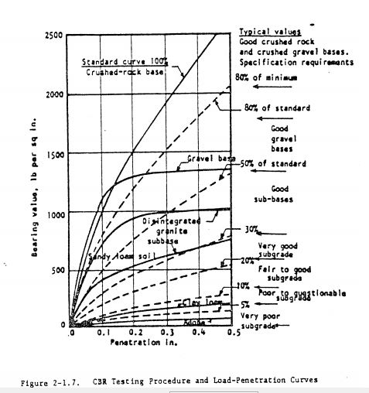

The above graph shows the bearing ratio of the material of CBR test.
Horizental side of the graph shows the penetration of the plunger in inches. The vertical side of the graph shows the bearing value. At the bottom of the given graph the first line shows that the penetration value has reached to maximum value of 0.5 in by applying a very small load thus shows that subgrade is very poor. The bold curve from the bottom of the graph show that 5% of the standard curve is of clay loam which shows the looseness of the soil because it is weak in withstanding stress.
The curve adjacent to the clay loam is the one which hold 10% of the standard penetration and is called fair to good subgrade. Its slope is more from the previous graph which shows increase in bearing capacity.
The curve which shows 20% of bearing value shows very good subgrade. As we go upside of the graph an increase in slope occur which shows the increase in bearing capacity.
Now the 2nd bold curve is crossed by the dotted curve line of the 30%. Here the bold curve shows drop at the end which shows that there maybe shear failure under high stress.
The 3rd bold curve shows disintegrated sub base. Here the graph first shows increase in slope and then the graph shows decrease increase and flattened at the last. The variation in the slope shows that the material is good to withstand small stresses but weak at high stresses.
From the above discussion it is concluded that the materials shows consistency of 20% in the graph progression it means that 20% of the material which is weak will remain weaker until the full load is applied. Above 20% the graph shows variation in slope.

Q: 4 (1):

Dry of Optimum:
The soil compacted at water content less than optimum water content have flocculated structure which is called dry of optimum.
The dry side of OMC is called dry of optimum.
The soil are always flocculated.
Wet of optimum:
The soil compacted at water content more than the optimum water content have dispersed structure which is called wet of optimum.
The soil to the wet side of the OMC is called wet of Optimum.
Here the fabrics become more oriented or dispersed.
Explanation:
Initially for a water content lesser than O.M.C the soil is rather stiffer in nature that will have lots of void spaces and porosity. This is the reason for lower dry density attainment.
When the soil particles are lubricated with the increase in the water content, the soil particles will be densely packed resulting in increased density. Now beyond a limit (OMC) the addition of water will not bring a change in dry density or will decrease the dry density.
The graph represents a zero-air void or 100 % saturation line. This is based on the theoretical maximum dry density where it occurs when there is 100 % saturation. As the condition of zero voids in soil is not real and a hypothetical assumption, the soil can never become 100% saturated. The graph below show compaction curve.
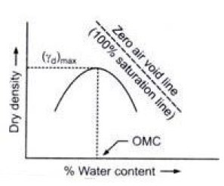

Q;4 (2):
Effects of Compaction on engineering properties of soil:
Compaction means pressing of the soil particles close to each other by mechanical methods. Air is expelled from soil mass and mass density is increased. It is done to improve the engineering properties. Like shear strength, stability etc. Reduces compressibility and permeability.
The following properties of soil are affected by compaction:
- Soil structure.
- Permeability.
- Swelling.
- Pore water pressure.
- Shrinkage.
- Compressibility
- Stress strain relationship.
- Shear strength
- Shear strength at moulded water content. B. Shear strength after saturation.
- EFFECTS ON SOIL STRUCTURE
The water content at which the soil is compacted plays an important role in soil structure. Soil compacted at water content less than optimum water content have flocculated structure. Soil compacted at water content more than optimum water content have dispersed structure.
At a point A, the water content is low and attractive forces are predominant, so results n flocculated structure. As the water content is increased beyond optimum, the repulsive forces increase and particles get oriented into a dispersed structure.
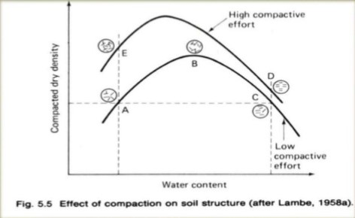

- EFFECT ON PERMEABILITY:
Permeability of soil depends on void size. As water content increases, there is an improved orientation of particles resulting in reduction of void size and permeability. Above optimum water content , the permeability slightly increases. If compactive effort is increased, the permeability decreases due to increased dry density.
- EFFECT ON SWELLING:
The effect of compaction is to reduce void space. Hence swelling is enormously reduced.
Further soil compacted dry of optimum exhibits greater swell than compacted on wet side because of random orientation and deficiency of water.
- EFFECT OF PORE WATER PRESSURE:
It is defined as pressure of ground water held within a rock or soil, in gaps between particles (pores). The pore water pressure for soil compacted dry of optimum is therefore less than that for the same soil compacted wet of optimum.
- EFFECT ON COMPRESSIBILITY :
The flocculated structure o the dry side of optimum offers greater resistance to compression than the dispersed structure on wet side. θ So, the soil compacted dry of optimum are less compressible.
- EFFECTS ON STRESS-STRAIN RELATIONSHIP:
The soil compacted dry of optimum have steeper stress strain curve than those on wet side. The strength and modulus of elasticity of soil on dry side of optimum will be high. Soil compacted dry of optimum shows brittle failure. And soil compacted on wet side experience increased strain.
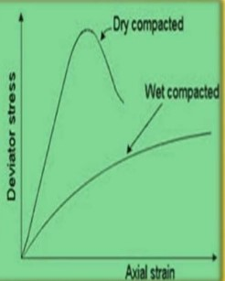

- Effect on shear strength:
In general the soils compacted dry of optimum have a higher shear strength than wet of optimum at lower strains. However at large strains the flocculated structure of soil is broken and ultimate strength will be equal for both dry and wet sides.
