NAME: AFTAB SHEHZAD
SECTION: A
ID NO : 16138
PAPER; ARCHITECTURE AND TOWN PLANNING
SEMESTER 2ND
ATTEMP ALL THE QUESTIONS
QUESTION: 1
ANS:
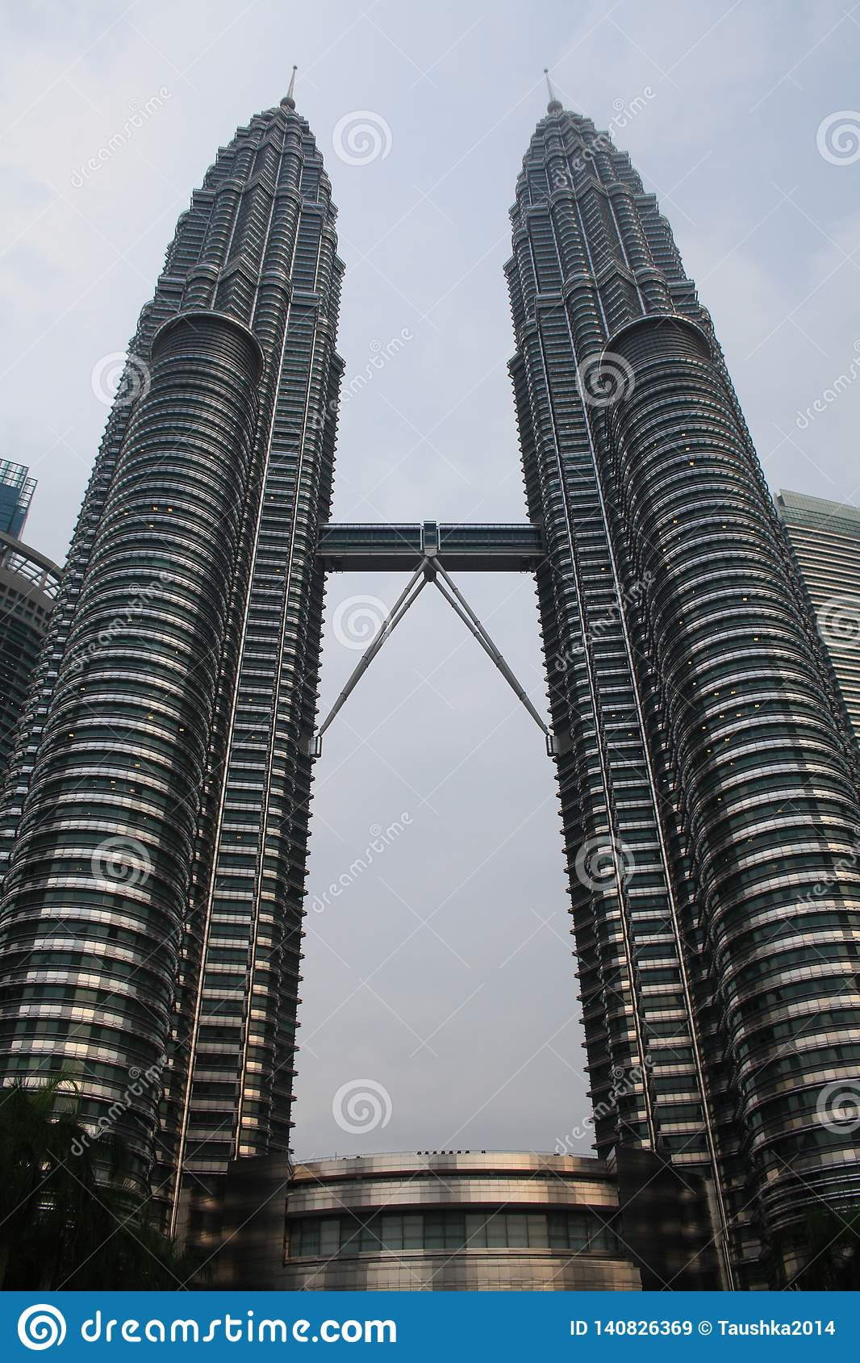
POSITIVE POINTS:
Balance:
- This building show balance having two equal halves displayed through each tower.
We can say that this building is symmetrical.
Elements on both sides are arranged equally either on sides of axis, so it is bilaterally symmetrical.

Rhythm:
- In architecture rhythm is the respective use of a group of visual elements of at least three times to establish a recognizable pattern.
From top to bottom the diameter of the building is decreasing by specific rhythm.
All the windows in the building are same size which is an example of rhythm by repetition.

Harmony:
- This building has certain harmony which is achieved by pulling the pieces of a visual image together and also by rhythm.

EMPHASIS:
- THE bridge between the two towers is very visible and catches the eyes of the viewers and it’s a good example of emphasis.

Movement:
- This building has a visual flow which leads eyes of the viewers from top to bottom.

NEGATIVE POINTS:
Contrast:
- There is no difference between values ,textures or colour so there is no visible contrast in the design of the building.
QUESTION 2:

ANS:

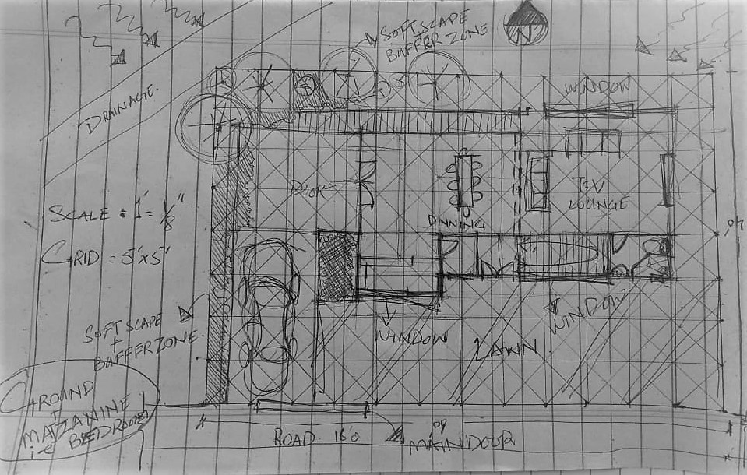

Question 3:
Ans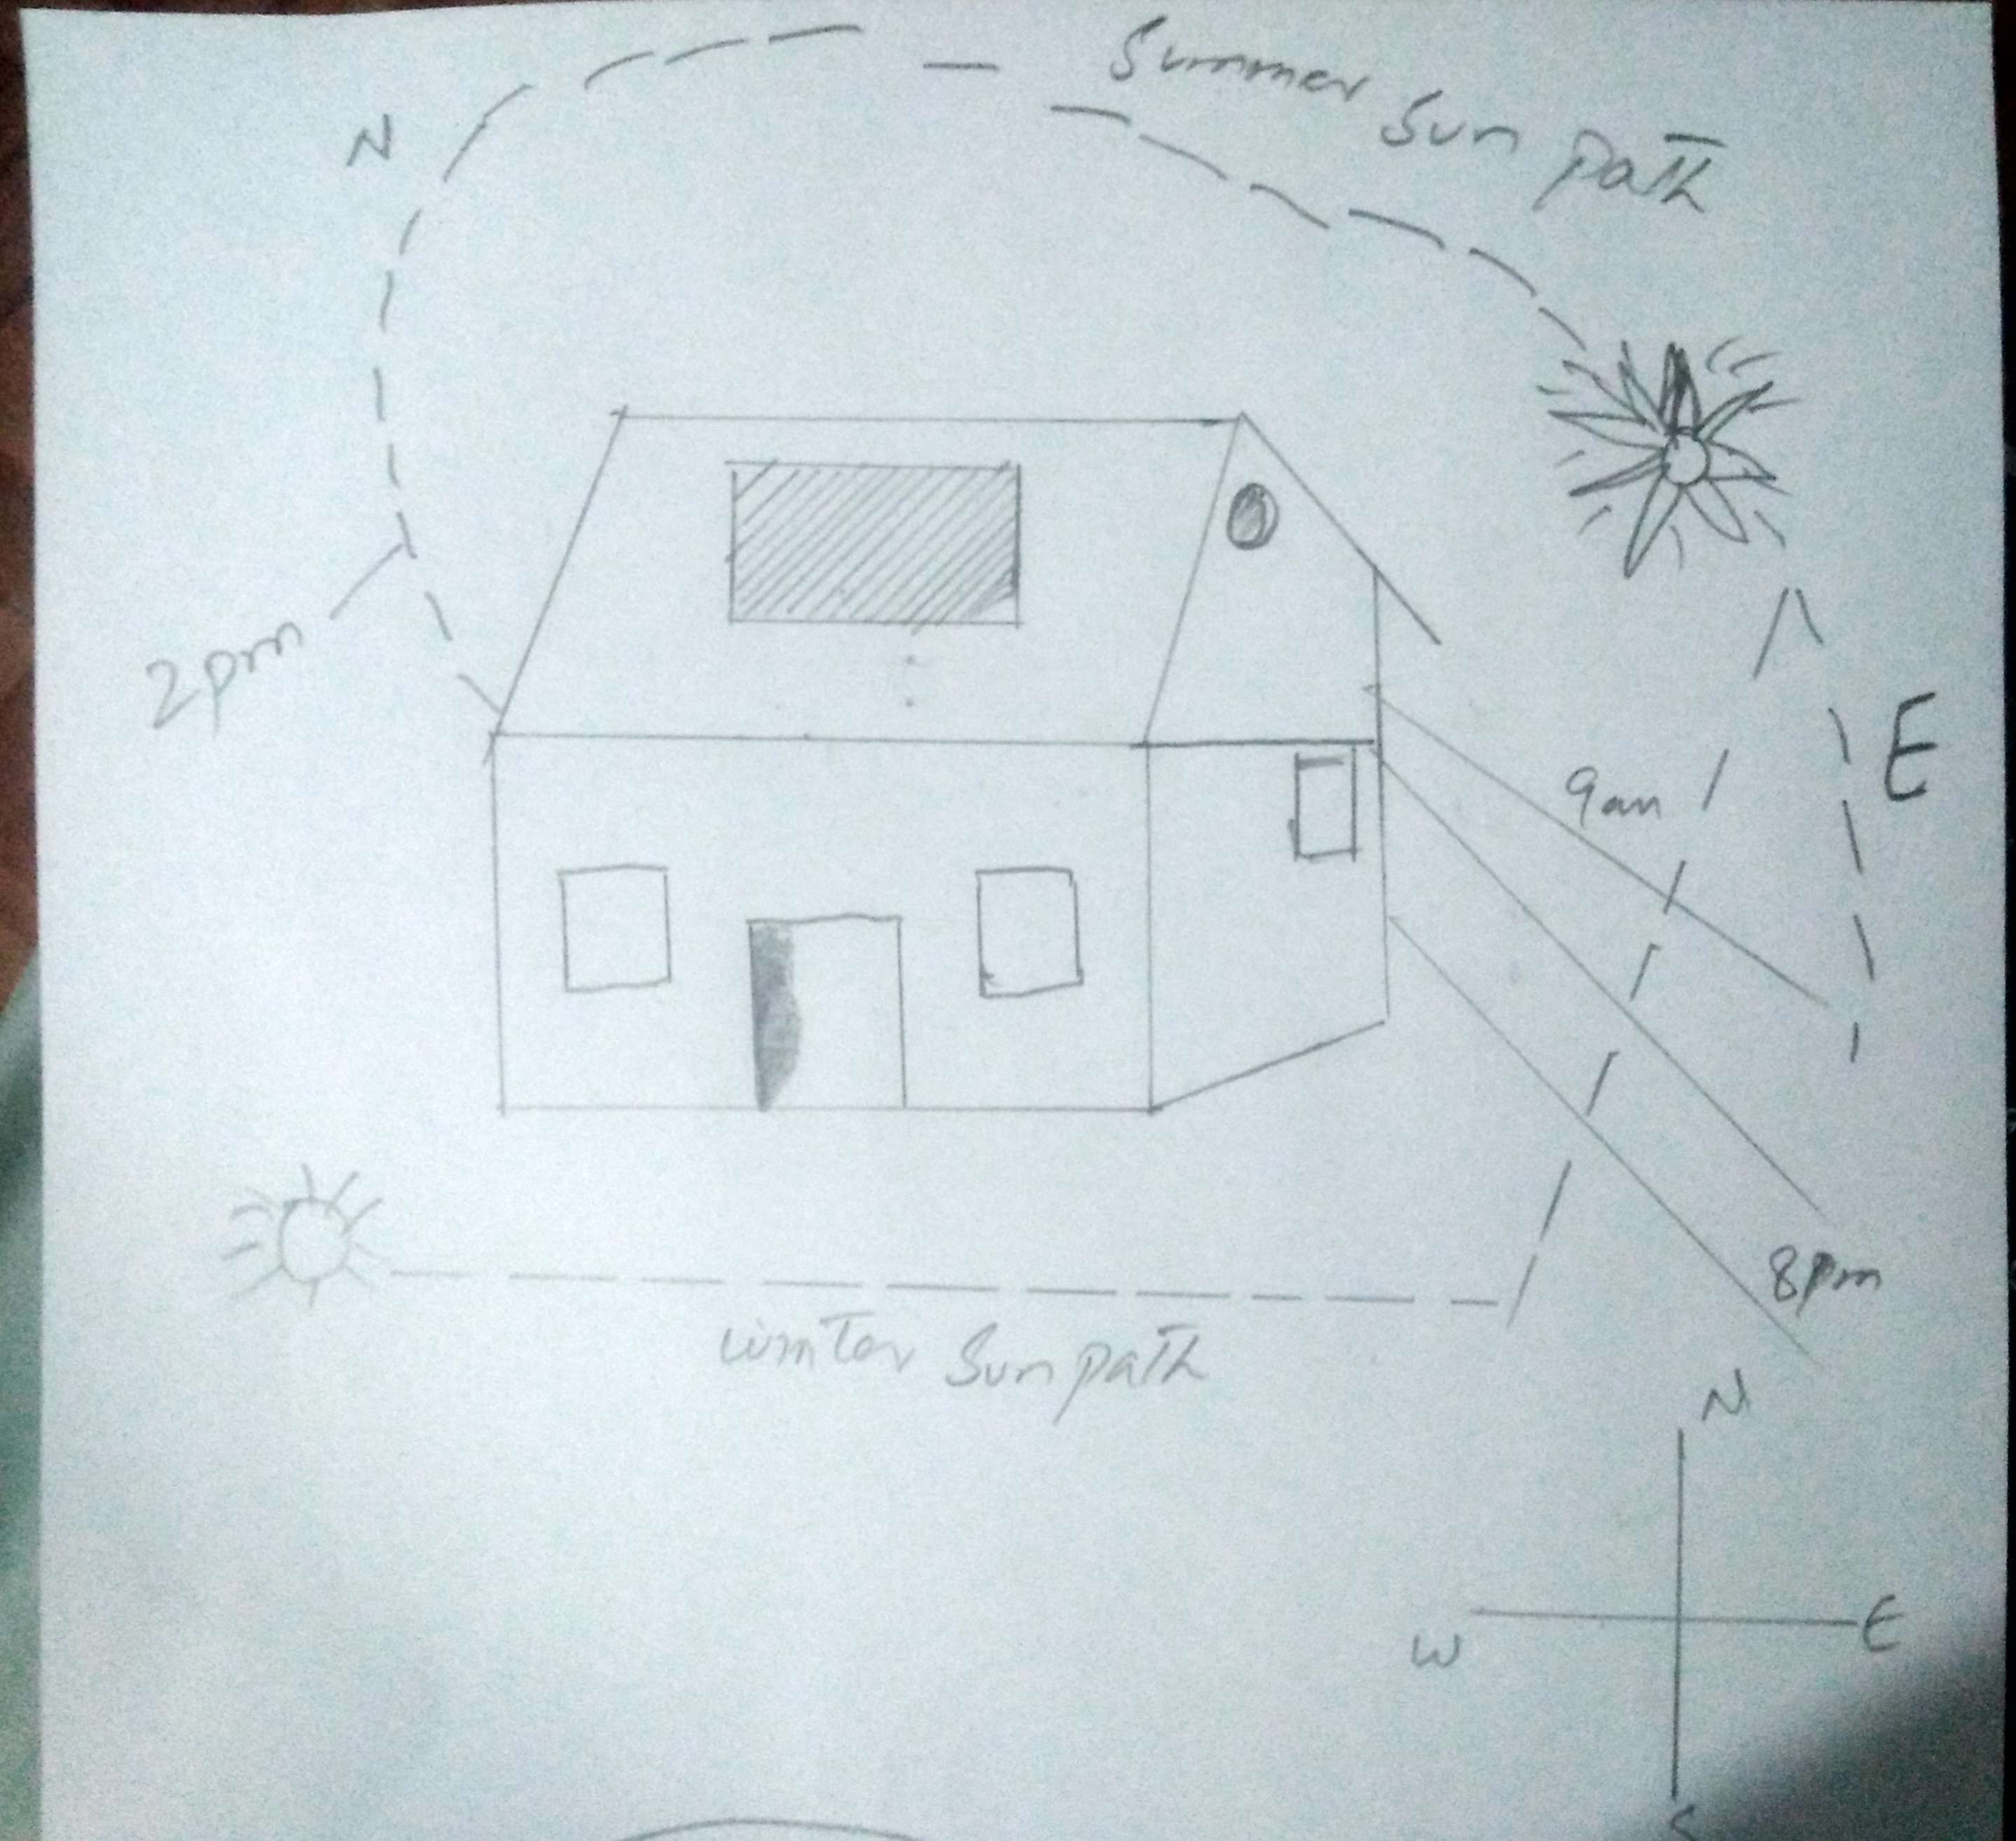

THE END

