Name: kiran qureshi
ID# 14166

Q#2: write detail note on the role SMEDA to initiate new business?
Ans: SMEDA : (Small And medium enterprise Development Authority)
Premier institution of the Government of Pakistan under Ministry of Industries & Production. SMEDA was established in October 1998 to take on the challenge of developing Small & Medium Enterprises (SMEs) in Pakistan. With a futuristic approach and professional management structure it has focus on providing an enabling environment and business development services to small and medium enterprises. SMEDA is not only an SME policy-advisory body for the government of Pakistan but also facilitates other stakeholders in addressing their SME development agendas.
The roles of SMEDA to initiate new business:
Are as follow:
To function as the promoter and facilitator of Sme sector in Pakistan by creating a conductive and facilitating environment as well as providing and facilitating service delivery to Some for enhancing their capacities and competiveness
Roles: to initiate a new business SMEDA roles is to facilitate the development and strengthening of SME representative bodies associations/ chambers
2 set up and manage a service provider’s database including machinery and supplier
- Conducting sector studies and analysis for sector devoppment strategies
- It play a key important role in devising and cording policies action plans and Strategies for starting a new business on the other hand it has a mandate to carry out research communicate with stake holder and advocate policies with different tires of the government with an ultimate objective of creating a conductive business environment
- Policy and planning is the hub of policy and regulatory research that provides SME specific policy input to all tiers of government.

Q1) If you want to open any business, Briefly explain what sort of business you will start and why ?
Ans:- Opening Poultry Farm is the best idea to open a business with small investment, “ OUR PRIME MINISTER IMRAN KHAN SAYS THAT POULTRY FARM IS THE BEST CHOICE TO START A BUSINESS”
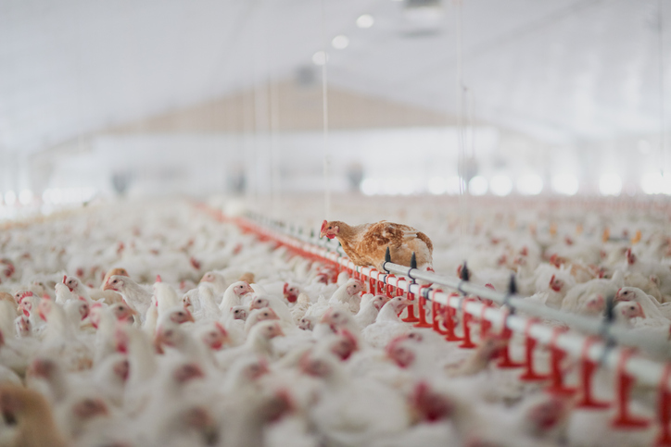
Poultry Farming:- Food businesses, irrespective of type and scale, always work in Pakistan. Food businesses prove to be the best investment opportunities in Pakistan. It can be a backyard poultry farm to deal in eggs and chicken or can be a fully established hen poultry farm. The demand for poultry is always high in the Pakistani market.

Some Facts
Poultry sector generates employment and income for about 1.5 million people.
The poultry sector is one of the most organized branches of the agro based sector of Pakistan. Its growth rate is 10-12% per annum.

What skills are required:-
When you deal with livestock, you must be aware of the animals’ feed, the environment they live in, their behaviors and most importantly, the diseases they are likely to get in different seasons of the year and appropriate vaccinations.
So it’s better to do proper research or hire someone who could manage things for you.
Poultry Farming Business Plan:-
No matter how great a business plan is, financial affordability and technical feasibility decide whether you should go for it or not. Now, since you know your budget and your area of interest hatching, egg production or meat production – prepare a comprehensive report that should take care of every detail, including required area, investment, birds, equipment, resources, marketing, and clientele, etc.
Starting a business involves planning, making key financial decisions, and completing a series of legal activities.
Following are the steps involved to open your business:-
1)Conduct market research:- So I will do market research market research will tell me if there’s an opportunity to turn your idea into a successful business.
- Write your business plan:- our business plan is the foundation of our business.
- Fund your business:- this plan will help you figure out how much money you’ll need to start your business. If you don’t have that amount on hand, you’ll need to either raise or borrow the capital. Fortunately, there are more ways than ever to find the capital you need.
- Pick your business location:-Your business location is one of the most important decisions you’ll make. Whether you’re setting up a brick-and-mortar business or launching an online store, the choices you make could affect your taxes, legal requirements, and revenue.
- Choose your business name:- It is not easy to pick the perfect name. You’ll want one that reflects your brand and captures your spirit. Name will be home run.
- Register your business:- Once you’ve picked the perfect business name, it’s time to make it legal and protect your brand.
- Apply for licenses and permits:- Keep your business running smoothly by staying legally compliant. The licenses and permits you need for your business will vary by industry, state, location, and other factors.
- Open a business account:- A small business checking account can help you handle legal, tax, and day-to-day issues. The good news is it’s easy to set one up if you have the right registrations and paperwork ready.
Why : because I think this idea will work and I have many facilities already to establish this business and it will b easy to handle it

