Name Saman Khan
ID 14957
Submitted to maam Salma
BS 4th semester
Morpology

Q1.Mark down the labial, lingual,incisal aspect of the central incisor?
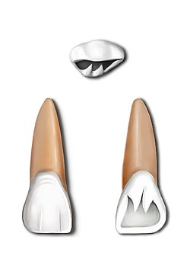
Lingual aspect
Labial aspect
incisal

Q2. Terminologies stand for……?
TBC……………..Tip of buccal cusp
TLC……………..Tip of lingual cusp
BTR………………Buccal triangular fossa
LTR……………..Lingual triangular fossa
DBDG………..Disto-buccal developmental groove
DTF………………Distal triangular fossa
MTF……………..Mesial triangular fossa
CG…………….central groove

Q3. simply the variation and anomalies of permanent maxillary incisor and permanent maxillary premolars?
Ans. Variations and anomalies of permanent central incisor:
All of the crowns surfaces , the lingual exhibits the greatest variation . as previously mentioned a pit may occasionally by present and the depth of the fossa has a considerable range. The labial or lingual aspect , a wide variation occurs in the amount of convergence of the mesial and distal surfaces toward the cervical.
Root length may considerably but deflections of the root are relatively rare . when the root is short with an abnormal contour of the crown. This condition is reffered as dwarfed root.
Variation and anomalies of Permanent lateral incisors:
The incisal portion of the cingulum may exhibit a tubercle . lingogingival fissure may extend all the way on to the root surface from the adjacent cingulum. Distorted crowns and unusual root curvatures are commonly seen. A diminutive peg-shaped is relatively common.
Variation and anomalies of 1st premolar:
Crown form generally does not differ widely, although the mesial concavity exhibits considerable variability in its area and depth.
Root form is variable as evidenced by the three common types. Deflected roots and abnormal curvatures are fairly common. Occasionally a three rooted specimen is found , with two buccal branches , and one lingual branch.
The root may on rare occasions penetrate the anterior portion of the maxillary sinus also known as antrum.
Variation and anomalies of 2nd premolar:
Crown may varies more than in the 1st premolar . a central groove may be absent so that only one centrally located pits is present on the occlusal surface.
Root variations occur and distal deflections of the apical third are not uncommon . on occasion there are two roots, buccaly and lingually positioned similar to those type 2, first premolar.
As with the other maxillary posterior teeth , the root occasionally penetrates the antrum.

