BS Radiology 4th Semester
Course Title:Conventional radiological procedures and clinical practice
Name: Muhammad Sohail
Id: 14829
Q1: A patient came with complaint of difficulty in swallowing; which imaging procedure is best for its diagnosis and what are the standard protocols for this procedure?
Ans. Barium meal standard protocols or indication.
Symptom of vemiting.
Upper abdominal mass.
GIT heamorrhage.
Gastric or duodenal ost rution.
Malignancies.
Patient preparation.
Pr is adrise no on the day of examination becouse it ten gastric melility.
It should be that then is no cotraindication to the agent.
Suspocaion of Aspiration large bowel obstrution.

Q2: Explain the different positions used to take films for barium meal.
Ans:
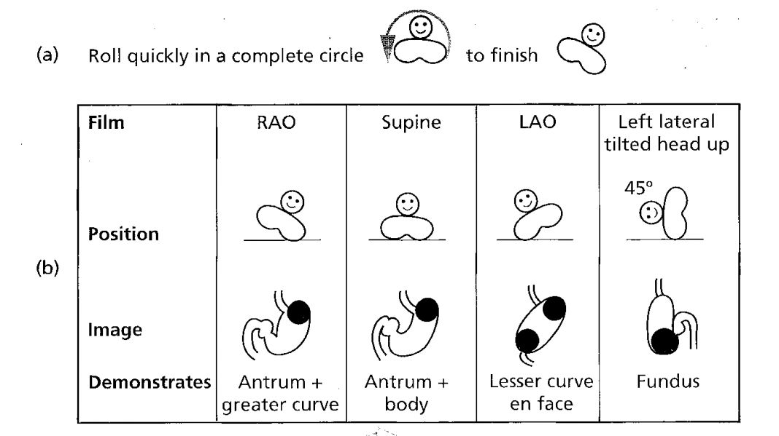
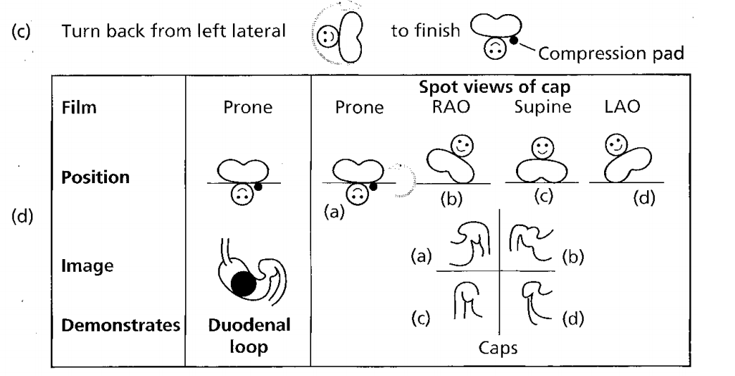
Q3: Write the general classification of contrast agents used in conventional radiological procedures also explain each classification.
Ans:
CLASSIFICATION OF CONTRAST MEDIA

X- RAY & CT ULTRASOUND MRI
Positive CM Negative CM ( water, air, co₂)
Non water soluble BaSo₄ Iodomated CM
Oily/non water soluble IODINATED CM water soluble iodinated CM
Hepatic excretion Iopanoic acid Renal excretion
High osmolar low osmolar
Ionic monomers Ionic dimers non ionic monomers non ionic dimers

