Name: yasir orakzai
Student id 15994

Instructor: Dr. Arooba.
Assignment for viva.

Question: Write a complete note on hip joint.
Hip joint:
Introduction:
The hip joint allow the same movement as the mobile shoulder joint, but the range of movement is restricted.
Articulation:
- The head of the femur articulation with the acetabulum of the hip bone to form the hip joint.
- The head of the femur forms more than half a sphere , and is covered with hyaline cartilage except at the fovea capitis.
- The acetabulum presence a horseshoe shaped, lunate articular surface, an acetabular notch and an acetabular fossa.
Stability:
- The hip joint is unique in having a high degree of stability as well as mobility
- The stability or strength depends upon
- Depth of the acetabulum and the narrowing of its mouth by the acetabular labrum.
- Tension and strength of ligaments.
- Strength of the surrounding muscles.
- Length and obliquity of the neck of the femur.
- Atmosphere pressure.
Ligaments:
- Fibrous capsules.
- Iliofemoral ligaments.
- Pubofemoral ligaments .
- Ischiofemoral ligaments.
- Ligament of the head of the femur.
- Acetabular labrum.
- Transverse acetabular ligaments.
Fibrous capsules:
- It is attached on the hip bone to the acetabular labrum including the transverse acetabular ligament and to bone above and behind the acetabulum and an femur to the intertrochanteric crest behind.
- Anterosuperiorly, the capsule is thick and firmly attached.
- This part is subjected to maximum tension in standing posture.
- Poster inferiorly, the capsule is thin and loosely attached to the bone.
- The capsule is made up of two type of fibers.
- Outer fibers – longitudinal
- Inner fibers—zona orbicularis
- The joint cavity communicates with a bursae lying deep to the tendon of psoas major.

Iliofemoral ligaments:
- It is inverted y shaped ligament of Bigelow, lies anteriorly.
- It is one of the strongest ligament of the body.
- Its prevents the truck from falling backwards in the standing posture.
- It is triangular in shaped.
Pubofemoral ligaments :
- It is support the joint inferomedially
- It is also in triangular in shape.
- Superiorly, it is attached to the iliopubic eminence, the obturator crest and the obturator membrane.
- Inferiorly, it merges with the anteroinferior part of the capsule and with the band of the iliofemoral ligaments.
Ischiofemoral ligaments:
- It covers the joint posteriorly
- It is fibres or twisted extend from the ischium to the acetabulum
- The fibres of the ligament from the zona orbicularis.
- Some of them are attached to the greater trochanter.

Ligament of the head of the femur:
- It is round ligament or ligamentum teres is a flat and triangular ligaments.
- The apex is attached to the fovea capitis, and the base to the transverse ligament and the margins of the acetabular notch.

Acetabular labrum:
- It is the fibro cartilaginous rom attach to the margins of the acetabulum.
- Is narrows the mouth of the acetabulum.
- This help in holding the head of the femur In positions.
Transverse acetabular ligaments:
- It is the part of acetabular labrum which bridges the acetabular notch.
- Notch Is thus converted to foramen which transmits acetabular vessels and nerves to the joint.
Blood supply:
- Obturator artery.
- Medial circumflex artery.
- Lateral circumflex artery.
- Two gluteal arteries.
Nerve supply:
- Femoral nerve.
- Obturator nerve.
- Superior gluteal nerve.

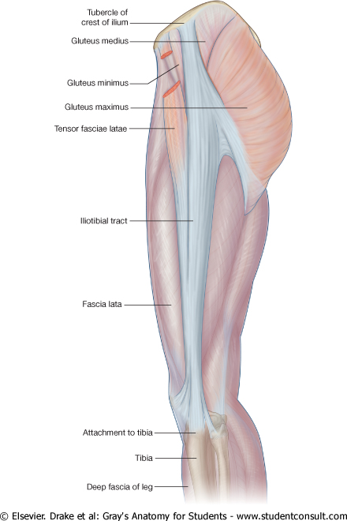

The end!

