Iqra National University Department of Civil Engineering

Submitted by: Shahid Rasheed

Class ID: 15287

Discipline: MS Civil Engineering

Course Title: Water Demand Supply and
Distribution

Course Code: CE- 562

Instructor Name: Nadeem Ullah

Date: April 19, 2020

- Hydrological Cycle

The hydrological cycle defines the course of a droplet of water from the moment it falls to the ground until it evaporates and returns to our
atmosphere. It is the normal water recycling system on Earth.
Due to solar radiation, water evaporates, generally from the sea, lakes, etc. The Earth's hydrological cycle is the complete number of all
Processes through which water travels from the soil and the ocean to
the atmosphere and back in the form of precipitation.

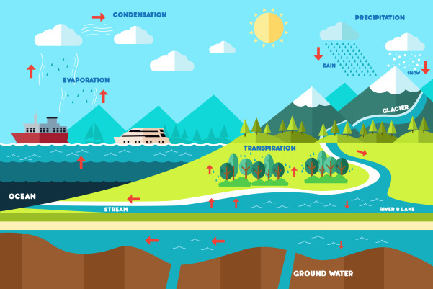

The hydrological cycle is intimately linked with changes in the atmospheric temperature and radiation balance.

Hydrological Cycle has been disturbed

Climate change intensifies this cycle because as air temperatures increase, more water evaporates into the air. Warmer air can carry more water vapor, which can cause more severe
rainstorms, contributing to major problems such as serious flooding in
coastal communities around the world.
Human activities can influence the hydrologic cycle in many other ways.
The quantities and timing of river flows can be significantly influenced by channeling to minimize the impediments to flow and by modifying the character of the watercourse by paving, compacting soils and altering the vegetation.

- Ground water Sustainability
Groundwater resource production and use to meet current and
potential beneficial uses without having undesirable environmental or
socio-economic consequences.
Zoning is used to ensure that land uses are compatible with protection of vulnerable aquifers.
Important technological measures for groundwatermanagement includeregulation of groundwater drainage to a safe level, regulation of groundwater discharges and management of aquifer regeneration in some area.

“Rainwater Harvesting” can be linked to ground water sustainability
Rainwater harvesting is a type of harvest in which the rain drops are collected and stored for the future use, rather than allowing them to run off.
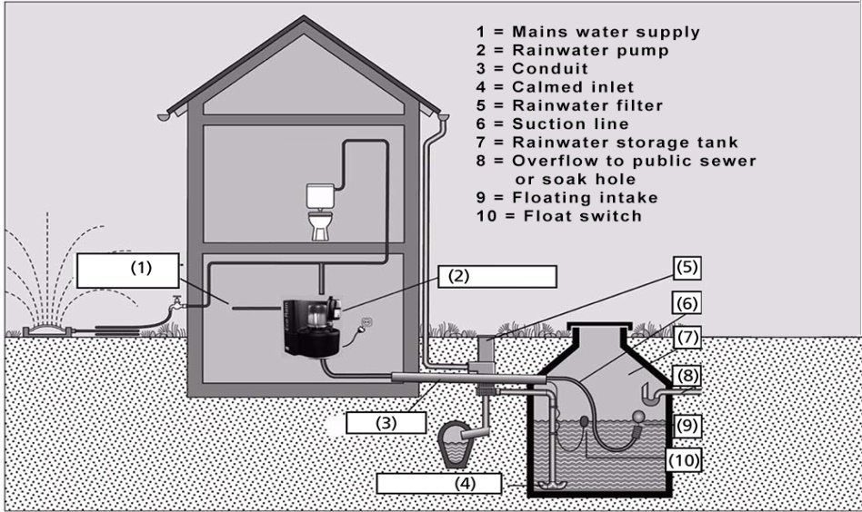
Sustainable use of water could maintain a balance between its demand and supply. Rainwater harvesting (RWH) is the most traditional and sustainable method, which could be easily used for potable and non potable purposes both in residential and commercial buildings.
Rain water harvesting is linked to ground water sustainability in the form of the rain water is collected in to the natural reservoir or the infiltration of surface water into subsurface aquifers and this water then found as ground water sustainability.

“Quality Parameters” should be considered in designing water supply system for a community
Water quality describes the condition of the water, including chemical, physical, and biological characteristics, usually with respect to its suitability for a particular purpose such as drinking or swimming.
A wide range of water quality parameters are monitored within the Lower Lakes with key parameters reported herein being pH, alkalinity, salinity, turbidity, nutrients, chlorophyll a and metals (aluminum and iron).

Biochemical oxygen demand (BOD) is the amount of dissolved oxygen needed (i.e. demanded) by aerobic biological organisms to break down organic material present in a given water sample at certain temperature over a specific time period.

The CRWN nitrogen tests measure nitrate (NO3-N). Excessive amounts of nitrates increase algae growth. Algae can rob the water of dissolved oxygen and eventually kill fish and other aquatic life.

Water temperature is one of the critical parameters that is used to assess our river/stream for aquatic habitats’ health

Turbidity of water is a measurement of the clarity of water that is affected by the presence of solids, small particles/sediments, or pollutants. The more sediment in the water, the more turbid the water is.

pH level is a measurement of the acidity or alkalinity of water. Level of pH can indicate chemical changes in water, and the biological availability of nutrients in water. The pH scale ranges from 0 to 14.

Chlorides are salts often present in areas of urban development. Chlorides in water usually occur as a result of the use of water softeners, road salt, and drainage of swimming pools.

