Name: Yasmen
ID: 16677
Class: DT Section B
Instructor: Ma’am Kalsoom
Assignment: Biochemistry final assignment

Question 2: write down clinical significance of the following enzymes.
Answer 2:
A; Alkaline phosphatse: (AlP)
This enzyme is present is the liver and bone and it is important for breaking down proteins.
And its level get higher than its normal level then it may be indicate liver damage or cause disease related to liver or disease such as blocked bile duct, or certain bone diseases.
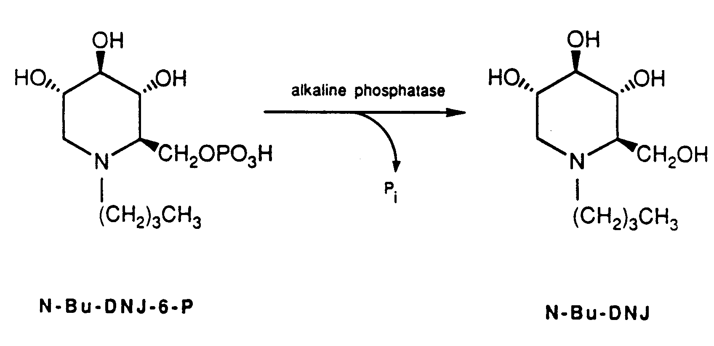
B; Creatine kinase: (Ck)
It is an enzyme that found heart, brain skeleton muscles and different type of other tissue.
And if it get increased amount of CK are released into the blood then by going there it will damage muscles. This test measures the amount of creatin kinase in the blood. The small amount of CK that is normally in the blood comes primarily from skeletal muscles any condition that causes muscle damage and / or interferes with muscle energy production or use can cause an increase in CK, muscles diseases caused by the higher level of CK.
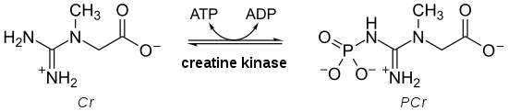

C; Gamma- Glutamyl Transferase: (GGT)
The Gamma- Glutamyl Transferase: (GGT) and the alkaline phosphatase (AlP) if both level get higher than normal level then it cause liver diseases and bile ducts but only ALP will be elevated in bone disease.
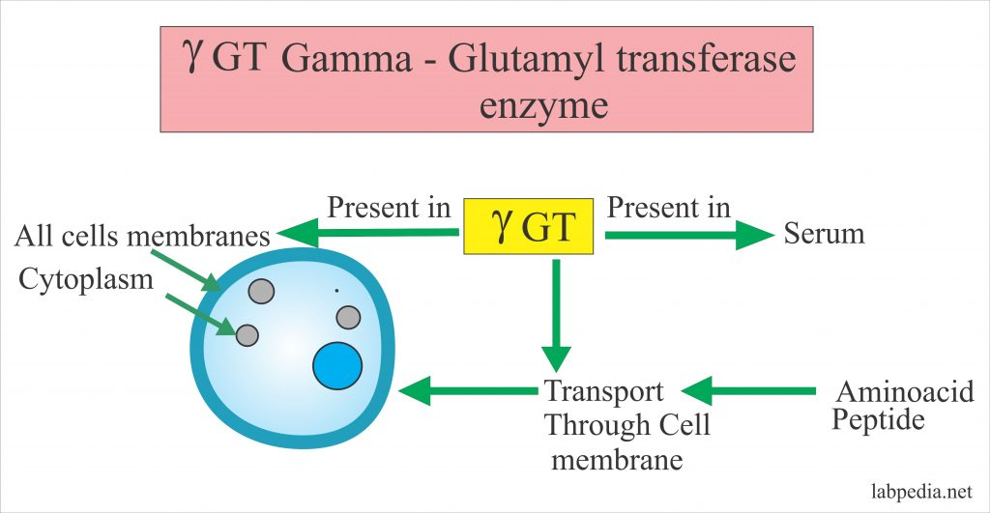

Question5: How uric acid formation take place in body?
Uric acid is a waste product found in blood. It’s created when the body breaks down chemicals called purines. Most uric acid dissolves in the blood, passes through the kidneys and leaves the body in urine. Food and drinks high in purines also increase the level of uric acid.
Purine nucleotides are (Adenosine, guanine, and inosine)
Normal range of uric acid in our body is 3-7mg/dl
Question 3: how many proteins are involve in electron transport chain and how do electron move in the electron transport chain?
Answer 3:
Four large protein complexes are involve in electron transport chain
Cluster of proteins present in mitochondrial inner membrane transfer electrons to form ATP’s
- Energy store in the form of hydrogen or electrons, NADH and FADH
  - In NADH and FADH two electrons are present
  - Eg NAD+ takes two electrons and change into NAD-,then NAD- takes one H+ from 2H+ and change into NADH
- In ETC various proteins are involved
- FMN (flavoprotein)
  - Fe.S (iron,sulphur protein)
  - Ubiquinone Q
  - Cytochrome (cytochrome c,b,a.a3)
These 4 proteins are called complex proteins and divided in 4
Complex 1- NADH – coenzyme Q reeducates
- Complex ll- Succinate- coenzyme Q reeducates
- Complex lll-Cytochrome c reeducates
- Complex lv- cytochrome o oxidase
How they function:
- Electrons move in complex 1……here FMN transfer 2e- electrons to Fe.S to then these move to Q
- And FADH2 gives es- to complex 2 (move in mitochondrial matrix) these 2estransfer to Q
- Then Q transfer these e- to complex 3,these then move to different proteins and pass to complex 4, last e- acceptor protein is cyto a3…
- In this process when e- moves, ATP synthesis takes place.
- From last protein e- moves to O2, O2 accept es- and change to O2
- O-2 + 2H+ -------- H2O
- H+ present in matrix
- Water synthesis takes place in ETC and in Krebs cycle CO2 synthesis takes place
- Every protein is more electronegative then previous protein
- Every time e- move its energy is utilize to make ATP
- So at every step redox reaction is happening.

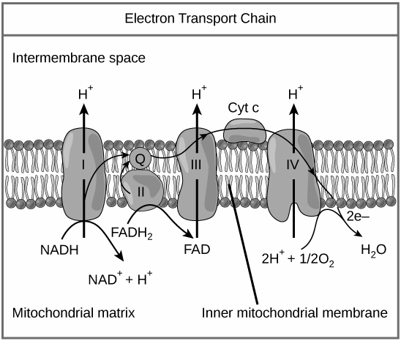

Question 1: Write down the 4 steps involve in beta oxidation.
Answer 1: Beta oxidation takes place in four steps:
- Dehydrogenation
- Hydration
- oxidation
- thyolisis.
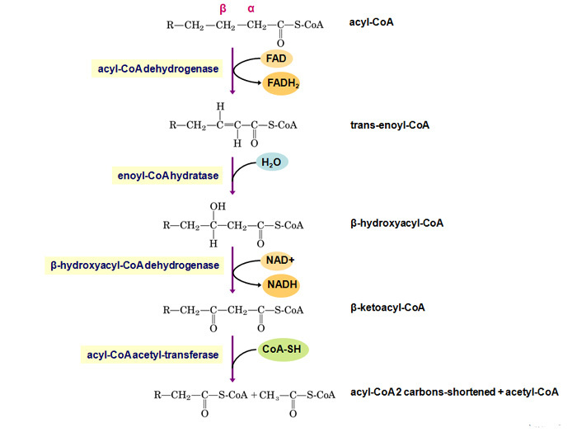
Each step is catalyzed by a distinct enzyme.
Dehydrogenation:
In the first step, acyl-CoA is oxidized by the enzyme acyl CoA dehydrogenase. A double bond is formed between the second and third carbons (C2 and C3) of the acyl-CoA chain entering the beta oxidation cycle; the end product of this reaction is trans-Δ2-enoyl-CoA (trans-delta 2-enoyl CoA). This step uses FAD and produces FADH2, which will enter the citric acid cycle and form ATP to be used as energy.

Hydration:
In the second step, the double bond between C2 and C3 of trans-Δ2-enoyl-CoA is hydrated, forming the end product L-β-hydroxyacyl CoA, which has a hydroxyl group (OH) in C2, in place of the double bond. This reaction is catalyzed by another enzyme: enoyl CoA hydratase. This step requires water.
Oxidation
In the third step, the hydroxyl group in C2 of L-β-hydroxyacyl CoA is oxidized by NAD+ in a reaction that is catalyzed by 3-hydroxyacyl-CoA dehydrogenase. The end products are β-ketoacyl CoA and NADH + H. NADH will enter the citric acid cycle and produce ATP that will be used as energy.

Thiolysis
Finally, in the fourth step, β-ketoacyl CoA is cleaved by a thiol group (SH) of another CoA molecule (CoA-SH). The enzyme that catalyzes this reaction is β-ketothiolase. The cleavage takes place between C2 and C3; therefore, the end products are an acetyl-CoA molecule with the original two first carbons (C1 and C2), and an acyl-CoA chain two carbons shorter than the original acyl-CoA chain that entered the beta oxidation cycle
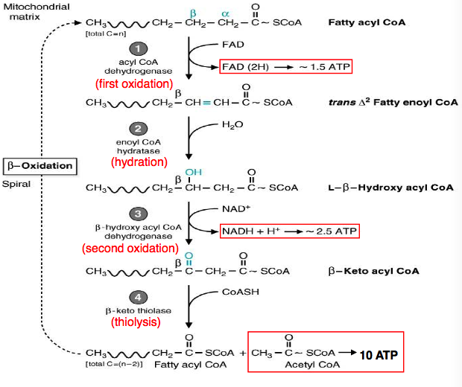
Question4: write steps involved in uric acid formation.
Answeer:
Uric acid step one by the one
In metabolism the nucleotide that
AMP IMP GMP
They act upon nucleothdase and covert it
AMP------------ Adnosine
IMP---------------Inosine
GMP--------------Guanosine
And release of and organic phosphate by the action of nucleothdase
This IMP convert to IMP and adenosine to inosine with the help of AMP deaminase
Now this Inosine convert to hypoxanthine than convert to xanthine then uric acid
This inosine covert to hypoxanthine with the help of purine nucleotide phosphorylase and release ribose one phosphate R1(P)
While covert hypoxanthine to xanthine and xanthine to uric acid there is an important enzyme by name of xanthin oxidose which contain (Iron, FAD, Melobdenum)
While guanosine -------------guanine -----------------xanthine
This reaction water molecule H2O +O2 leave with the permission of criartical that K2O2
