NAME: Syed Muhammad Raahim
ID NO: 14838
DEGREE: DPT 4th
PAPER: BIOCHEMISTRY
SUBMITTED TO: MAM KULSOOM
Q1: Write brief note on steroid hormone?
Ans:
Steroid hormone:
Steroid hormone, any of a group of hormones that belong to the class of chemical compounds known as steroids; they are secreted by three “steroid glands”—the adrenal cortex, testes, and ovaries—and during pregnancy by the placenta. All steroid hormones are derived from cholesterol. They are transported through the bloodstream to the cells of various target organs where they carry out the regulation of a wide range of physiological functions.

These hormones often are classified according to the organs that synthesize them: the adrenal steroids are so called because they are secreted by the adrenal cortex, and the sex hormones are those produced by the ovaries and testes. This distinction is not exclusive, however, because the adrenal cortex also secretes sex hormones, albeit to a lesser extent than do the gonads, and the ovaries under abnormal conditions may produce adrenal steroids.
The adrenal cortex produces the adrenocortical hormones, which consist of the glucocorticoids and the mineralocorticoids. Glucocorticoids such as cortisol control or influence many metabolic processes, including the formation of glucose from amino acids and fatty acids and the deposition of glycogen in the liver. Glucocorticoids also help to maintain normal blood pressure, and their anti-inflammatory and immunosuppressive actions have rendered them useful in treating rheumatoid arthritis and preventing the rejection of transplanted organs. Mineralocorticoids such as aldosterone help maintain the balance between water and salts in the body, predominantly exerting their effects within the kidney.
The androgens are the male sex hormones. The principal androgen, testosterone, is produced primarily by the testes and in lesser amounts by the adrenal cortex and (in women) by the ovaries. Androgens are primarily responsible for the development and maintenance of reproductive function and stimulation of the secondary sex characteristics in the male. Androgens also have an anabolic (synthesizing and constructive, rather than degradative) function in stimulating the production of skeletal muscles and bone as well as red blood cells. To enhance the anabolic activity of androgens without increasing their masculinizing ability, anabolic steroids were developed. Though originally intended to combat diseases marked by wasting, these synthetic hormones have been abused by individuals desiring to increase their muscle mass, such as athletes seeking to gain a competitive advantage. Overdosing has been linked to serious side effects, including infertility and coronary heart disease.
Estrogens are one of the two types of female sex hormones. They are secreted mainly by the ovaries and in smaller amounts by the adrenal glands and (in men) by the testes. Estradiol is the most potent of the estrogens. Functioning similarly to androgens, the estrogens promote the development of the primary and secondary female sex characteristics; they also stimulate linear growth and skeletal maturation. In other mammals these hormones have been shown to precipitate estrus (heat). The ovarian production of estrogen plummets during menopause.
Progestin, the most important of which is progesterone, are the other type of female sex hormone and are named for their role in maintaining pregnancy (pro-gestation). Estrogens and progestin’s are secreted cyclically during menstruation. During the menstrual cycle, the ruptured ovarian follicle (the corpus luteum) of the ovary produces progesterone, which renders the uterine lining receptive to the implantation of a fertilized ovum. Should this occur, the placenta becomes the main source of progesterone, without which the pregnancy would terminate. As pregnancy progresses, placental production of progesterone increases, and these high doses suppress ovulation, preventing a second conception. The contraceptive quality of progesterone led to the development of structurally modified progestins and estrogens—the oral contraceptives known as birth-control pills, used by women to prevent unwanted pregnancy.

Cyclical changes during a woman's normal ovulatory menstrual cycle.

Q2: What is deamination and transamination?
Ans: V Transamination, a chemical reaction that transfers an amino group to a ketoacid to form new amino acids. This pathway is responsible for the deamination of most amino acids. This is one of the major degradation pathways which convert essential amino acids to non-essential amino acids (amino acids that can be synthesized de novo by the organism).
Transamination in biochemistry is accomplished by enzymes called transaminases or aminotransferases. α-ketoglutarate acts as the predominant amino-group acceptor and produces glutamate as the new amino acid.
Aminoacid + α-ketoglutarate ↔ α-keto acid + Glutamate
Glutamate's amino group, in turn, is transferred to oxaloacetate in a second transamination reaction yielding aspartate.
Glutamate + oxaloacetate ↔ α-ketoglutarate + aspartate

Q3: WRITE DOWEN THE METABOLISM OF PROTEIN?
ANS: METABOLISM OF PROTEIN:
Protein metabolism denotes the various biochemical processes responsible for the synthesis of proteins and amino acids (anabolism), and the breakdown of proteins by catabolism.

- Dietary proteins are very large complex molecules that cannot be absorbed from the intestine.
- To be absorbed, dietary proteins must be digested to small simple molecules (amino acids), which are easily absorbed from the intestine.
- DIGESTION IN THE STOMACH:
Protein digestion begins in the stomach by gastric juice, pepsin and renin are the enzymes present in stomach.
ii. DIGESTION IN SMALL INTESTINE:
- Digestion of proteins is completed in the small intestine by proteolytic enzymes present in pancreatic juices.
In pancreatic juice trypsin, chymotrypsin, elastase, carboxypeptidase enzymes are present and
In intestine juice amino peptidase, tripeptidase enzymes are present the end products of protein digestion in the small intestine are amino acid.

Q4: EXPLAIN BRIEFLY TRANSLATION OF DNA IN EUKARYOTES?
ANS: TRANSLATION OF DNA IN EUKARYOTES:-
Translation is the process by which the sequence of nucleotide in a messenger RNA molecule directs the incorporation of amino acid into protein is called translation.

TRANSLATION PROCESS:
- In a eukaryotes cell, translation occurs in the cytoplasm.
- Translation involves three major steps:
- INITIATION
- ELONGATION
- TERMINATION

- INITIATION:-
The initiation of translation of DNA in eukaryotes is complex, involving at least 10 eukaryotic initiation factors (elFs) & divided into 4 steps:

- Ribosomal dissociation.
- Formation of 43s preinitiation complex.
- Formation of 48s initiation complex.
- Formation of 80s initiation complex.

- ELEMINITION:-
- Ribosomes elongate the polypeptide chain by a sequential addition of amino acids.
- The amino acid sequence is determined by the arder of codons in the specific mRNA.
- Elongation, a cyclic process involving certain elongation factors.
- Elongation may be divided into three steps.
- Binding of aminoacyle t- RNA to A-site.
- Peptide bond formation.
- Translation.

- TERMINATION:-
- One of the stop or termination signal (UAA, UAG AND UGA) terminates the growing polypeptide.
- When the ribosomes encounters a stop codon, there is no tRNA available to bind to the A site of the ribosome,
-instead a release factor binds to it.
- In eukaryotes, a single release factor- eukaryotic release factors 1 (eRF1) - recognizes all three stop codons, and eRF3 stimulates the termination events.
- Once release factors binds, the ribosomes unit falls aparts,
-releasing the large and small subunits,
-the tRNA carrying the polypeptide is also released,
Freeing up the polypeptide product.
- Ribosome recycling occurs in eukaryotes.

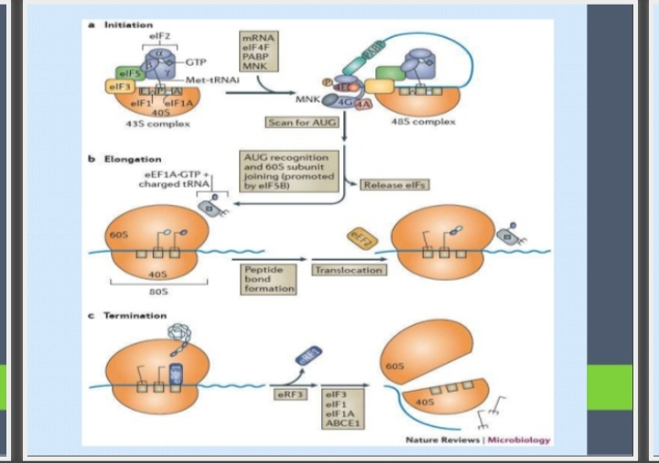

Q5: WRITE DOWEN CLINICAL SIGNIFICANCE OF CHOLESTROLE?
ANS: CLINICAL SIGNIFICANCE OF CHOLESTROLE:-
Normal RANGE; 150-200 mg /dl
Hypercholesterolemia associated with;
- Diabetes Mellitus (increase availability of acetyle CoA due to unavailability of oxaloacetate).
- Nephrotic syndrome (increase globulins & increase in plasma lipoproteins).
- Hypothyroid/ myxedema (associated decrease HDL receptors on hepatocytes).
- Obstructive jaundice (obstruction in excretion of cholesterol through bile).

HYPOTHYROIDISM (Is a condition in which your thyroid gland doesn’t produce enough of certain crucial hormones).
Jaundice
Hyperlipidemia (high level of cholesterol or try glyceride in your body)
Atherosclerosis (buildup of fats, cholesterol and other substances in and on your artery walls (plaque), which can restrict blood flow).
Addition factors for coronary artery disease include – lifestyle
Cigarette smoking, coffe drinking, Emotional Stress, obesity ,Lack of exercise , High blood pressure etc

