Name:-Dawood Shah Alam
ID:-16212
Section:-B
Department of Civil Engineering
2nd Semester
Subject:-Introduction to Architecture and Town Planning
Submitted To:-Miss Alina Babar
Q1. Take any building from internet, put its picture in Microsoft word and explain its positive and negative points according to principles of design. What could be done to make the building more attractive? Answer must be at least 200 words.
Ans. Villa Savoye (Le Carbusier Design)
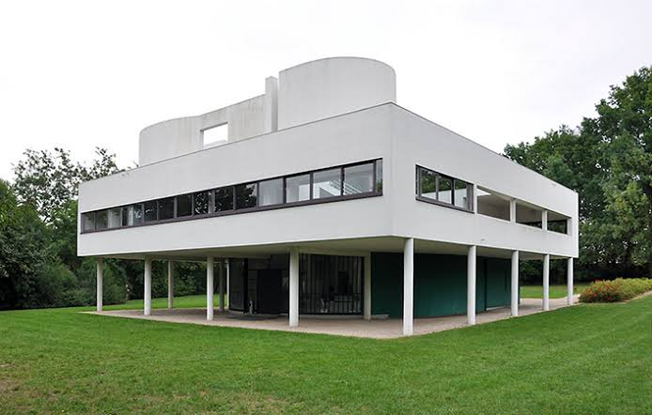

This is the Villa Savoye(modernist villa) located in Poissy France. It was designed by Le Carbusier and his cousin Pierre Jeanneret who were Swiss Architects. Villa Savoye was built between 1928 and 1931.
Positive Points:-
- The support of the pilotis (pillars) on the ground floor, which elevated the building from the earth and also allowed the garden to be extended to the space beneath.
- The use of long horizontal windows which allowed the sunlight from outside and it was also good for ventilation. This idea was very good as there was minimum loss of mechanical energy in both summer and winter season.
- A free floor plan, there were no load bearing walls, walls were placed freely and only were aesthetically needed.
- The roof was not any ordinary roof, it also functioned as a garden and a terrace, reclaiming for nature because of the land occupied by the building. This added to the beauty of the villa.
- The freely designed facades which only functioned as a skin for the walls and windows, and not only limited to load bearing considerations, which also added to the beauty and uniqueness of the villa.
- The villa had good ventilation of air from all sides.
- The location of the villa is also at an excellent place as there is greenery (trees and grass) from all four sides.
- Use of simple white color makes the building beautiful and also the building (villa) looks simple from the outside. It does not look complex and is not difficult to understand.
- Also the pilotis (pillars) are round and circular in shape which ultimately adds to the beauty of the villa.
- There is also very less noise pollution as the villa is located at country side not city.
- One of the other positive points is the solarium on the second floor as it has health giving properties.
Negative Points:-
- Although the functional roof with the garden was a good idea but each autumn there were rainwater leaks in the roof due to exclusion of downpipes and sills.
- The exclusion of downpipes and sills was because the white color could be exposed to staining and erosion from overflowing rainwater.
- Also the building was marked by cracks because the material was not good for structural durability.
- Although the ground level pilotis looked beautiful due to round and circular shape but the pilotis were more symbolic rather than actual structure elements.
- Even though the villa looked beautiful and simple from the outside but the planning was complex from the inside.

To Make The Building More Attractive:-
To make the building more attractive and flawless the following can be done:
- We can use lighting material in the building which will make it more attractive and glowing during the night time.
- Installation of downpipes in the building which would prevent leakage of roof.
- To prevent the white color from erosion and staining paints or weather shields which are good against erosion and staining can be used.
- Also rocks can be placed in the grass as a path for people to enter the building, this will add to the beauty and delight.
- The upper exterior walls of the building can be made with designs, patterns or quotes. This will make it more attractive.

Q2. Design and sketch an ideal single storey house on the site. The design should be free hand and can be drawn on graph paper. If a graph paper is not available then make a grid of 5’x5’ on a separate white A4 size paper. The house should be naturally ventilated and have natural lighting. Also, it should be free of noise. The site is located in Peshawar. Label or explain the plan neatly.
Site Problems:
- Open drainage in direction of summer winds which is a major source of bad smell
- Noise from west side and winter winds from north-east side
- Existing 2 storey building on south side blocking some solar radiations
Ans.
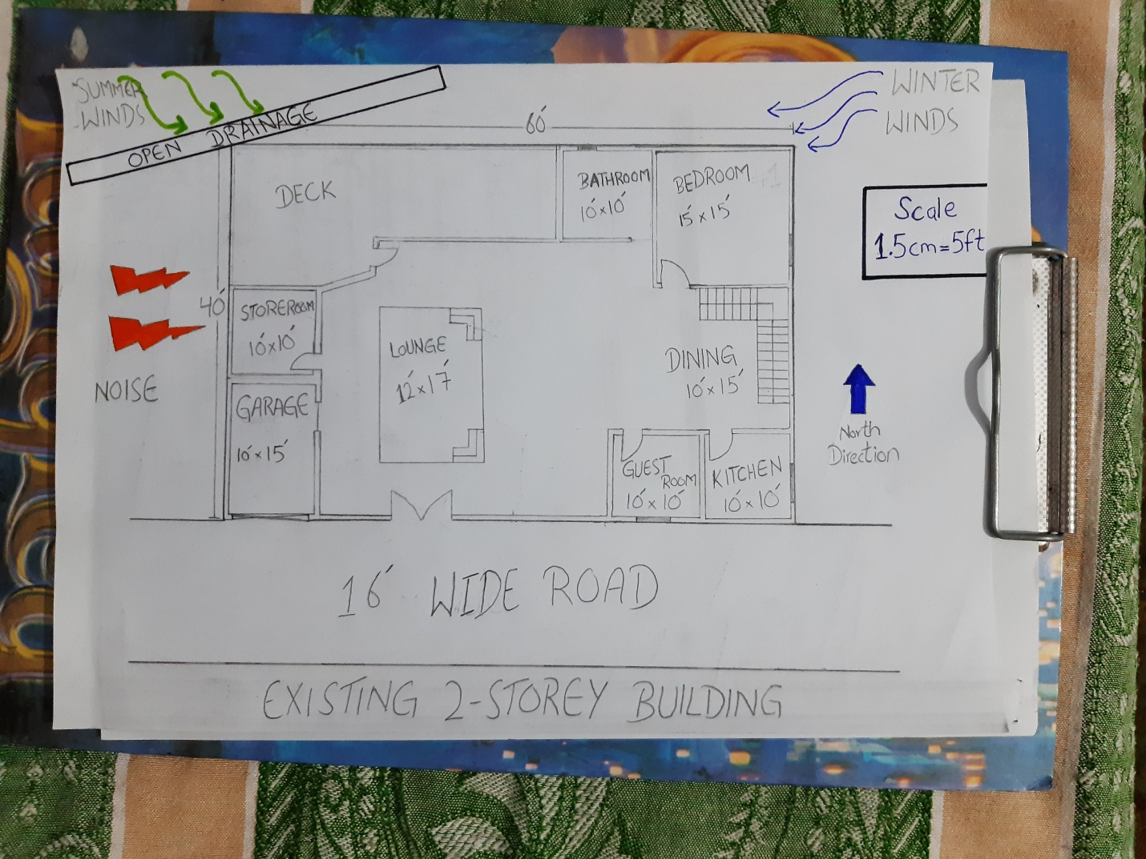
Note: - Due to the lockdown the stationery shops were closed, hence there was no graph paper.

Q3. Select a site at the place where you live. Do micro site analysis of site and make its sketch on another A4 paper and write about it in detail. You can take your own lawn as site for analysis or any other site in the neighborhood. Additionally, make a solar path diagram for your area on a separate piece of paper to find the exact sun angles for both winter and summer. Watch videos on YouTube to understand a make solar path diagram. Use these sun angles to make a rough sketch of a room. Show window height, type of fix sun shade used, angle and height of shade as well as its depth and width by keeping sun angles in mind. The purpose for the sketch is to show how winter sun is allowed and summer sun is blocked.
Ans. The site which I have taken is my own home lawn. The site is located in Agriculture University, Professors Colony Peshawar.
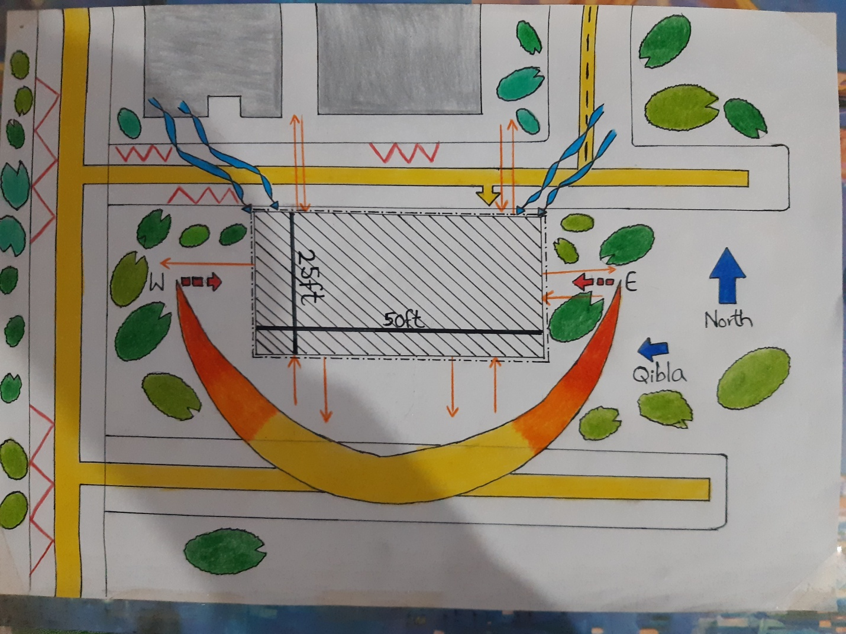
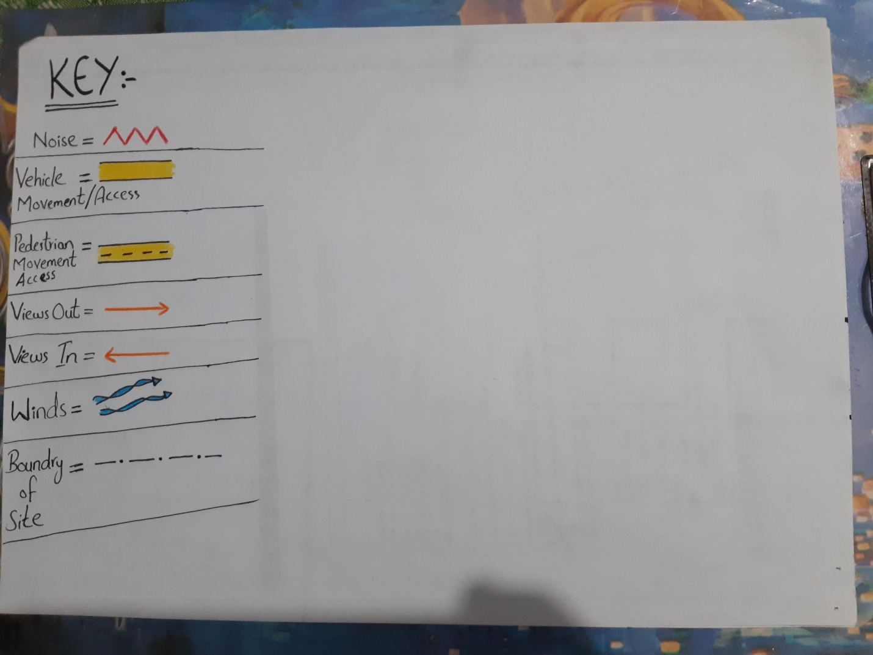
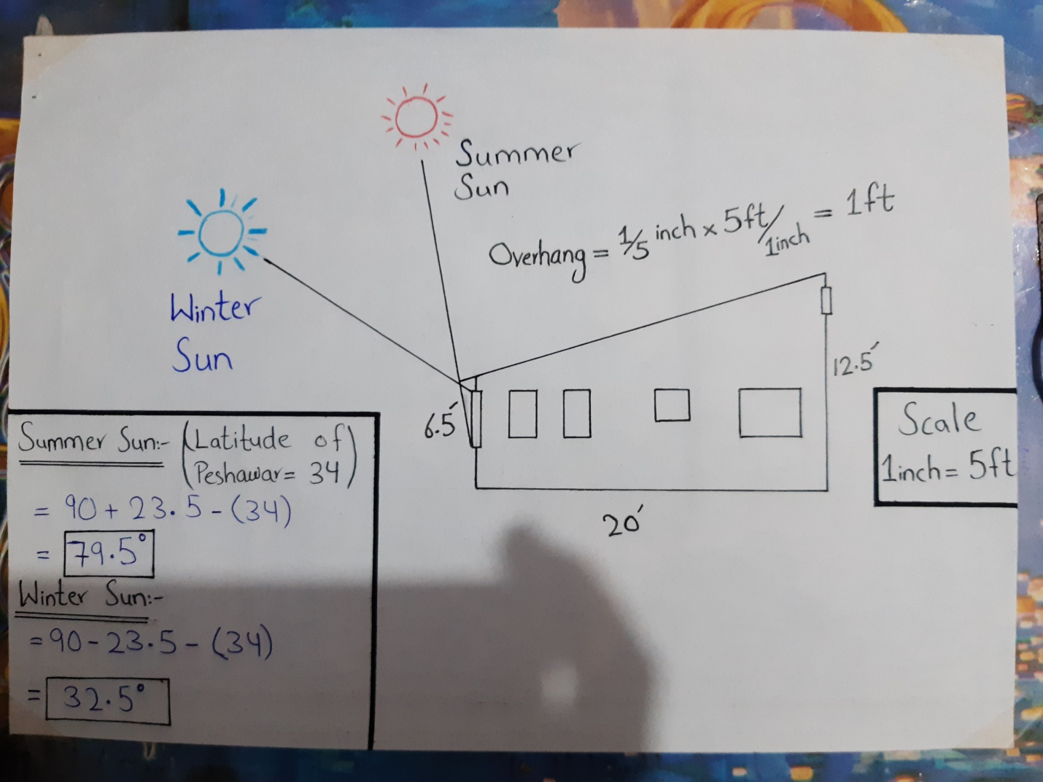
The above sketch shows how the summer sun is blocked and winter sun is allowed.

