Mid Term Assignment Session 2020

Dental Technology (6th semester)
Subject: Maxillofacial Surgery

Total Marks: 30
Passing marks: 15 WARDAH NAVEED ID 13637
Note: Attempt ALL questions.
Q1. A) Define Oral mucosa.
Ans: The oral mucosa is the mucous membrane lining that is present inside the mouth. It is made up of stratified squamous epithelium also known as oral epithelium and an underlying connective tissue called lamina propria.
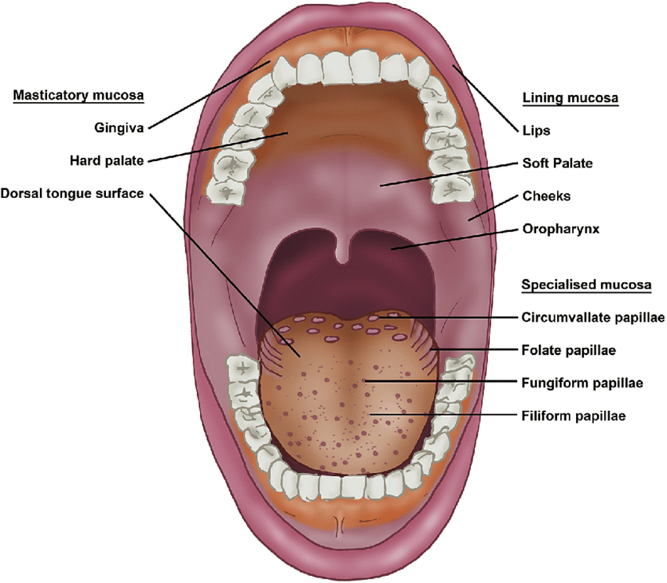
https://www.researchgate.net/figure/Oral-mucosa-and-lingual-papillae-Keratinised-masticatory-mucosa-covers-the-gingiva-hard_fig1_317575795

B) Enumerate the two components of oral mucosa.
Ans: Two main components are
- stratified squamous epithelium known as oral epithelium
- underlying connective tissue called lamina propria
Oral epithelium is further divided into types:
- keratinized epithelium
- non keratinized epithelium
Lamina propria is further divided into types:
- Papillary layer
- Reticular layer
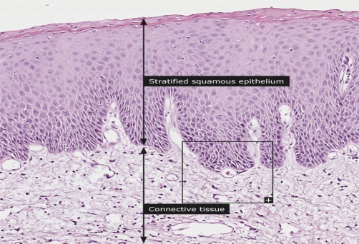
https://www.proteinatlas.org/learn/dictionary/normal/oral+mucosa/detail+1

C) Enumerate types of oral mucosa. Which type comprises most of the oral cavity?
Ans: Masticatory Mucosa 25%: consist of keratinized stratified squamous epithelium which are located at the dorsum of the tongue, hard palate and attached gingiva.
Lining Mucosa 60%: also made up of keratinized stratified squamous epithelium and are seen in the lips, cheeks, vestibule, floor of the mouth, interior surface of the tongue and soft palate
Specialized Mucosa15%: It is present on the dorsal surface of the tongue specifically on lingual papillae.
Thus it is lining mucosa that comprises most of the oral cavity.
https://link.springer.com/chapter/10.1007/978-3-319-56065-6_1

D) Define Connective Tissue Papilla, Basement Membrane and Rete Ridges.
Ans:Connective Tissue Papilla: these are irregular and upwards projection of connective tissues, consists of blood vessel and other vesicular bundles that can also be a source of nutrition supplier.
Basement membrane: is a thin fibrous membrane, that separates the lining of an internal or external body underlying connective tissues in. The primary function of the basement membrane is to attach the epithelium to the loose connective tissue.
Rete ridges: are also known as rete pegs these are extensions or projections that move into the underlying connective tissue mucous membranes. These allow contact between epidermis and dermis increase the contact area between these layers.
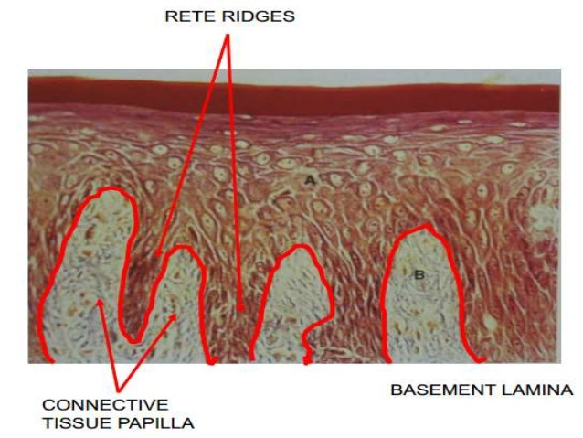
E) Why is the name specialized given to specialized mucosa?
Ans: Present on the dorsal surface of the tongue specifically on lingual papillae. Occupying 15% of the oral cavity. Although its masticatory mucosa by function but due to its high extensibility and lingual papillae, it is classified as specialized mucosa.
Q2. A) Enumerate layers of keratinized surface epithelium in orderly manner.
Ans: Keratinized epithelium is associated with masticatory function and has four layers of cells
- Stratum Basale (bottom)
- Stratum Spinosum
- Stratum Granulosum
- Stratum Corneum(top)
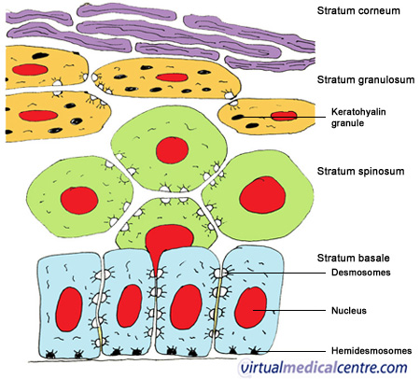
B) Which two layer comprises Stratum Germinativum?
Ans:Cells of stratum granulosum are flat and are found in layers of three to five cells thick
- Stratum Basale
- Stratum Spinosum
C) What is meant by pyknotic nucleus and where it is present?
Ans:Present in para keratinized epithelium these pyknotic are known as false nucleus and thus does not function normal nucleus.
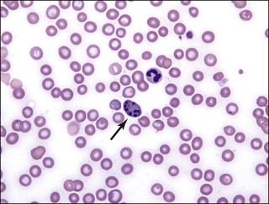
https://www.sciencedirect.com/topics/agricultural-and-biological-sciences/pyknosis

Q3. A) Define Extraction and its types.
Ans: EXTRACTION: The painless removal of the whole root or tooth, causing trauma that is minimum towards the investing tissues, so that the wound heals uneventfully and no post-operative prosthetic problem is created.
Extraction can be of two types:
- Intra-Alveolar extraction or conventional extraction or forceps extraction
- Trans Alveolar extraction or surgical extraction
B) A patient comes to your clinic with carious tooth which cannot be restored by endo treatment. You decided to go for extraction. In pre operative radiograph you observed severely curved and thick roots embedded in bone.
a) Which type of extraction would you do in such case?
Ans: According to the given case study above the best extraction choice would be the trans Alveolar extraction or surgical extraction
b) Give explanation, why would you choose this type of extraction.
Ans: This surgical or extraction technique is used for recovering roots that were fractured during extraction routine or those teeth that cannot be extracted by the routine closed methods for a variety of reasons
C) Give 2 indications and 2 contraindications of closed/forcep extraction.
Ans: The following 2 indication of closed/forceps extraction:
- In case of sever caries
- In case of sever periodontal disease
The following 2 contraindication of closed/forceps extraction
Systematic:
- Severe uncontrolled DM
Local:
- Tumor

Q4. A) What is curettage and why is it important after extraction?
Ans: Curettage is a medical procedure with the use of an instrument called curette which is derived from a French word that means to scoop, it is a method commonly used to remove the tissues by scrapping or scooping.
B) After how many days of extraction, you will remove stitch?
Ans: If the stitches are dissolvable then they usually last for 5-7 days, but may become loose only after 1-2 days.
Suture removal depends on the material and procedure. Generally, the healing of the wound takes place after 8 to 12 days.
After suture removal, the patient will continue the specific oral hygiene procedures pre-scribed after surgery for 2-3 days
C) Write the steps of stitch removal in your own words.
- Ans: begin with washing your hands .
- Introduce yourself to patient making him or her comfortable ..
- Ensure patient’s privacy and dignity patient must be introduced and made clear what procedure he or she is about to undergo.
- We will need the following sterile suture scissors or suture blade, sterile dressing tray (to clean incision site prior to suture removal), non-sterile gloves, normal saline and dressing material.
- Position patient appropriately and create privacy for procedure to make her as comfortable as possible.
- Remove dressing and the begin to inspect the wound using non-sterile gloves to avoid contact : After assessing the wound, decide if the wound is sufficiently healed to have the sutures removed if not then let it wait for a few more days
- Remove non-sterile gloves and wash your hands thoroughly again
- Apply clean non-sterile gloves to avoid contact.
- Clean incision site to do so we begin Cleaning also loosens and removes any dried blood or crusted exudate from the sutures and wound bed this to limit the risk of infection from microorganisms on the wound site or surrounding skin.
- hold scissors in dominant hand and forceps in non-dominant hand for better grip
- Grasp knot of suture with forceps and gently pull up knot up while placing the tip of the scissors under suture and close to the skin.
- Cut under the knot as close as possible to the skin at the distal end of the knot.
- Continue this till the end
- Remove it al then wipe the area with disinfectant
- Dress back the wound
- Q5. A patient comes to your clinic 2 days after extraction with severe throbbing pain in his socket which radiates to ear and eye. The patient also complaints of bad breath and foul taste in the mouth. There is empty space in extraction site with visible bone.
- What is your diagnosis?
Ans: The condition this patient is facing is termed as the dry socket

- What is the reason for empty space in extraction site?
Ans: A socket is formed which is a hole in the bone formed where the tooth was once present after its extraction
- How does this condition occur?
Ans: A hole is present in the bone after the tooth is pulled a clot is formed to protect the underneath structures Sometimes that clot can become dislodged or dissolve a couple of days after the extraction. This leaves the bone and nerve exposed leading to infection and severe pain that can last for 5 or 6 days.
- What management will you provide to patient?
Ans: Use of non-steroidal anti-inflammatory drug (NSAID), such as aspirin or ibuprofen to ease the discomfort or the pain, if that doesn’t work well for some patient then doctor may prescribe a stronger drug or will anesthetize the area.
- Flushing out the socket can remove any food particles or other debris that may contribute to pain or possible infection.
- dentist or oral surgeon may pack the socket with medicated gel or paste and medicated dressings
https://getyoursmileback.co.uk/hormones-and-dental-health-what-every-woman-needs-to-know/description-image-result-for-dry-socket/ 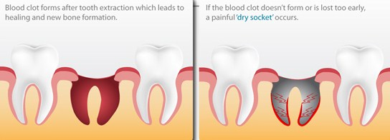
Q6. A) After extraction, what post operative instructions will you give to patient?
Ans: These steps are taken immediately following surgery:
- Bite on the gauge pad for 30 minutes to cover the extraction followed by drinking of cold juice consumption of ice cream to stop bleeding.
- Numbness will be felt for some time as it is temporary will wear off within 2-6 hours take care not to bite your lips, cheeks or tongue.
- Take all medications as instructed by your dentist aviod use of painkillers on an empty stomach.
- If you have received sutures, an appointment will be needed to remove the sutures in 7-10 days.
These steps are for the first 24 hours following surgery do not:
- Avoid smoking
- Avoid sucking on straws
- Avoid Blowing your nose
- Brush or rinse but avoid brushing near the surgical site for 3 days.
- Avoid Spit excessively
- Avoid drinking hot liquids
- Avoid chewing from same side of mouth where the surgery occured
- Avoid eating hard, crunchy foods such as chips or nuts
B) Why do we give post operative instructions?
Ans: Postoperative care is the management of a patient after surgery.
The goal of postoperative care is to prevent complications such as infection, to promote healing of the surgical incision, and to return the patient to a state of health and to prevent mouth sores, mouth cancers, infections, dry socket

