NAME: GHAZI SAMEEN
TEACHER: MAM SAMEN SHAH
ID: 15457
SUBJECT: Introduction to Psychology

Q:1
ANS: SENSATION:
Process of receiving, converting, and transmitting information from the outside world. Sensory receptors are specialized neurons that respond to specific types of stimuli. When sensory information is detected by a sensory receptor, sensation has occurred.
You have probably known since elementary school that we have five senses:
Vision
Hearing
Smell
Taste
Vestibular sense (balance)
Kinethesis (body movement)
Touch
FOR EXAMPLE:
Like if we hear a song so hearing is sensation.
Sense of smell when we are in a place which is stinky or etc.
PRECEPTION:
A constructive process by which we go beyond the stimuli that is presented to us and attempts to construct a meaningful situation. While our sensory receptors are constantly collecting information from the environment, it is ultimately how we interpret that information that affects how we interact with the world. Perception refers to the way sensory information is organized, interpreted, and consciously experienced.
There are two main types of perception that are as follow:
- Top –down
- Bottom –up
Top-down: perception is guided by higher-level knowledge, experience, expectations, and motivations
Bottom-up: perception that consists of recognizing and processing information about the individual components of the stimuli
Some main concepts of perception are listed below:
- Selective attention
- Feature detectors
- Habituation

FOR EXAMPLE: if a boy is crying and we see him so we got to know that what is he feeling like he is sad and not feeling happy this is feeling for him is basically our perception

Q:2
ANS: m&m’s: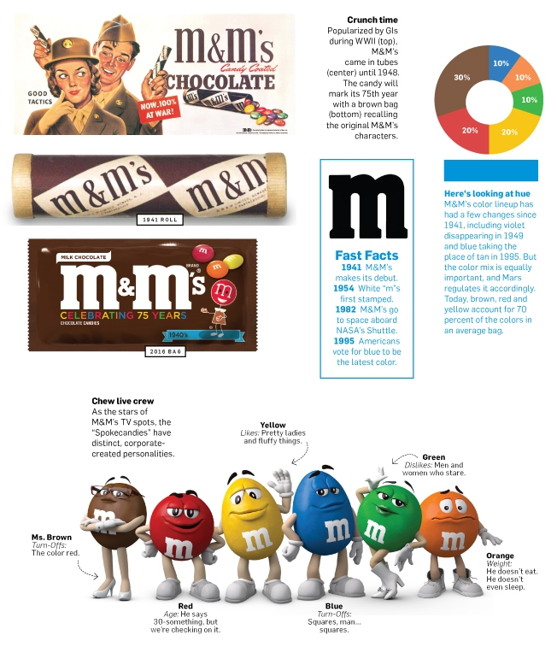
As you read this, M&M's the best-selling candy in America, the treat that Mars makes invention of M&M's. 400 million of every day, and the milk chocolate that melts in your mouth and not in your hand is marking its 75th birthday. More on that in a moment. First, a quiz: Name the two forces that were instrumental to the. For 75 years, our fans have made M&M'S the iconic and beloved chocolate brand it is today," said Berta de Pablos-Barbier, Vice President, Marketing, Mars Chocolate North America. "We aren't satisfied with solely looking back on our history as America's favorite chocolate candies. We are looking to the next 75 years of innovation and transformation to engage, entice and excite consumers of today and tomorrow."

B&H:
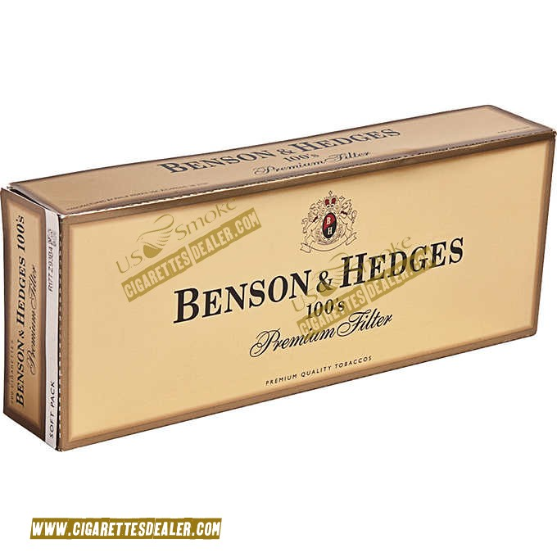
Benson & Hedges was founded in London in 1873 by Richard Benson and William Hedges as Benson and Hedges Ltd. Alfred Paget Hedges succeeded his father in the business in 1885, the same year which Richard Benson left the business. The 1900s saw branches of Benson & Hedges Ltd. opening in the United States and Canada. In 1928, the American branch became independent, and was bought by Philip Morris in 1958. Benson & Hedges Ltd in the UK was acquired by the Gallaher Group in 1955.
An in this add they just told the consumer about the extra ordinary form of their tobacco and their exceptional taste of smoke and that they are conscious about the health of the consumer due to which they are using a very good quality filter and tobacco as compared to the other cheap brand.
AUDI:

In this add they told about the jealousy of people and heaters or AUDI and the people who don’t like Audis because of the price bracket it had in the market and those who cannot afford they used to talk like this kind of stuff but AUDI don’t have any kind of issue from it and they appreciate there heaters just because they are playing the role of an unpaid promoters for them.

Q:3 (A)
ANS: TYPES OF MEMORY:
* Sensory memory: Short Term, Long term
* Explicit memory: it’s Actually a Long term memory
• Episodic memory: Month of Birthday, these are actually long term memories
* Sementic memory: tyres of trunk, Color of Apple
* Implicit memory: driving a car, riding a bike, buttoning a shirt
* Procedural memory: it is related To Implicit Memory using the shift Stick while Driving.

(B)
ANS: LONG TERM MEMORY:. Long-term memories are a type of relatively lasting memory. Long-term memory refers to the storage of information over an extended period. If you can remember something that happened more than just a few moments ago whether it occurred just hours ago or decades earlier, then it is a long-term memory.

SHORT TERM:
Also known as primary or active memory is the information we are currently aware of or thinking about. The information found in short-term memory comes from paying attention to sensory memories. Short Term memory is just saved for Few Seconds.
Maximum 20-40 Seconds.

