BIOCHEMISTRY
Name: Laiba israr
ID: 15168
Final Term Exam
Instructor: Mam Kalsoom

Attempt the following questions each carries equal marks

- Explain briefly translation of DNA in eukaryotes?
Answer:
DNA contains genes. A gene is a continuous strand of nucleotide containing a region that originates RNA molecule. This region begins with promoter region and ends with a terminator.
- Gene Expression:
For some genes the encoded RNA is used to synthesize a protein in a process called Gene Expression. For these gene expression can be divided into two processes.

- Transcription
- Translation

- In eukaryotic cells transcription occurs in nucleus and translation occur in cytoplasm of the cell.

- Translation Of DNA in Eukaryotes:

- Translation is a process by which the genetic code contained within an mRNA molecule is decoded to produce the specific sequence of amino acids in the polypeptide chain.

- Translation Protein synthesis:

- Translation involves translating the sequence of a messenger RNA (mRNA) molecule to sequence of amino acids during protein synthesis. It is the process in which ribosome in the cytoplasm or ER synthesis proteins after the process of transcription of DNA to RNA.

- There are four specific codons one that starts and the three that code for stop.

- Initiation
- Elongation
- Termination

- Initiation:
Translation begins with a messenger RNA strand binding to a small ribosomal subunit up stream to start codon. Each amino acids is brought to a ribosome by a specific transfer RNA molecule. The type of amino acids is determine by the anticodon sequence of transfer RNA. Complementary base pairing occurs between the codons of messenger RNA and the anti-codon of transfer RNA. After initiation transfer RNA molecule bind to a start codon, the larger ribosomal subunit binds to form the translation complex and initiation is complete.
- Elongation:
In larger ribosomal subunit there are three distinct regions called E, P, A sites. During elongation individual amino acids are brought to mRNA strand by a transfer RNA molecule through complementary base pairing of the codons and anticodons. Each anticodon of the transfer RNA corresponds to a particular amino acids.
- A charge transfer RNA molecule bind to A site and peptide bond forms between its amino acids and the one attached to transfer RNA molecule at a p site. The complex slides down on E site to the right where a non-charged transfer RNA molecule exits from E site and A site is open to accept the next transfer RNA.

- Termination:

A release factor binds to A Site at a stop codon and polypeptide is released from a transfer RNA reached. A release factor bind to the A site at the stop codon and a polypeptide is released from a transfer RNA in a P site. The entire complex dissociate and can resemble to begin the process again at initiation.

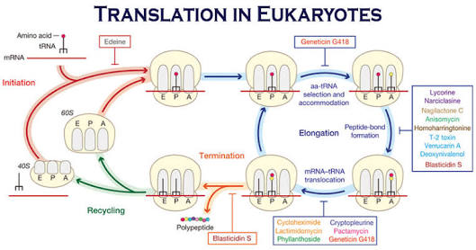

- Write brief note on steroid hormone?

Answer:
Hormone:
Hormone are chemical substances that act like messenger molecules in the body. After being made in one part of the body, they travel to other parts of the body where they help control how cells and organs do their work.

- Steroid Hormones:

- Steroid hormone is a steroid that acts as a hormone. Steroid hormones are produced in the adrenal cortex, testis, ovary and some peripheral tissues. All steroid hormones are derived from cholesterol and differ only in the ring structure and side chains attached to it .steroid hormones are the crucial substances for the proper functioning of the body. Enzymes which produce steroid hormones from cholesterol are located in mitochondria and smooth endoplasmic reticulum.

- All steroid hormones are lipid soluble and water insoluble.

- Types of steroid hormones:
- Glucocorticoids
- Mineralocorticoids
- Androgens
- Estrogens
- Progestogens

- Glucocorticoids:
Originate in the adrenal cortex and affect mainly metabolism by decreasing inflammation and increasing resistance to stress. E.g. cortisol, cortisone and corticosterone.
- Mineralocorticoids:
It originate in adrenal cortex and maintain salt and water balance e.g. aldosterone.
- Androgens:
Androgens originate in the adrenal cortex and gonads and primarily affect maturation and function of secondary sex organs male sexual determination e.g. testosterone.
- Progestogens:
It originate from both ovaries and placenta.

- Functions Of Steroid Hormones:

- Steroid hormones plays a major role in.

- Carbohydrate regulation
- Bone metabolism
- Cardiovascular fitness
- Stress response
- Mineral balance
- Reproductive functions
- Activates DNA for protein synthesis.

- Characteristics:

- Are made from cholesterol, are lipophilic and can enter target cell.

- Are immediately released from cell after synthesis

- Interact with cytoplasmic or nuclear receptors

- Activate DNA for protein synthesis

- Are slower acting and have longer half-life than peptide hormones.

- Examples. Cortisol, estrogen, testosterone.
How steroid hormone works in the body:
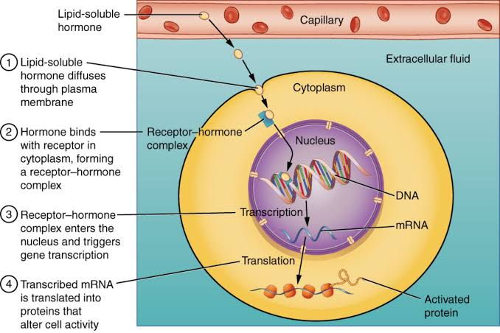

- Write down clinical significance of cholesterol?

Answer:
Cholesterol:

It is derived from the ancient Greek word Chole –bile and stereos –solid.
Cholesterol is a waxy fat like substance that’s found in all the cells in your body. Your body needs some cholesterol to make hormones, vitamin D, and substances that help you digest foods. Your body make all the cholesterol it needs. It is found in food and animal sources like egg yolk, cheese, and meat.

Cholesterol can cause by unhealthy lifestyle, unhealthy eating habits, lack of physical activity and smoking.

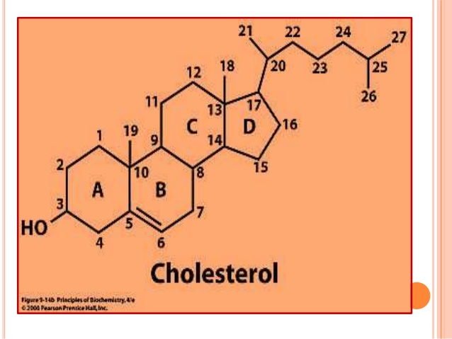

- Clinical significance of cholesterol:
- Normal serum cholesterol levels-150-200mg/dl(adult)
- Normal serum cholesterol levels in new born -100mg/dl

- Hypercholestrolemia:

- Serum cholesterol levels – 200mg/dl

- It is associated with diabetes mellitus ( increase availability of acetyl CoA due to unavailability of oxaloacetate)

- Nephrotic syndrome:

- Nephrotic syndrome is a kidney disorder that causes your body to pass too much protein in your urine. nephrotic syndrome is usually caused by damage to the clusters of small blood vessels in your kidneys that filter waste and excess water from your blood.

- Hyperthyroidism:

- Overactive thyroid occurs when your thyroid gland produces too much of the hormone thyroxine. Hyperthyroidism can accelerate your body’s metabolism, causing unintentional weight loss and rapid or irregular heartbeat.

- Obstructive jaundice:

- Obstructive jaundice is a condition in which there is blockage of the flow of bile out of the liver.

- Hyperlipidemia:

- Means your blood has too many lipids such as cholesterol and triglycerides.

- Atherosclerosis:
- Refers to the buildup of fats, cholesterol and other substances in and on your artery walls plaque which can restrict blood flow.
- Additional factors for Coronary Artery Disease include – unhealthy Lifestyle
- Cigarette Smoking, , Emotional Stress,
- Lack of exercise, High Blood Pressure etc.

- Write down the metabolism of protein?
Answer:
Metabolism:
All chemical reactions involved in maintaining the living state of the cells and the organism.
- Metabolism types:
- Catabolism
- Anabolism

- Protein:

- Proteins are essential nutrients for the human body. They are one of the building blocks of the body tissue and also serve as a fuel source.

- Metabolism of Protein:

- Proteins are not stored in the human body. They are constantly broken down into their constituent amino acids and then reused for protein synthesis. The amount of a specific protein in the body is kept constant. Dietary proteins are very large complex molecules that cannot be absorbed from the intestine.to be absorbed dietary proteins must be digested to small simple molecules which are easily absorbed from the intestine.

- Digestion in the stomach:

- Protein digestion begins in the stomach by gastric juice, pepsin and rennin are the enzymes present from the intestine.

- Digestion in the small intestine:

- Digestion of proteins is completed in the small intestine by proteolytic enzymes present in pancreatic and intestinal juices.

- In pancreatic juice:

- Trypsin, chymotrypsin, elastase, carboxypeptidase enzymes are present.

- In intestinal juice:

- Aminopeptides, tripeptidase, dipeptidase enzymes are present . The end products of protein digestion in the small intestine are amino acids.

- Protein absorption:

- It is an active process that needs energy

- It occurs in small intestine

- Absorption of amino acids is rapid in the duodenum and jejunum, but slow in the ileum.

- 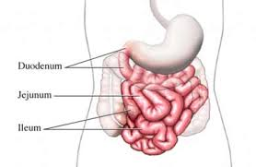

- What is deamination and transamination?
Answer:
Transamination:
It is the transfer of NH2 group from an AA to a keto acid with simultaneous production of a corresponding keto acid and AA respectively. Thus creating a new amino acid and keto acid is shown below. Catalyzed by a group of enzymes called transaminases (aminotransferases). Pyridoxalphosphate ( PLP) co –factor .
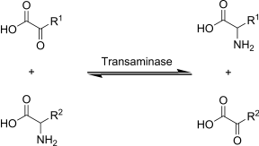

- Amino acid participating in transamination:
- All amino acids except:
- Lys
- Thr
- Pro
- Keto acid participating in transamination:
- Three keto acids mostly participates
- a -ketoglutrate
- Oxaloacetate
- Pyruvate
- Site of transamination:
- Cytoplasm of :
- Liver
- Kidney
- Heart
- Sk. Muscle
- Brain.
- Mechanism of transamination:
- Step 1:
- Transfer of amino acids group from AA₁ to co enzyme PLP to form pyridoxamine phosphate.
- Amino acids is converted to keto acid₂
- Step2:
- Amino group pyridoxamine phosphate is then transferred to keto acid₁ to produce a new AA₂ and enzyme with PLP is regenerated.

- Deamination:
- The removal of amino group from the amino acids as NH3 is deamination. Deamination results in the liberation of ammonia for urea synthesis. The carbon skeleton amino acids is converted to keto acids. Deamination may be either oxidative or non- oxidative.
- It is activated by ADP and inhibition by GTP.
- It is an allosteric enzyme.
- Oxidative Deamination:
- Oxidative deamination is the liberation of free ammonia from the amino group of amino acids coupled with oxidation.
- Site: mostly in liver and kidney.
- Oxidative deamination is to provide NH3 for urea synthesis.
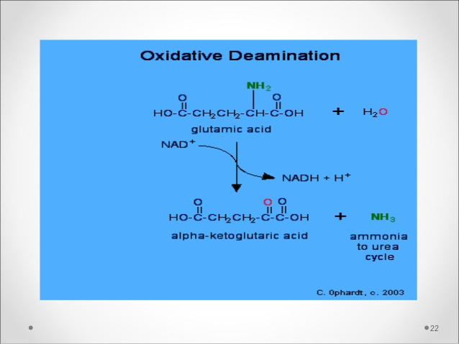

- Allosteric regulation:
- GTP and ATP – allosteric inhibitors.
- GDP and ADP – allosteric activators.
- Steroid and thyroid hormones inhibit GDH.

Transamination VS Deamination:
