Final Term Assignment (2020)
Course Title: Basic Physiology (DT– 2nd) Instructor: Dr. Irfan Ali Khan

Question Paper Time: 48 hours
Class Code. 15930 Name/Class Rollno: Farman Ullah
Note:
- Attempt all questions from this section.
- Use Blue / Black Ink only. Do not use red color.
- Tick or encircle only one option in each given question.
It’s an open book Conceptual Assignment paper. Time to Use your brain now.

- Briefly explain the process of hematopoiesis along with diagrammatic illustration. (Marks 10)
Answer:
Hematopoiesis is the process by which immature precursor cells develop into mature blood cells. The currently accepted theory on how this process works is called the monophyletic theory which simply means that a single type of stem cell gives rise to all the mature blood cells in the body. This stem cell is called the pluripotential (pluripotent) stem cell.
SITES OF HEMATOPOIESIS
Age of animal | Site of hematopoiesis
Embryo | yolk sac then liver
3rd to 7th month | spleen
4th and 5th months | Marrow cavity – esp. granulocytes and platelets
7th month | marrow cavity - erythrocytes
Birth | Mostly bone marrow; spleen and liver when needed
Birth to maturity | number of active sites in bone marrow decreases but retain ability for hematopoiesis
Adult | Bone marrow of skull, ribs, sternum, vertebral column, pelvis, proximal ends of femurs

Bone marrow is the site for other important activities in addition to hematopoiesis. These include the removal of aged and defective erythrocytes and the differentiation of B lymphocytes. It is also the site of numerous plasma cells.
THE PROCESS OF HEMATOPOIESIS:
The monophyletic theory of hematopoiesis states that pluripotent stem cells multiply to produce more pluripotent stem cells, thus ensuring the steady and lasting supply of stem cells. Some of the pluripotent stem cells differentiate into precursor cells that are at least partially committed to become one type of mature
blood cell.
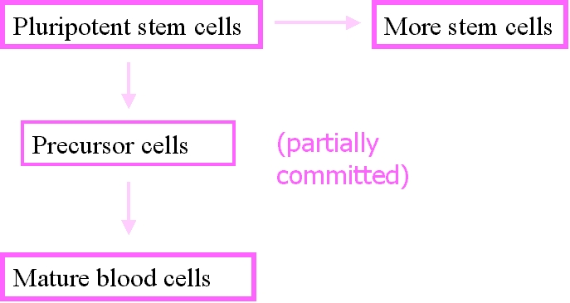
Pluripotent stem cells multiply slowly into one of five possible unipotential stem cells which then multiply rapidly into the precursor of the specific mature blood cell for which they are destined.
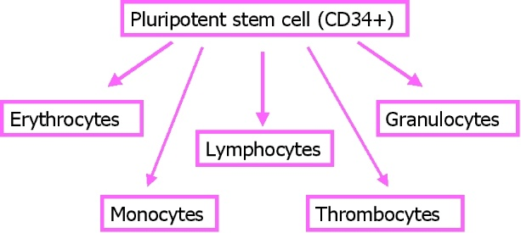
Although the pluripotent stem cells and the unipotential stem cells cannot be distinguished from one another histologically, the precursor cells can be distinguished with a trained and practiced eye.

Diagram:

On the page below

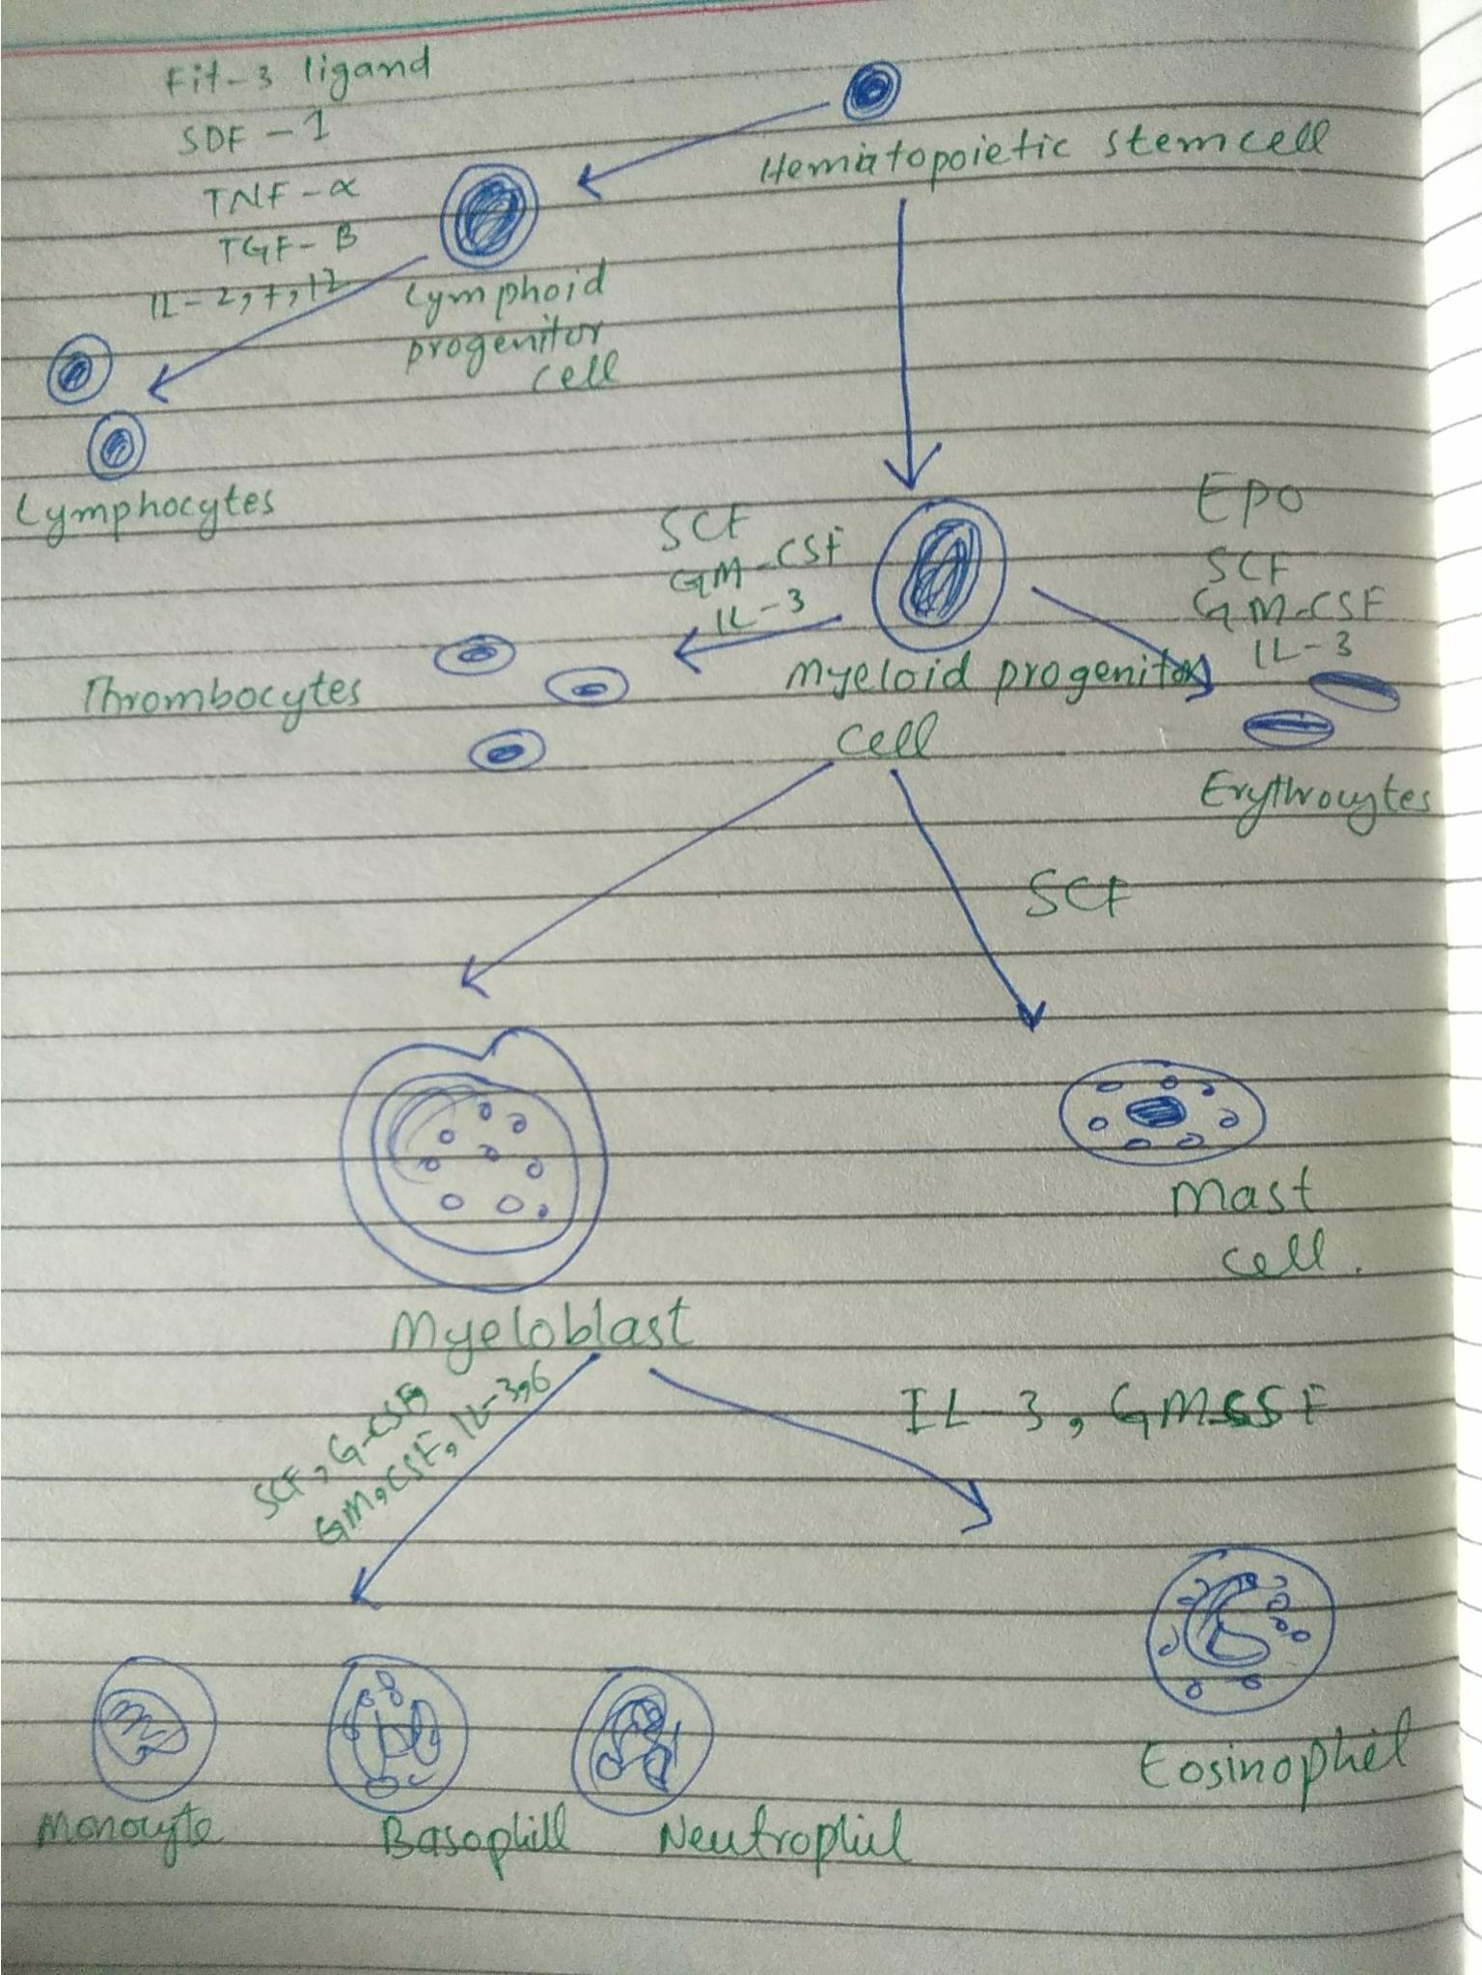
Diagram of hematopoiesis
- What are the factors that influence the respiratory rate, explain in detail. (Marks 10)
Answer:

Factors Influencing Respiration:
Chemical- carbon dioxide, hydrogen ions and oxygen levels are the most important factors that regulate respiration.

Chemoreceptors- sensory receptors that detect CO2, H, and O2 levels in the blood. Located in the respiratory center, the carotid arteries and aorta…. CO2 levels are the main influence, oxygen levels only affect breathing with dangerously low.
If CO2 levels increase, the respiratory center( medulla and pons) is stimulated to increase the rate and depth of breathing. This increases the rate of CO2, removal and returns concentrations to normal resting levels.

Inflation reflex- stretch receptors in the visceral pleura are sensitive to the degree of stretching by the lungs. This is to prevent excessively deep inspirations that may damage the lungs.

Higher brain centers- the cerebrum allows voluntary altering of breathing, but these capabilities are limited. One can choose to hold their breath for a period of time, but eventually the respiratory center will take over as the CO2 levels increase.

Body temperature- increase in body temperature such as during exercise or fever increases respirations.

- Enlist different layers of skin, write a detailed note on epidermis. (Marks 10)
Answer:
Skin has three layers:
The epidermis: the outermost layer of skin, provides a waterproof barrier and creates our skin tone.
The dermis: beneath the epidermis, contains tough connective tissue, hair follicles, and sweat glands.
Hypodermis: The deeper subcutaneous tissue is made of fat and connective tissue.
Epidermis; The epidermis is the outermost layer of our skin. Its main purpose is protection. ... The stratum spinosum, which helps bond skin cells together, and stratum granulosum, which produces a waxy material that aids in waterproofing the skin layers, are located between the stratum corneum and the stratum basale.The epidermis of thick skin has five layers: stratum basale, stratum spinosum, stratum granulosum, stratum lucidum, and stratum corneum. The stratum basale is a single layer of cells primarily made of basal cells. A basal cell is a cuboidal-shaped stem cell that is a precursor of the keratinocytes of the epidermis.

- Define lymphatic system, what are different components of lymphatic system? (Marks 10)
Answer;
Lymphatic system :
lymphatic system is a network of tissues and organs that help rid the body of toxins, waste and other unwanted materials. The primary function of the lymphatic system is to transport lymph, a fluid containing infection-fighting white blood cells, throughout the body.
Components:
Vessels; They are called "Lymphatics"
Fluid: They are called "Lymph", it flows through the lymphatics
Lymphocytes: They are white blood cells, which are cells of the lymphatic system
Lymphoid Tissues and Organs
Tonsils, Lymph Nodes, Spleen, Thymus

- What is blood pressure? How will you check and record blood pressure of a patient? (Marks 10)
Answer;
Blood pressure: The blood pressure is the pressure of the blood within the arteries. It is produced primarily by the contraction of the heart muscle. ... The first (systolic pressure) is measured after the heart contracts and is highest. The second (diastolic pressure) is measured before the heart contracts and lowest.
Measuring of Blood pressure:
To begin blood pressure measurement, use a properly sized blood pressure cuff. The length of the cuff's bladder should be at least equal to 80% of the circumference of the upper arm.
1-Wrap the cuff around the upper arm with the cuff's lower edge one inch above the antecubital fossa.
2-Lightly press the stethoscope's bell over the brachial artery just below the cuff's edge. Some health care workers have difficulty using the bell in the antecubital fossa, so we suggest using the bell or the diaphragm to measure the blood pressure.

3-Rapidly inflate the cuff to 180mmHg. Release air from the cuff at a moderate rate (3mm/sec).

4-Listen with the stethoscope and simultaneously observe the dial or mercury gauge. The first knocking sound (Korotkoff) is the subject's systolic pressure. When the knocking sound disappears, that is the diastolic pressure (such as 120/80).

5-Record the pressure in both arms and note the difference; also record the subject's position (supine), which arm was used, and the cuff size (small, standard or large adult cuff)

Stay home, stay Safe

