Name Mudassir shah
id 16147
paper Principal of markiting

Q 1 ..
Answer 1 ..SWOT anlysis
*streinght ..
..*thing your company as well ..
*qualities that separate you from your competitor .
*internal resource serch as skill...
weakness
thing your company lack...
thing your competiter do better than you ...
resource limitation ..
opportunities
*under served market for specfiec product .
*few competition in your area..
*engineer need your product or services ...
*press media coverage for your company ....
threat ...
*engineer competiter
*changing regulatory envirment .
*negative press media coverage ..
*changing costumer attitudes to word your company ....
•the swot analysis company use it
once you examined all four aspect of swot you likely be face your long list of potential take action to take you want to build on ypur streinght boos your weaker area head of any threat and exploit every opportunely .
but before you leap into action look for potential connection between the quadrant for your matrix .....
swot anlysis for inu
inu streinght
•chartered with the hec
•web service for (sic )current student
specialized program and seminar .

inu weakness
engineering faculty not full recognize
building under construction
inu staff is hired in other universties
inu threat

great competition of other universties
most competiton or other subjec..
inu opertunities
new campuses
new faculity in it ms and phd program
international scholarship ..

Q 2
Answer 2
Idea generation
The new product devlopment in the start in the the idea generation the systematic serch for new product ideas major source for new product ideas include internal and external
Source such as the costemer and competiter distributor for supplier for other
*internal idea source .
The internal idea source the can idea new company through formal r and d
Beyond and internal r&d process the company can pick the the brain and its employ from executives to scientist and engineer and manufacture staf to sale people …
Many company have devlope and successful intra preneuril program that encouraged employ to envision and devolpe new ideas
*external idea source ..
Companies can also obtain good new product idea from any number to external resource ….
2 idea screening …..
The 1st idea reducing stag is idea screening which help spot good idea and drop poor ones as soon possible
Product devlopment cost rise greatly in the liter stage so company want to go ahead only with those product idea that will turn into profitable product
Once marketing expert proposes an or r_w_w( real win worth doing) new product screening farm work that the three question
*1st it is real
Is their it is need and desire for the product and will costemer by it ..is their clear product concept that will a such product satisfy the market
*2nd we can win
Does the product after a sustainable in the competitive advantage does the company have the resources to make a such product success …
*Finally its worth doing
Does the product fit the company over all growth strategy does it up sufficient profit potential the company should be able to answer yes to all three r w w question before developing the new product idea further…..
Concept devlopment and testing
Product concept …
The product concept is
•Concept testing ..
Testing new product concepts with the group of target consumer to find out if the concept in in strong consumer appeal
*Tasting
Once you a develop fo prototype or the type of the product or service it time to test with costemer this can be done in formal focused group or costemer this can be done in formal focusing group
Business analysis
Business analysis is discipline recognize business need and finding solution to various the business problem in a simple word it is set of task in technique which work to select stakeholder
Product devlopment
Also called new product devlopment management it is serious of step that all include counsumption designs devlopment and market of newly created or newly good are service ……..

Q 3
Ans 3
The product life cycle
The life cycle of the product through from when its process a product goes through from the when its frits introduced into the market untill it decline or is removed from it market is called product life cycle
1 devlopment
The product development stage is often referable as the valleys of death as this stage cost to accumulate the no correspond revenue …
2 introduction
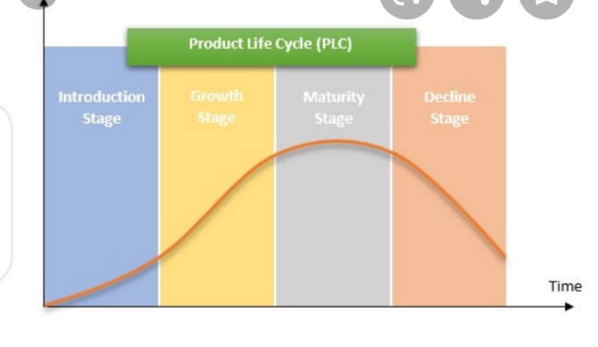
The introduction stage is about develop market for the product and building product awareness ….
3 maturity
At the mature stage sale well level up competitions increase so product features we need to be enhance to maintain the market … …
4 decline
The decline stage of the life product cycle is associate the decrease revenue to market saturation high competitions and changing costemer need ….
4 Growth
By the growth stage are consumer are already talking to the product in increase buying the product consist its proven its become more populer ……
Q 4
A 4
Branding
A brand Is the name of term sign symbol or design or a combination of these that identifile the marker or seller product is called branding

Example
Include the Nike swoosh the golden of arches mc donald and the apple use the apple computer…….

The end

