ANATOMY PAPER
NAME:IRSA IJAZ
ID #:16228
DEPARTMENT:RADIOLOGY
Q1. Write anterior compartment of thigh and posterior compartment of leg muscles with origin, insertion and action. (10)
Ans)LOWER LIMB
Function:
- Locomotion
- Carry weight of entire erect body
- Support
- Points for mascular attachment
COMPONENTS:
- Thigh: femur
- Knee:patela
- Leg:tibia ( medial)
Fibula ( lateral)
- Foot: tarsals(7)
Metatarsal (5)
Phalanges(14)

ANTERIOR COMPARTMENT OF THIGH:

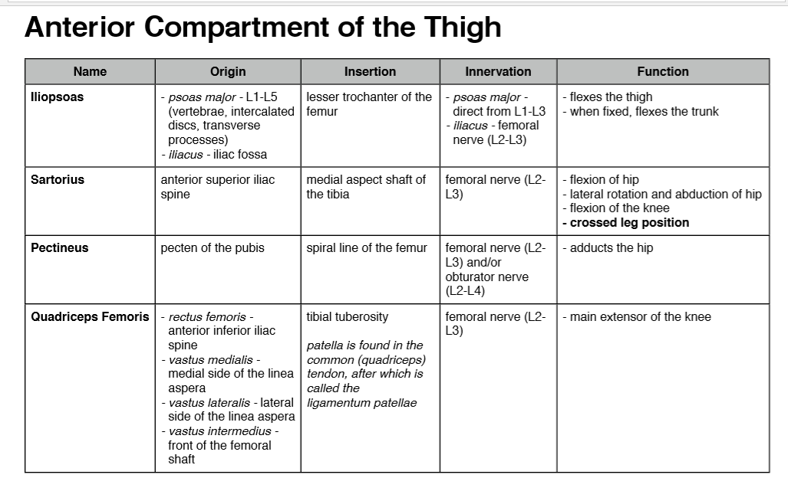
POSTERIOR COMPONENT OF LEG:

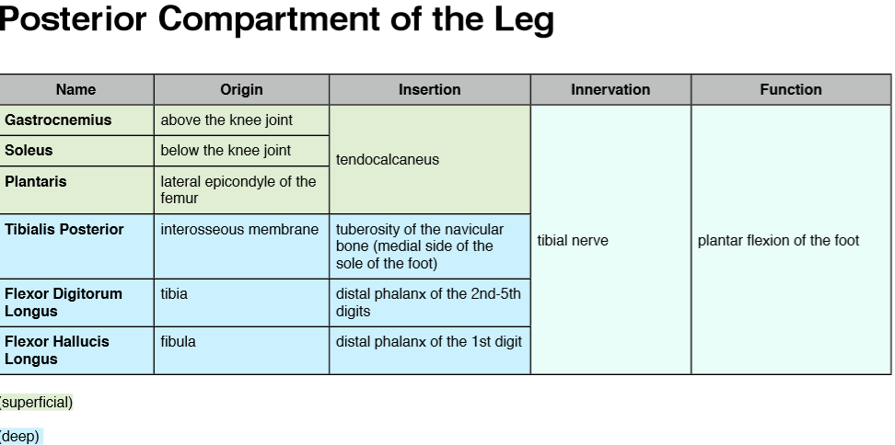

MUSCLES OF LEG :
- Anterior compartment:
Dorsiflex ankle, invert foot, extend toes,
Innervation : deep fibular nerve
- Lateral compartment:
Plantarflex, evert foot
Innervation: superficial fibular nerve
- Posterior compartment superficial and deep layers:
Plantarflex foot , flex toes
Innervation:tibial nerve
ANTERIOR COMPARTMENT:
Tibialis anterior:
- Origin:tibia
- Insertion tarsals
- Action:dorsiflexion, foot inversion
Extensor digitorum longus
- Origin tibia and fibula
- Insertion pgalanges
- Action toe extension
Extensor hallucis longus
- Origin:fibula , interosseous membrane
- Insertion:big toe
- Action:extend big toe , dorsiflex foot
- All innervated by deep fibular nerve
LATERAL COMPONENTS:
Fibularis(peroneus) longus
- Origin: lateral fibula
- Insertion:5th metatarsal,tarsal
Action:plantarflex , evert foot
FIBULARIS( PERONEUS)BREVIS:
- Origin:distal fibula
- Insertion:proximal 5th metatarsal
- Action:plantarflex, evert foot
- All innervated by the superficial fibular nerve

SUPERFICIAL POSTERIOR COMPARTMENT
Gastrocnemis(2heads)
Origin : medial and lateral condyles of femur
Insertion:posterior calcaneus via Achilles tendon

SOLEUS:
Origin:tibia and fibula
Insertion:posterior calcaneus via Achilles tendon
Action:plantarflex foot
Plantaris( variable)
Origin:posterior femur
Insertion:posterior calcaneus via Achilles tendon
Action:plantarflex foot, week knee flexion
All innervation by the tibial nerve
DEEP POSTERIOR COMPARTMENT:
Popkteus
Origin:lateral condyle femur and lateral meniscus
Insertion:plantarflex
Action:flex and medially rotate leg
Hexor digitorum longus
Origin:tibia
Insertion:distal pgalanges of toe 2-5
Action:plantarflex and invert foot , flex toe
Hexor hallucis longus
Origin:fibula
Insertion:distal phalanx of hallax
Action:plantarflex and invert foot, flex toe
Tibialis posterior

Origin:tibia , fibula , and interosseous membrane
Insertion:tarsals and meta tarsals
Action:piantarflex and invert foot
All innervated by the tibial nerve

. Define the following (10).
- Endocrine gland
- Exocrine gland
- Thalamus
- femoral triangle
Ans) ENDOCRINE SYSTEM
Definition:
The endocrine system is a chemical messenger system comprising feedback loops of the hormones released by internal glands of an organism directly into the circulatory system, regulating distant target organs.
Major endocrine glands:
In humans, the major endocrine glands are the
- Thuroid gland
- adrenal glands.
FUNCTION:
The endocrine glands influence reproduction, metabolism, growth and many other functions.
HORMONES SECREATED :
- major hormones — luteinising hormone (LH), follicle-stimulating hormone (FSH), prolactin, growth hormone, thyroid stimulating hormone (TSH), oxytocin, anti-diuretic hormone (ADH), adrenocorticotrophic hormone (ACTH)
- influences — reproduction, growth, childbirth, breastfeeding, hormone regulation.
EXOCRINE GLANDS:
Definition:
Exocrine glands are glands that secrete substances onto an epithelial surface by way of a duct.
Major endocrine gland:
Exocrine glands include
- sweat,
- salivary,
- mammary,
- ceruminous
- , lacrimal,
- Sebaceous
- , prostate
- Mucous
HORMONES SECREATED :
- FSH
- GTnRH
- LH
THALAMUS:
Definition:
either of two masses of grey matter lying between the cerebral hemispheres on either side of the third ventricle, relaying sensory information and acting as a centre for pain perception.
Location:
The thalamus is a paired structure of gray matter located in the forebrain which is superior to the midbrain, near the center of the brain, with nerve fibers projecting out to the cerebral cortex in all directions.
Function:
The thalamus is composed of different nuclei that each serve a unique role, ranging from relaying sensory and motor signals, as well as regulation of consciousness and alertness.
Femoral triangle:
Definition:
The femoral triangle (of Scarpa) is an anatomical region of the upper inner human thigh. It is a subfascial space which in living people appears as a triangular depression inferior to the inguinal ligament when the thigh is flexed, abducted and laterally rotated.
LOCATION:
Femoral triangle. The femoral triangle is a wedge-shaped area formed by a depression between the muscles of the thigh. It is located on the medial aspect of the proximal thigh. It is the region of the passage of the main blood vessels between the pelvis and the lower limb, as well as a large nerve supplying the thigh.
Function:
The femoral triangle contains some of the major neurovascular structures of the lower limb. Its contents (lateral to medial) are: Femoral nerve - Innervates the anterior compartment of the thigh, and provides sensory branches for the leg and foot.
Q3. Write the Extraocular muscles. Enlist both voluntary and involuntary. (10)
ANS)EXTRAOCULAR MUSCLES:
Definition:
The extraocular muscles are located within the orbit, but are extrinsic and separate from the eyeball itself. They act to control the movements of the eyeball and the superior
Funtion:
Functionally, they can be divided into two groups:
- Responsible for eye movement – Recti and oblique muscles.
- Responsible for superior eyelid movement – Levator palpebrae superioris

INVOLUNTARY | VOLUNTARY
- Superior tarsal or Muller's muscles | - Superior rectus
- Inferior tarsal muscle | - Inferior rectus  - Medial rectus  - Lateral rectus  - Superior oblique  - Inferior oblique  - Levator palpebrae superioris
Q4. Describe the arches of foot and functions of arches. (10)
ARCHES OF FOOT
Definition:
Anatomical terminology. The arches of the foot, formed by the tarsal and metatarsal bones, strengthened by ligaments and tendons, allow the foot to support the weight of the body in the erect posture with the least weight
. They are categorized as
- Longitudinal
- transverse arches.
Longitudinal arches:
The longitudinal arches of the foot can be divided into medial and lateral arches.
TRANSVERSE ARCHES:
Supporting arch which runs across the vault from side to side, dividing the bays. it usually projects down from the surface of the vault. Compare with transverse rib
ARCHES OF FOOT:
- Bone of the foot are arranged to form three strong arches
- Arches are fully developed by the age of 12 or 13
- Two longitudinal arches ( lateral and medial)
- One transverse
Function:
Arches help the foot support and distribute the weight of the body and provide leverage during walking
Q5. Write a note on cerebrum, its lobes and functions. (10)

CEREBRUM :
- It is the largest part of the brain
- The principal and the most anterior part of the brain in vertebrates
LOCATION:
- The cerebrum is located in the upper part of the cranial cavity , which is a space inside the top of the skull
HEMISPHERE:
- It consists of two hemispheres, left and right
- The two hemispheres are divided by a fissure
- The hemispheres communicate through corpus callosum
Lobes:
The cerebrum is divided into five lobes:
FRONTAL LOBE
- Most anterior position of the cerebrum
- Also called ‘ motor cortex'
LOCATION:
Upper forehead
FUNCTION:
- Controls motor function
- Personality
- Speech
- Control movement
- Control planning
- Control emotions
- Control reasoning
- And problem solving

PARIETAL LOBE:
- It is the most superior part of the cerebrum
- Also known as ‘ sensory cortex'
FUNCTION:
- ITS function is to receive and interpret nerve impulses from sensory receptors
- Interpretation of language
- Receive sensory information from the skin like touch , temperature , pain , pressure
OCCIPITAL LOBE:
- IT IS THE MOST posterior part of the cerebrum
- Also known as ‘ vision cortex'
- FUNCTION:
- Receive input from eyes
- Control vision
- TEMPORAL LOBE:
- It is the left and right lateral portion of the cerebrum
- Also called as auditory cortex
- FUNCTION:
- Control hearing
- And smell
- FUNCTION OF cerebrum
- It determine the intelligence of a being
- It helps in movement
- It controls speech
- It is responsible for sensory processing
- It performs higher function like interpreting touch ,vision, hearing
- Controls emotions

