ANS= FOLLOWING ARE THE SLUMS IN PESHAWAR DISTRICT
1.Shaheedabad/Subhanabad
Shaheedabad and Subhanabad are located in Northern part of Peshawar City at 71.5083°E, 34.0232°N. These settlements are surrounded by agricultural land from all sides except in the East where a Christian Colony shares the boundary with Subhanabad. One metalled and two unmetalled roads connect these settlements with Tehkal area in the South and are situated at a distance of 1 kilometre. In the North, the slum is connected to Warsak Road at a distance of 3 kilometres. In the East an unmetalled road connects it to the Canal Road 1 kilometre away from the Subhanabad.

2.Tajabad Tajabad
Lane 10 (Miangano Mohallah) falls in Town III. It is located in southern part of Peshawar city at longitude 71.4692°E and latitude 33.988°N, and at an elevation of 1,255 feet from mean sea level. A metalled Road (Achini Payan Road) connects it to the Peshawar Ring Road which is located at a distance of 1 kilometre in the South. In the North this area is connected with Canal Road and G. T. Road. Since its Eastern and South-Eastern parts are surrounded by the agricultural land, it can be easily categorized as the urban-rural fringe.
3.Gujjar Camp
Gujjar camp is located at 71.4715°E, 34.0093°N near Peshawar University. In West it is bounded by the Kabul river tributary. The slum is not directly accessible through a road. The nearest transport terminal is available at a distance of 1.5 kilometres on Palosi road in the East through the University of Peshawar campus, and another access is situated 1 kilometre away towards the South on Canal Road and is accessible through congested streets. The nearby slum of Gujjar Camp is Tajabad.

4.Changarabad
Changarabad is located at 71.5907°E, 34.0185°N at an elevation of 1,045 feet from mean sea level in the middle of the Peshawar city. This area is restricted by the railway line in the South and an irrigation canal in the East. The Pakistan Railway’s residential colony is located in the West
Recommendaton to improve livelihood

Based on the study’s findings, the following recommendations are presented for successful integration of slums as developed settlements, while also suggesting means to explore livelihood opportunities for slum residents in the context of Peshawar.
Sanitation and Health Lack of sanitation and improper waste management is one of the most perilous outcomes of unplanned urban growth. The direct impact of sanitation on human well-being means that slum residents are exposed to vicious cycles of deteriorating health, which further exasperates their living conditions. Frequent health problems result in increased health expenditures, and such micro shocks further push the residents into abject poverty, 60% of whom are already living below the international poverty line. Furthermore, this puts an added burden on the public health system as majority of the slum residents access government hospitals for medical assistance. To address this concern, there is a need to conduct an assessment and development of the community sewage systems and drainage infrastructure with the participation of residents. Moreover, to shift the focus from curative to preventive health measures, regular hygiene promotion sessions should be held with the community highlighting the importance of basic hygiene and sanitation measures. As empirical evidence shows, small changes in habits such as washing hands and managing daily waste at an individual level can result in significantly positive outcomes
Livelihoods and Status of Women While in some instances slum residents may be posing a burden on the state, on the other hand they are also contributing to Peshawar’s economy. For instance, all utilities in the slums are billable and 70% are paying housing rent on the current market rates. Yet, due to low literacy rates and absence of skilled worker programmes, more than 45% of the slum population is engaged in daily wage labour, while the youth is becoming more and more idle resulting in increased use of drugs and high incidence of crime. To address this issue, it is imperative to provide TVET86 programmes specially designed for the altitudinal and educational levels of the slum residents, particularly the youth. Successful implementation of such programmes will focus on developing skilled workers in areas of carpentry, plumbing, mechanics etc, which will assist in creating livelihood opportunities and a chance of higher income for slum residents. Similarly vocational training, specifically Home Based Worker (HBW) programmes should be explored for women and girls aged between (15-35 years), most of whom are homebound with no access to education or income generating opportunities due to social and cultural restrictions. This will adequately address one of the highlighted needs of women residents requesting ‘training centres’ for girls. Moreover, livelihoods programme should also focus on developing skills of midwives and community health workers. The proposed intervention will be an added advantage for serving the specific needs of women in slums, while at the same time creating income generating opportunities for those women who are mostly restricted to slum peripheries.
Access to Education Primary education is a critical pre-requisite for any child to successfully integrate in a given society. However, given the current situation in surveyed slums, financial and physical access to primary education prevents many from exercising this basic right. Therefore, it is critical that while the provincial government promotes education for the masses, it should specifically focus on the challenges of slum residents (and low income poor populations) and address the underlying problems including: (a) financial costs associated with transportation, and tuition fees, (b) safe access to schools that ensures physical safety and well-being of children (especially girls), and (c) awareness campaigns for encouraging female education

Pilot Upgradtaion It is recommended that, UN-Habitat in collaboration with UPU, design pilot up gradation problems for Shaheedabad and/or Tajabad. This is because in comparison to the other slums, these areas provide a good demographic mix as well as a strategic geographic location with relative proximity to University Town. Moreover, the physical infrastructure of these areas is comparatively better off than the other surveyed slums and there are no significant property disputes.

QNO3:
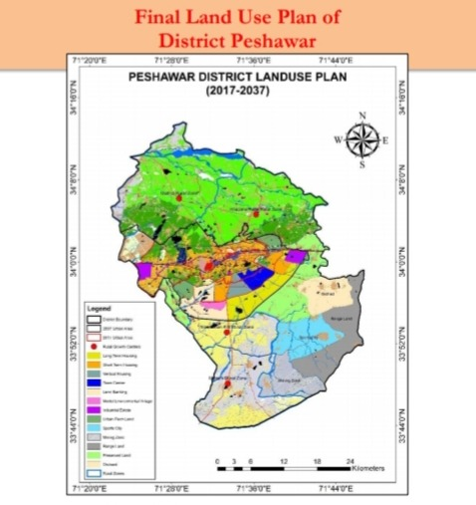
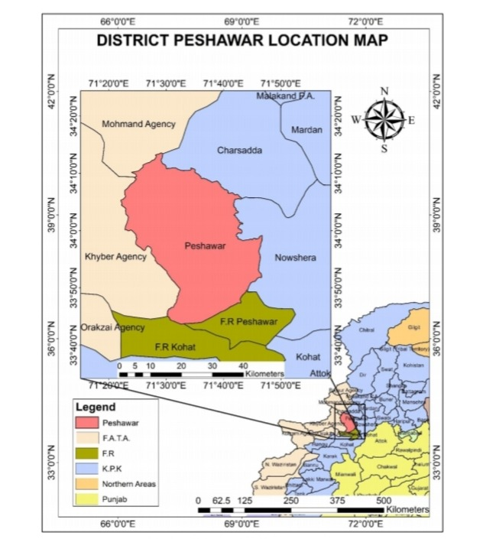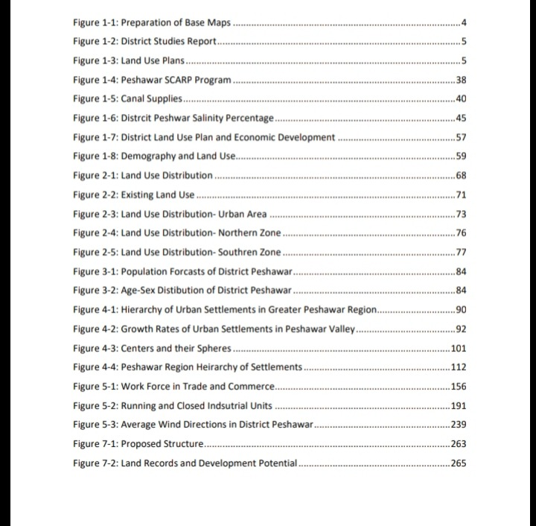

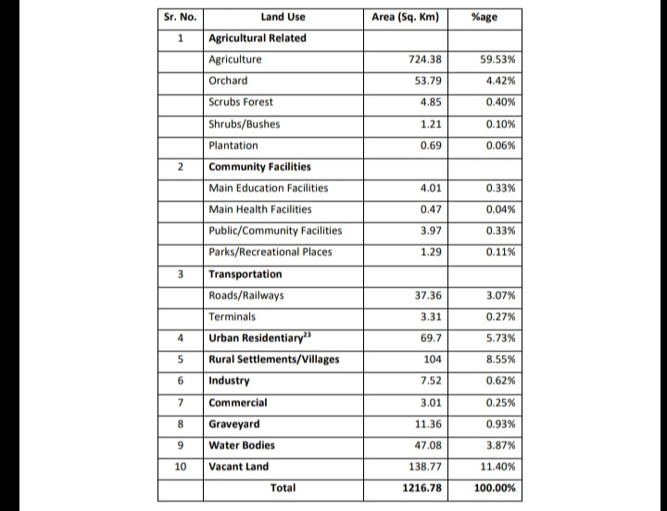
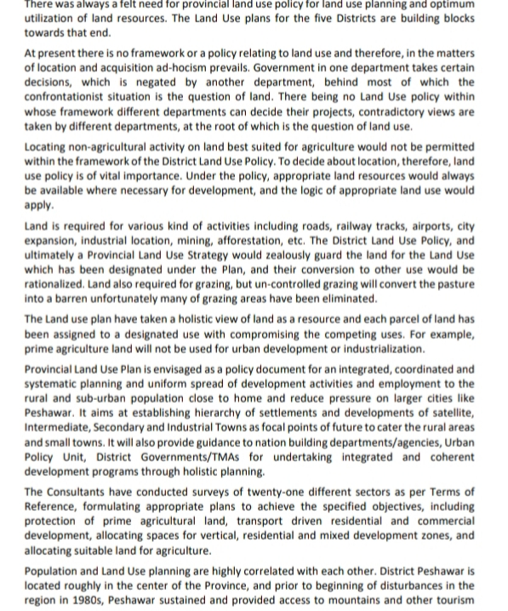

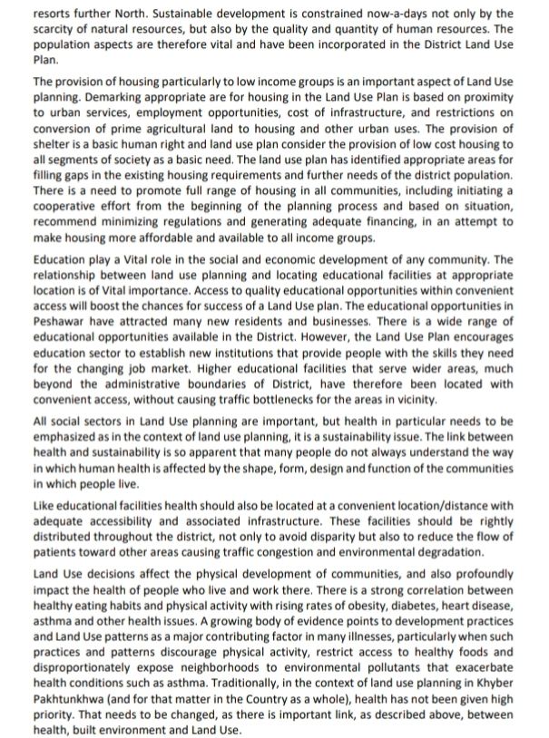

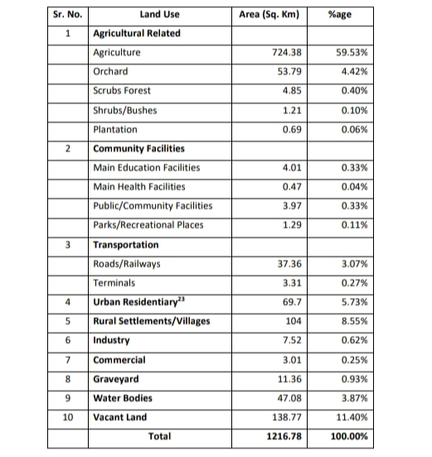
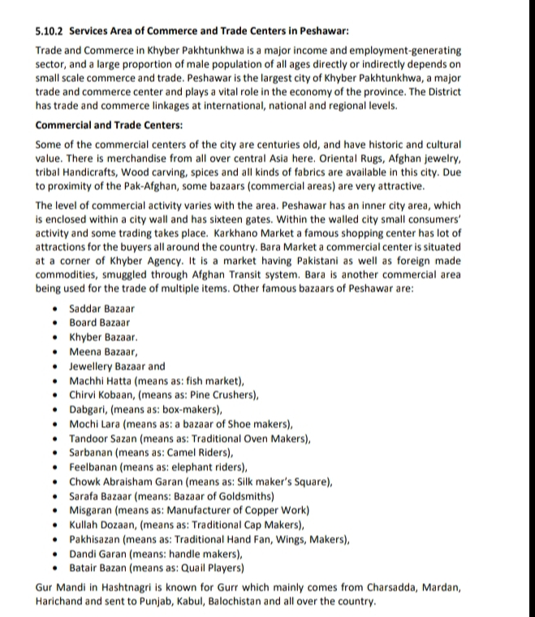
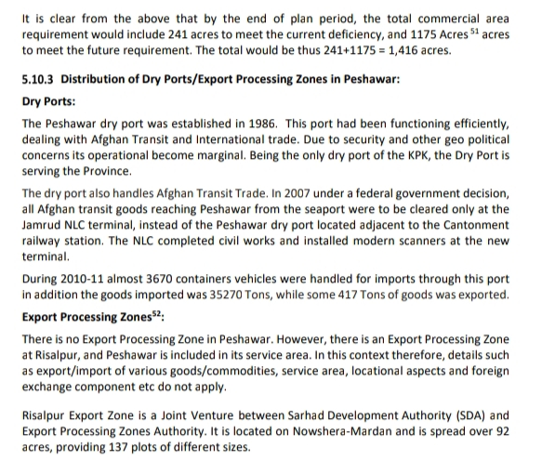

QNo2 :
