IQRA NATIONAL UNIVERSITY
Mid Term Assignment
SUBJECT: Calculus
Name: Muhammad Khan
ID: 16776
Q1: The function g (t) is defined by
g(t) = 0 t < 0
$t^{2}$ 0 ≤ t ≤ 3
2t +3 3 < t ≤ 4
12 t > 4
- State any point of discontinuity
- Find, if they exist
- $\lim_{t→3}{g}$
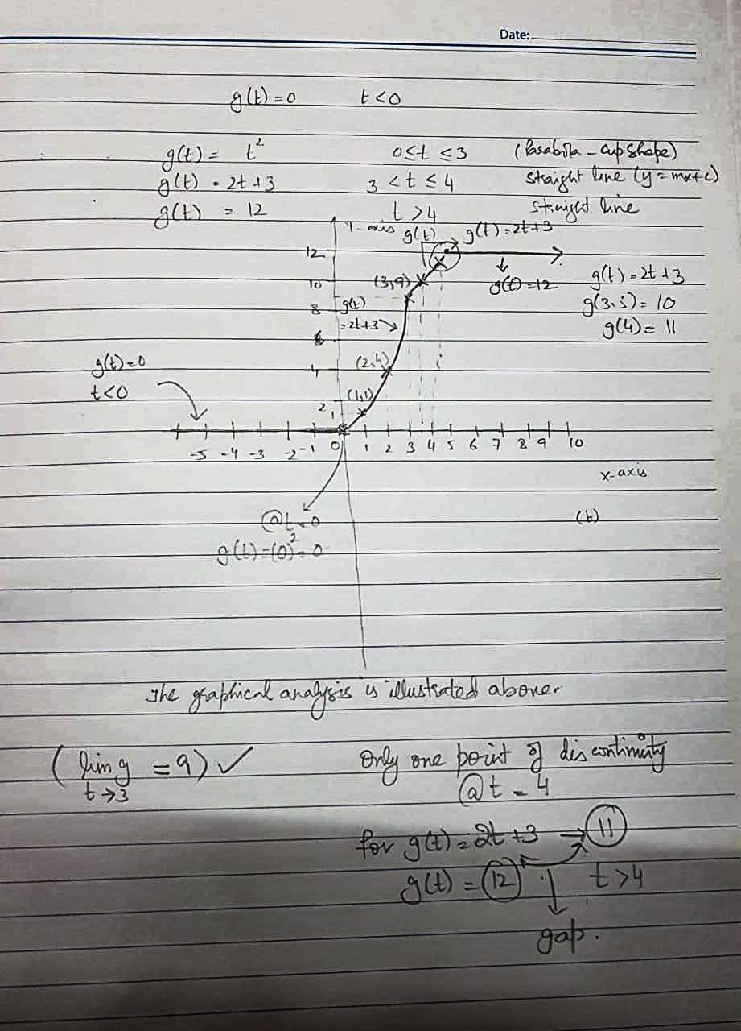

Q2: Find the Maclaurin’s series for
Y(x) = $x^{2}+ \sin{x}$
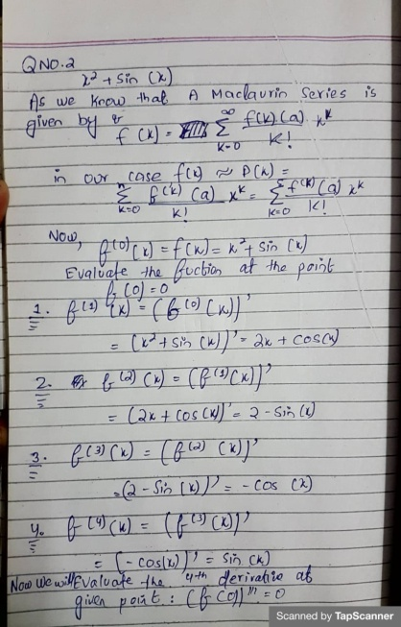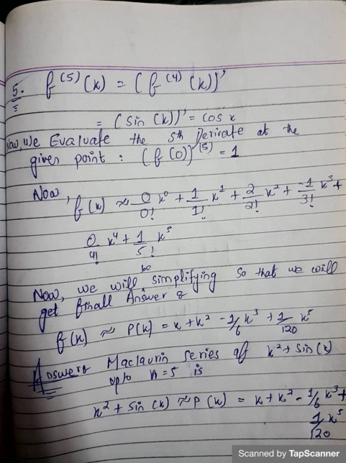

Q3 (a) Find y$''$given
1+xy =$x^{2}+ y^{2}$
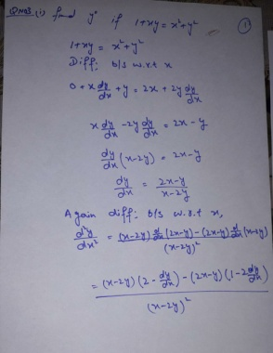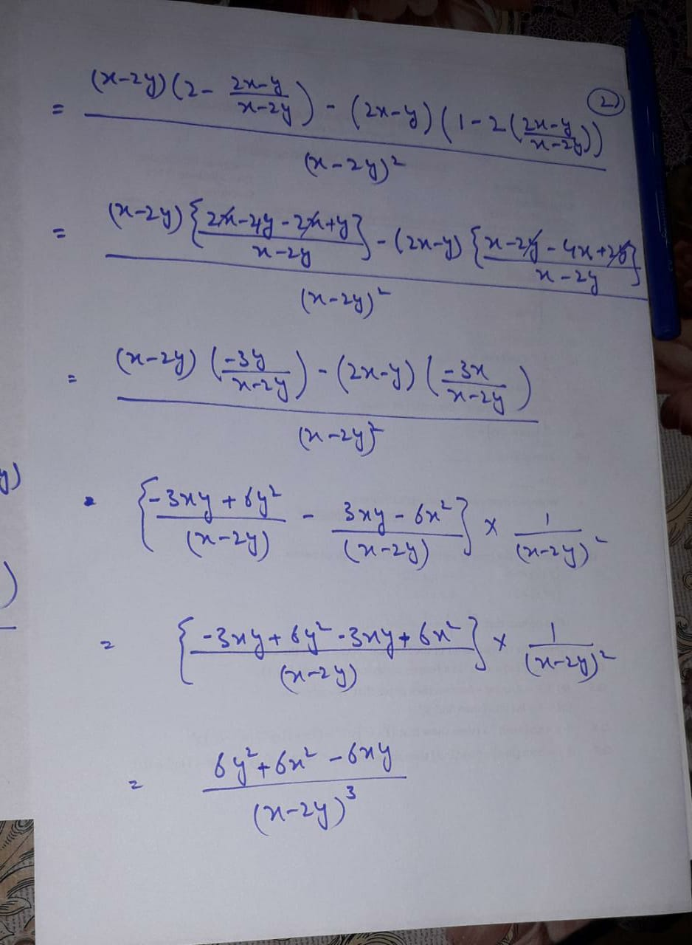

(b) Find $y^{'}$by using logarithmic differentiation
Y = $x^{3}{(1+x)}^{9}e^{6x}$
