RADIOLOGY SEC B PHYSIOLOGY, 2ND SEMESTER
MAM KOUSAR SHAH JEHAN
STUDENT NAME_:MAZHAR UL HAQ___________ , ID___16789__________
SECTION: B bs radiology
Attempt all questions. Every question carry 10 marks.
Q1. Write the functions and composition of blood?
ANS: FUNCTION OF BLODD:
- Blood is type of liquid connective tissue.
- The major function of blood is transport.
- Blood transport nutrients from the digestive tract and storage sites to the rest of the body.
- Blood transport hormones from the glands in which they are produced to their target cell.
- Blood transport oxygen to the cell.
Blood helps to regulate:
- PH by interacting with acids and bases.
- Water balance by transferring water to and from tissues.
COMPOSITION OF BLOOD:
Blood is formed of four main components, plasma , red blood cells, white blood cells, and platlets.
It contains about 55% plasma and 45% blood cells

Q2. What is erythrocyte, erythropoiesis, erythrocytosis and erythropenia?
ANS: ERYTHROCYTE:
- Eryhtrocyte or Red blood cell are the most abundant type of blodd cell.
- Approximately 2.4 millions new erythrocytes are produced per second.
- Approximately a quarter of the cell in the human body are red blod cells.
- The cells develop in the bone marrow and circulate for about 120 days in in the body.
ERYTHROPOIESIS:
- Erythro means “red” and poiesis means “ make”.
- It is the process which produce red blood cells.
- Erythropoiesis takes place in the bone marrow, where hemopoitic cells differentiate and eventually shed their nuclei to become reticulocytes.
- It is stimulated by decreased O2 in circulation, which is detected by the kidney, which then secrect the hormone eryhtroprotein.
- The whole process lasts about 7 days.
ERYTHROCYTOSIS:
- if the erythrocyte count is more than normal, such state is called eryhtrocytosis.
- Primary erythrocytosis is caused by a problem with cells in the bone marrow, where Rbcs are produced.
- Secondary eryhtorcytosis : a disease or the use of use of certain drugs can cause this type.
ERYTHROPENIA:
- A decreased in the number of erythrocytes, associated with anemia.
- Primary erythropenia: Bone marrow disorder
- Secondary erythropenia: due to any kidney disaese

Q3. What is platelets and write about clotting mechanism and its all steps?
ANS: PLATELETS:
Also called thrombocytes are a component of blood whose function id to react to bleeding from blood vessel injury by clumping, thereby initiating a blood clot.
Clotting mechanism: clotting means blood changes from liquid to gel.
Instantly after an injury to the blood vessel which has damage the endothelium lining the vessel. clotting mechanism stop bleeding from damage vessel and maintained hemostasis.
Steps of mechanism:
- Adhesion :
-injury to the blood vessel
-endothelium lining the vessel damage
-underlying collagen exposed to circulating platelets
-platelets binds with the surface receptor of collagen and adhere tightly
-this is adhession

-
-

- Activation:
-platelets change shape
-activated platelets adhere tightly at inury site.
- Aggregation of platlets:
-platelets connect to each other through receptor bridge
-platelets plug formed at injurt site unless the interruption is physically too large.
- Deposit and maturation of fibrin:
-now fibrin deposition start and thus started secondary hemostasis.
-Thus fibrin clot formed
Now clot retraction and platelets inhibition.

Q4. Write a detail note on ABO system?
ANS: blood types are inherited and represent contribution from both parents.
ABO determine someone’s blood type (A, B, AB and O) with + or –or null denoting RhD status.
ABO SYSTEM:
TYPE A: 47%
TYPE B: 9%
TYPE AB: 3%
TYPE O: 47%
ABO blood system was presented by DR. Karl Landsteiner in 1900. This is
- Inherited from parents
- Based on A and B antigen-agglutinogens
- May have
-neither of them
-one of them
-both of them

AGGLUTINOGENS AND AGGLUTINUS:
- Agglutinogens on surface of RBC
- Agglutinins on surface of plasma
- Can cause blood transfusion reaction.

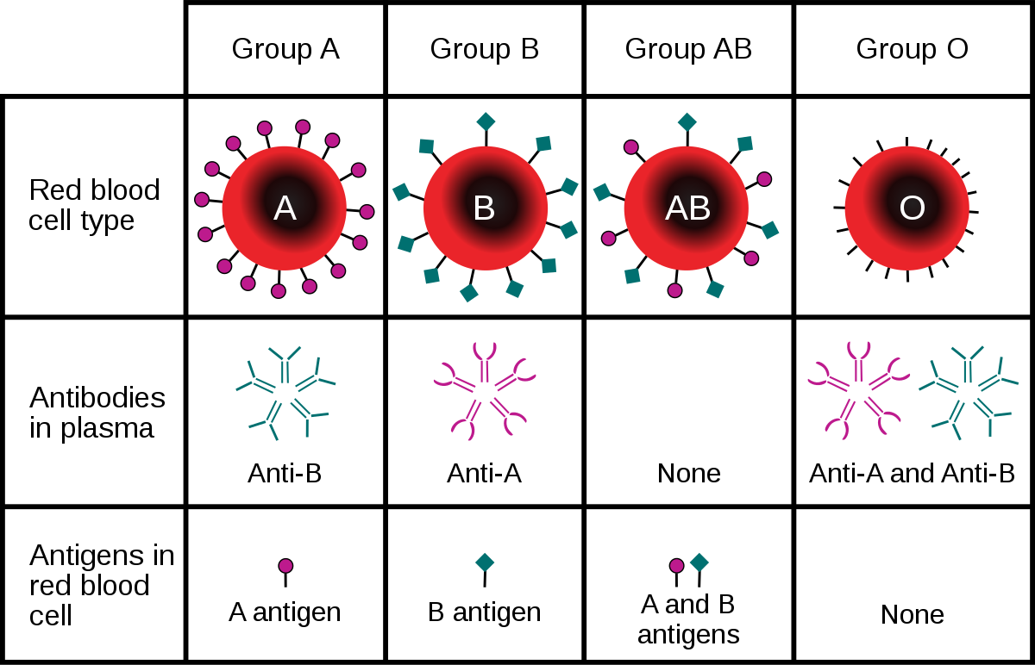

Q5.(i) A person fell down from a tree and become unconscious, with bleeding from head, what will you do as a first aid?
Answer:
- Person should be immobilized .
- Next i will be stop bleeding by place a pack on it.
- I would check his breathing
- I would immediately take him to emergency.

(ii) you have to meet with your friend and you came to know he is covid positive, what precautionary measures will you take?
ANSWER:
Following precautionary measure shall I take:

- First I will take my precautionary measures such using hand sanitizer, wearing gloves , face mask.
- I will immediately inform the hospital for covid 19 patients
- Then I will brief him about the diesese.
- I would advise him not to contact with other members of your family.
- Family memebers if show symptoms show be tested for covid

