IQRA NATIONAL UNIVERSITY
DEPARTMENT ALLIED HEALTH SCIENCE
DPT 4th SEMESTER FALL 2020

TIME 48 HOURS
COURSE ANATOMY
MID TERM
MARKS 30
INSTRUCTOR DR AROBA

NAME BILAL AHMAD
ID 15030

SEACTION A

Select The possible Answers.

- Sub Arachnoid hemorrhage is caused by the rupture of which vessels.
- . Middle meningeal artery..
- .Middle meningeal vein.
- .Cerebral Artery.
- Cerebral veins

Answer. Cerebral artery

2.The superior sagittal sinus is located between the.

A . Inner table of the skull and the endosteal (parietal of the dura.
B . Endosteal (parietal) and the meningeal (visceral) layer of the dura .
C . Meningeal (visceral ) layer of the duraand the arachnoid layer.
D . Arachnoid layer of the pia matter .

ANSWER. Endosteal (parietal)and the meningeal (visceral)layer of the dura.

3.How many poles does a cerebrum has?

. 1 poles
. 2 poles
. 3 poles
. 4 poles

ANSWER. 3 poles

4 . What type of cell present in the fifth layer of the cerebral cortex.

- . Large pyramidal cell
- . Giant pyramidal cell.
- . Betz cell.
- . Both b and c.

ANSWER. Betz cell.

5 . A fetal origin posterior communicating artery arises from the .

- .basilar artery .
- . Middle cerebral artery .
- . Internal carotid artery.
- .vertebral artery.

ANSWER.basilar artery.

6. Regarding sympathetic and parasympathetic nervous system.which of the following is true.

- . Long preganglionic fiber and short postganglionic fiber in SNS.
- . Long preganglionic fibrr and short postganglionic fiber PSNS.
- . Short postganglionic fiber and short postganglionic fiber in SNS.
- . Short preganglionic fiber and long postganglionic fiber in PSNS.
- . Both b and c .
- . Both A and D.

Answer.long preganglionic fiber and short postganglionic fiber PSNS.

7. Sensory information inter the CNS via the dorsal portion. Motor command CNS via the ventral portion.

. True
. False

Answer. True

8. Which of the following regarding taste area is true .

A . Brodmmans area 43.
B . Situated in lower end of post central gyrus in superior wall of lateral salcus insula .
. Both A and B .
.none of them are true .

Answer. Both A and B

9.
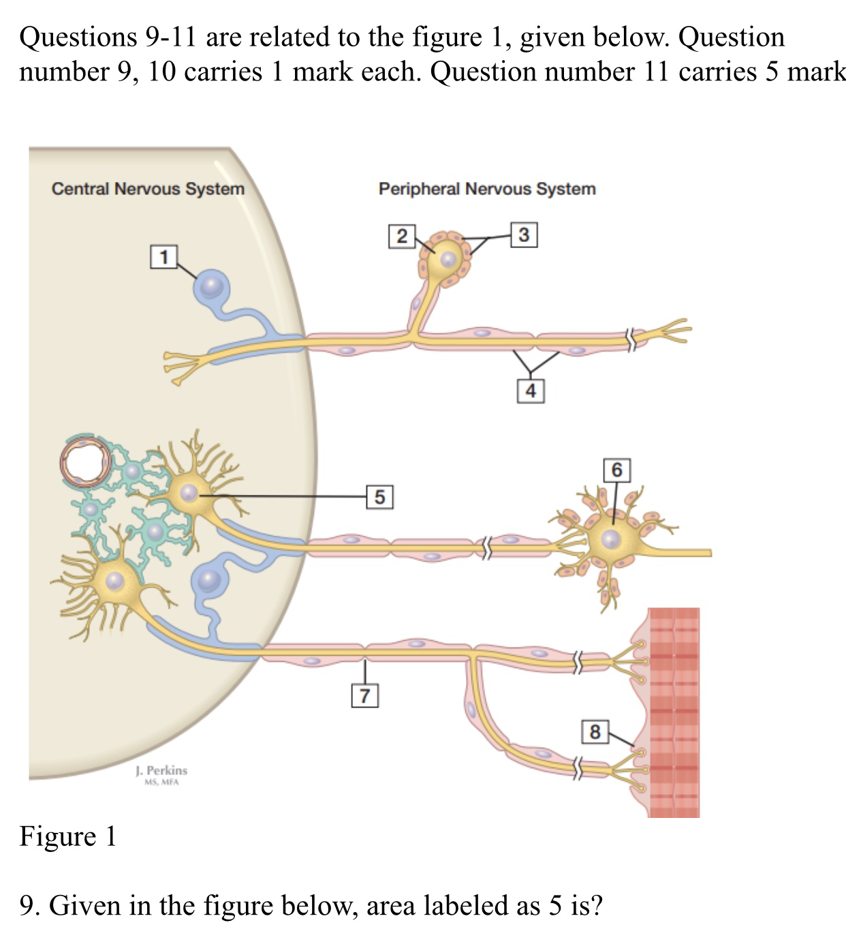

ANSWER . Primary sensory (ganglion) cell body

10 .Giving the figure below area labelled as 6 is ?

A postganglionic autonomic neuron
B preganglionic autonomic neuron
C motor end plate ( nerumuscular junction
D primary sensory ganglion cell body

ANSWER. Postganglionic autonomic neuron.

11. In the figure 1 shown above label the following number.

2 neuron cell body .
3 Glial cell.
4 schwan cell
7 Node of . Ranvier.
8 motor and plate .

SEACTION B

ANSWER THE FOLLOWING QUESTION.ADD DIAGRAM /PICTURE IF NEED.

Question.No 1 osman .a 23 year old boye suffered a traumatic brain injury in the right side orbital lobe. Which side and wich half of the retinal filed sensory input would be lost? Reason why?

Answer.Homonymous hemianopsia ( or Homonymous hemianopsia is hemianopic visuall filled loss in the same side of the both eyes . Homonymous hemianopsia occurs because the right half of the his visual pathway for the left hemifield of both eyes. And the left half of the brain has visual pathways for the right hemifield of the both eyes. When one of these pathway is damaged the corresponding visual field is lost.
Soin this case right side was injured so left side of both eyes visual ability was lost.

QUESTION NO 2 .what are the difference between spinal nerve and cranial nerve.

ANSWER.
Cranial nerve.

1.cranial nerve are the nerve that arises directly from the brain and pass through separate aperture in the skull
2. Comprise 12 nerve pairs.
3. Numbered 1 to 12 .
4 .Distribute in the head and neck and facials regions..
5.my contain sensory/motor/mixed neuron.
6. Involved in vision sence of the smell . Hearing. Sense of taste. And aye movement.
8. From dorsal and ventral roots.

Spinal Nerve.
1.spinal nerve are a series of paired nerves that originated from the nerve roots from the spinal cord of both side.
2 .comprise 31 nerve pair .
3.classified into five group as 8 cervical nerve pairs 12 thoracic nerve pair . 5 lumber nerve pairs.5 sacral nerve pairs . And 1 pair of coccygeal nerve pair.
4 distribution in the skin. Sweet gland.mucosa. Blood vessels . Joint.and skeletal muscle.
5 composed of both sensory and motor neuron.
6 involved in movement . Sensation . And sweet seacretion .
7 do not from dorsal and ventral roots .

QUESTION NO 3 what do you know about the reticular formation of spinal cord .
Answer.reticular formation is the name suggests is the junction of neuron and nerve fiber present in the brain.

Function.
Reticular formation consists of more then 100 small neural network with verified function including the following.
1 reticular activates system control the state of wake fullness and alertnees
2 control of skeletons muscle modulated muscle tone reflex activity.
3 control somatic and visceral sensation .
4 control the automatic nervous system
5 control the vital centre respiratory and and CVS regulatory centre.
Control the endocrine system reticular formation can influence the synthesis in releases of inhibiting hormone thereby control the activity of hypophysis cerebri
7 influences bilogical clooks .
8 pain modulation. The reticular formation is one means by wich pain signal from the lower body reach the cerebral cortex . It is also origion of the descending and analgesic pathway . The nerve fiber in these pathway act in the spinal cord to block the the trasmissione of some pain signal to the brain.

BLOOD SUPPLY.
The reticular formation is derived from the from the branches of the vertebral artery and the basilar artery. Blood supply is the same part of the brain stem containing the reticular formation .

Signature Bilal Ahmad

