NAME Naveed Rahman
ID 14144
Department BS Radiology
Subject Cross sectional anatomy

what is cervical spine ?
The neck is part of a long flexible column, known as the spinal column or backbone, which extends through most of the body. The cervical spine neck region consists of seven bones C1-C7 vertebrae which are separated from one another by intervertebral discs.
Cervical spine mean:
The cervical spine, also known as the neck, is comprised of seven vertebral bodies (C1-C7) that make up the upper most part of the spine. These vertebrae connect the spine to the skull.

The function of the cervical spin:

The cervical spine is delicate—housing the spinal cord that sends messages from the brain to control all aspects of the body—while also remarkably strong and flexible, allowing the neck to move in all directions. The neck is connected to the upper back through a series of seven vertebral segments.

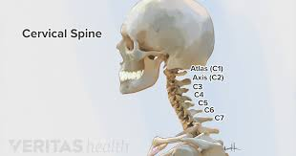

Causes cervical spine pain:

The Cervical Spine and What Can Go Wrong
Ligaments, muscles, and tendons help stabilize and move the cervical spine. The most common cause of neck pain occurs when one of these soft tissues becomes strained or sprained from overuse or overextension. This type of injury typically heals within a week or two.

What are the symptoms of cervical pain?

- Neck stiffness and pain.
- Headache that may originate in the neck.
- Pain in the shoulder or arms.
- Inability to fully turn the head or bend the neck, sometimes interfering with driving.
- Grinding noise or sensation when the neck is turned.

Treatment of cervical spine:
- Nonsteroidal anti-inflammatory drugs. While some types of NSAIDs are available over the counter, you may need prescription-strength versions to relieve the pain and inflammation associated with cervical spondylosis.
- Corticosteroids. ...
- Muscle relaxants. ...
- Anti-seizure medications. ...
- Antidepressants.

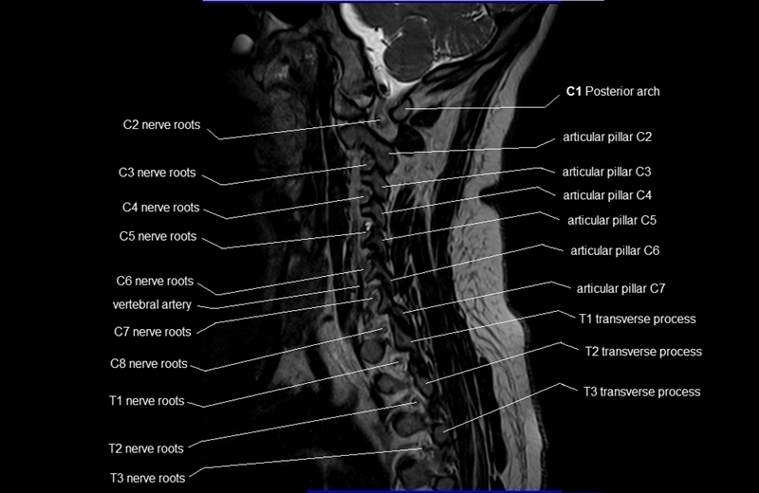
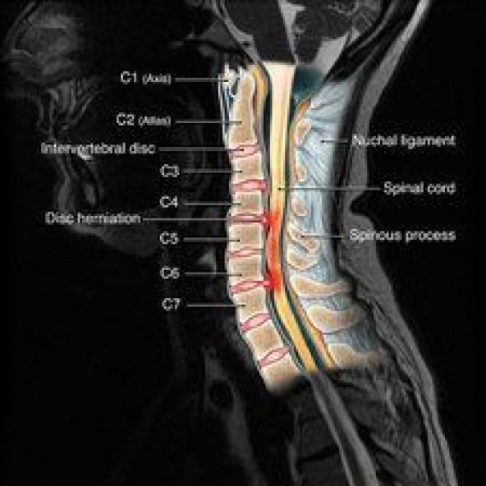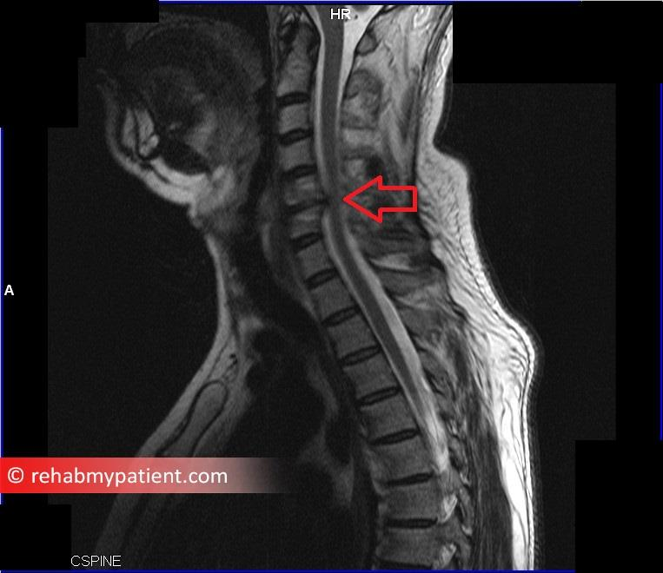

What is thoracic spine?
The section of the spinal column called the thoracic spine begins below the cervical spine (C7, neck), roughly at shoulder level and continues downward until it reaches the first level of the low back (L1, lumbar spine). Twelve vertebrae, numbered T1 through T12 from top to bottom, make up the thoracic spine.
The meaning of thoracic spine:

Thoracic vertebrae are the twelve vertebral segments (T1-T-12) that make up the thoracic spine. These structures have very little motion because they are firmly attached to the ribs and sternum (breastbone).

What are the symptoms of thoracic spine nerve damage?

If any of the thoracic nerves become inflamed, such as from a thoracic herniated disc or a narrowing of the foramen, thoracic radiculopathy can develop with symptoms of pain, tingling, numbness, and/or weakness radiating along the nerve root.

What can cause thoracic back pain?

The most common cause of thoracic back pain is inflammation of the muscles or soft tissues of the thoracic spine. This inflammation can occur for a number of reasons: A sudden sprain or strain (as in car accidents or sports injuries). Sitting or standing in a slouched position over time.

How is thoracic back pain treated?

Because pain in the thoracic region is often caused by muscle tension and poor posture, initial treatment efforts focus on relieving the tension with stretching, massage, and over-the-counter medications such as acetaminophen or ibuprofen. Heat and/or ice therapy can help reduce muscle pain and stiffness as well.

cross section important:

Geologic maps are important tools for understanding geologic structures. They also help geologists find important economic minerals and avoid hazards. ... Cross sections show the geology of a vertical plane below the earth's surface. Cross sections are valuable tools for visualizing structures
.
MRI scans can take from 30 minutes to an hour or more, depending on how much of your spine is being scanned. After a spine MRI, you can go back to your normal activities right away.
The pain may increase with certain positions or movements of the neck. Thoracic spine — Symptoms of a thoracic disc herniation can be comprised of posterior chest pain radiating around one or both sides of the rib cage. Such pain is usually triggered by physical exertion and can even be caused by taking a deep breath.

Thoracic back pain is pain that occurs in the thoracic spine. The thoracic spine is located at the back of the chest (the thorax), mostly between the shoulder blades. It extends from the bottom of the neck to the start of the lumbar spine, roughly at the level of the waist.

Certain sleeping positions can help ease your back pain, so find one that is most comfortable for you. Try sleeping with a pillow between or underneath your legs for extra support. If you sleep on your side, put the pillow between your knees and draw them up slightly toward your chest.
