- Property No. 3:
If k is subgroups of the data consisting of n₁,n₂,…., nk observation have representative means $\overline{x}, \overline{x},…..\overline{x}K$
Then

- Property No. 4:
If $yi=a+bi$, a and b are any two number then $\overline{y}=ab\overline{x}$
Proof:

Geometric Mean:
It is a statistical concept which is used to find the measurement of central tendency. It is denoted by G.M.
It can be define as the product of n values “X1, X_{2,} X_{3,}……X_{n} “and nth root of this product is called geometric Mean.
It means G.m is the anti- Logarithm of the A.M of the logarithm of the values themselves.
Mathematically it can be written as:

Harmonic Mean:
It is denoted by H.M. it can define the reciprocal of A.M and the reciprocal of the values is called Harmonic Mean.
Mathematically it can be written:

Note: When the caules are expressed as “x” per “y” and “x” is constant, the H.M is required, but if “y” is constant, then A.M is required.
Median:
It is the statistical concept which is used to find the location or position of the value / data in a group of values / data.
Median can be define” as that median divides a group of ordered data into two equal parts. One part is larger than the middle values and the other part is smaller than the middle values”.
OR
Median divides a group of ordered data into two equal parts, 50% of the data are above the middle values and 50% are below the middle values
The median is calculated for discrete or ungrouped frequency distribution by forming a cumulative frequency distribution.
For frequency distribution the median is a value on horizontal scale through which a vertical line divides the histogram of the distribution into two parts. The values lies in a certain group is called median group
Mathematically it is written as:

Mode:
It is a French word which means Fashion.
“The most represented values in a group of data is called mode.”
OR
“The values which appears maximum times in a group of data is called mode.”
Sometimes the data have more than one mode and sometimes the data have no mode.
Mathematically it can written as;

For grouped frequency distribution the mode would lies in the class that carries the highest frequency, this class is called model class. A distribution has a single mode is called unimodal distribution, while a distribution with two or more modes is called bimodal or multimodal distribution.
MERITS AND DEMERITS
Arithmetic Mean:
Merits:
- It is rigidly defined.
- It is easy to calculated and simple to understand.
- It is based on all observation.
- It is determined for almost every kind of data.
- It is finite and not indefinite.
- It is ready put to algebraic treatment.
- It is least affected by fluctuation of sampling.
Demerits:
- The A.M is highly affected by extreme values.
- It cannot average the rates and percentage property.
- It is not an appropriate average for highly skewed distributions.
- It cannot be computed accurately if a item is missing.
- The mean sometimes does not describe weight any of the observed values.
Harmonic Mean:
Merits:
- It is based on all observation.
- It cannot be much affected by the fluctuation of sampling.
- It is capable of algebraic treatment.
- It is an appropriate average for averaging ratios and rates.
- It does not give much weight to the larger items.
Demerits:
- Its calculation is difficult.
- It gives high weight-age to the small items.
- It cannot be calculated if anyone the item is zero.
- It is usually a value which does not exist in the given data.
Geometric Mean:
Merits:
- It is rigidly defined and its value is a precise figure.
- It is based on all observation.
- It is capable of further algebraic treatment.
- It is not much affected by fluctuation of sampling.
- It is not affected by extreme values.
Demerits:
- It cannot be calculated if any one of the observation is negative or zero.
- Its calculation is rather difficult.
- It is not easy to understand.
- It may not coincide with any of the observation.
Median:
Merits:
- It is easily calculated and understood.
- It is located even when the values are not capable of quantitative measurement.
- It is not affected by extreme values. It can be computed even when a frequency distribution involves “open-end” classes like those of income and price.
- In a highly skewed distribution, median is an appropriate average to use.
Demerits:
- It is not rigorously defined
- It is not capable of lending itself to further statistical treatment.
- It necessitates the arrangement of data into an array which can be tedious and time consuming for a large body of data.
Mode:
Merits:
- It is simply defined and easily calculated. In many cases, it is extremely easy to locate the mode.
- It is not affected by abnormally large or small observation.
- It can be determined for both the quantitative and the qualitative data.
Demerits:
- It is not rigorously defined.
- It is often indeterminate and indefinite.
- It is not based on the entire observation.
- It is not capable of lending itself to further statistical treatment.
- When the distribution consists of a small number of values, the mode may not exist.
Examples
Q. the marks obtained by 9 students are given below:
45, 32, 37, 46, 39, 41, 48, 36.
Calculate Arithmetic Mean.
Solution

= 40 marks
It is relevant to not, that, if these marks represent the entire set of observations for the population, the above calculation gives the population mean i.e µ would be equal to 40 marks.
Q. Calculate the weighted mean from the following data.

Solution:
We calculated the weighted mean:

Q. the mean heights and the number of students in three section of a statistics class are given.

Example:
Calculate the mean weight of apples from the data given in Example 2.2 (in the book) directly from the observed values and from the data grouped into frequency distribution.

Solution:
Calculation based on ungrouped data;
We calculated the mean weight directly from all the observed values which add to 7324.
( the 2nd column consist of subtotal of actual observation in any class)

This is the exact mean of the given data.
Next, we find the mean weight, by multiplying the actual mean of the observations in any class by the corresponding frequency, adding the products and then dividing by n (column 5).
Thus;

It should be noted that the numerical value calculated from the frequency distribution is slightly different from the value obtained directly from the ungrouped data.
Example:
Given the following frequency distribution of weight. Calculate the mean weight by short method.

Example:
Find the geometric mean of 45, 32, 37, 46, 39, 36, 41, 48, and 36.
Solution:
The geometric mean, G is calculated as

Example: Given the following frequency distribution of weights, calculate the geometric mean.
Weight in Grams | 65 – 84 | 85 – 104 | 105 – 124 | 125 – 144 | 145 – 164 | 165 – 184 | 185 – 204
F | 9 | 10 | 17 | 10 | 5 | 4 | 5

Example:
Find the harmonic mean from the following frequency distribution of weight.
Weight in Grams | 65 – 84 | 85 – 104 | 105 – 124 | 125 – 144 | 145 – 164 | 165 – 184 | 185 – 204
F | 9 | 10 | 17 | 10 | 5 | 4 | 5
Solution:
Example:
Compute the Geometric and Harmonic Means for the following distribution of annual death rates.
x | 3.95 | 4.95 | 5.95 | 6.95 | 7 .95 | 8.95 | 9.95 | 10.95 | 11.95 | 12.95 | 13.95
f | 1 | 4 | 5 | 13 | 12 | 19 | 13 | 10 | 6 | 4 | 1

We Can construct the following table to compute the geometric and harmonic Mean.

Example: Given below are the marks obtained by 9 students.
45, 32, 37, 46, 39, 36, 41, 48, and 36
Find the median and the quartiles.
To find the median and the quartiles, we first arrange the marks in order from lowest to highest.
The ordered marks are.
32, 36, 36, 37, 39, 41, 45, 46, 48

Example:
Find the median, the quartiles and the 8th decile for the distribution of examination marks given below.
Marks | 30-39 | 40-49 | 50-59 | 60-69 | 70-79 | 80-89 | 90-99
Number of students | 8 | 87 | 190 | 304 | 211 | 85 | 20

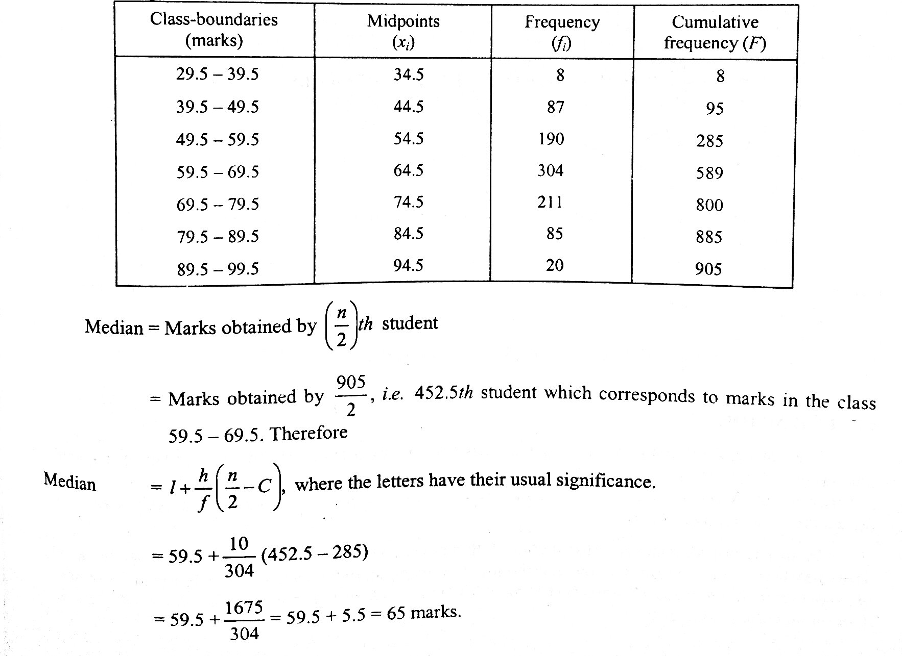
Solution:

