Name: warda
ID:16101
Dpt 2nd semester section B:
Biomechanics assignment;
- Question:1;
- Answer;
- Biomechanics of articular cartilage:
Articular cartilage:
A thin, dense ,translucent,white connective tissue known as hyline articular cartilage covers the ends of bones of synovial or diarthrodial joint.
- Articular cartilage is avascular connective tissue(devoid of blood vessels ,lymphatic channels and neurologic innervation.
- Its cellular density is less than that of any other tissue.
Functions of articular cartilage:
1: To distribute joint load over a wide area thuss decreasing the stress sustained by the contacting joint surface.
2: To allow relative movement of the opposing joint surfaces with minimal friction and wear.
- Structure and composition of articular cartilage:
It is composed of dense extracellular matrix (ECM) with a sparse distribution of highly specialized cells called chondrocytes.
Extracellular matrix (ECM):
It is principally composed of water ,collagen and Proteoglycan with other noncollagenous proteins and glycoproteins present in lesser amounts. These structural components together with water determine the biomechanical behavior of this tissue.
Chondrocytes :
- The chondrocytes is the residents cell type in articular cartilage .These are highly specialized, metabolically active cells that play a unique role in the development, maintenance and repair of ECM.
- Each chondrocytes establishes a specialized microenvironment and is reponsible for the turnover of the ECM is the immediate vicinity .
- Unfortunately chondrocytes have limited potential for replication ,a factor that contributes to the limited intrinsic healing capacity of the cartilage in response to injury.
- Its survival depends on an optimal chemical and mechanical environment.

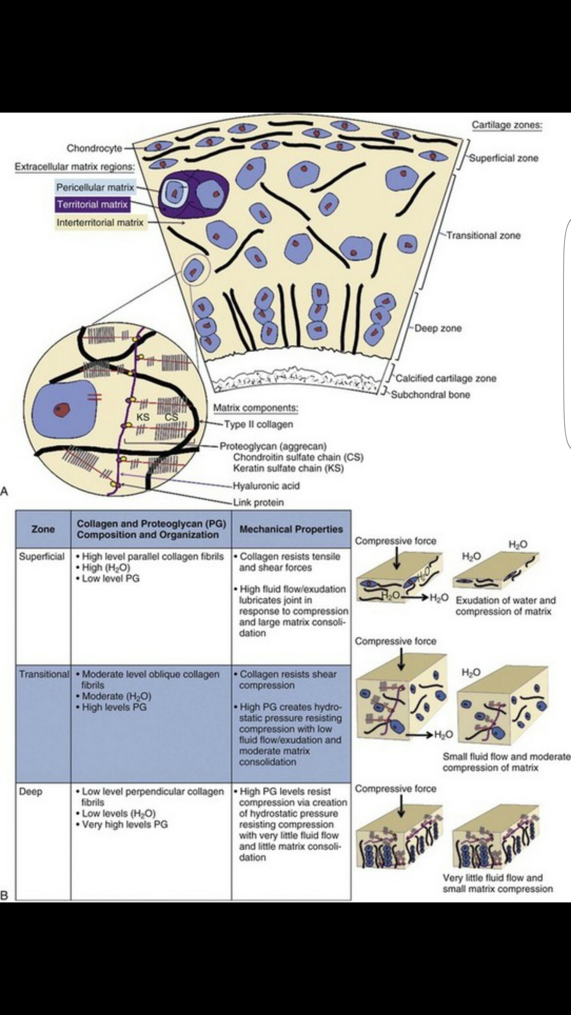
Biomechanical behaviour of articular cartilage:
During joint Articulation forces at the joint surface may vary from almost zero to more than ten times body weight .it is estimated that peak contact stress may reach to 20Mpa in the hip while rising from the chair .thus articular cartilage under physiological loading condition is a highly stressed material.
To understand load carrying mechanism within ECM,its intrinsic mechanical properties compression, shear and tension must be determined. The following subsections will characterize the tissue behavior under these loading modalities .
- Nature of articular cartilage viscoelasticity.
- Biphasic creep response of articular cartilage in compression
- Biphasic stress relaxation response of articular cartilage in compression.
- Permeability of articular cartilage
- Behaviour of articular cartilage in pure shear.
- Swealling behaviour of articular cartilage.
- Lubrication of articular cartilage.

Biomechanics of articular cartilage degeneration:
Articular cartilage has only a limited capacity for repair and regeneration and if subjected to abnormal range of stresses can quickly undergo total failure. Following factors are related to failur of articular cartilage;
- The magnitude of imposed stress.
- The total number of sustained stress peaks .
- The change in the intrinsic molecular and microscopic structure of collagen-PG matrix.
- The changes in intrinsic mechanical properties of tissue.

Summary:
Articular cartilage is the highly specialized connective tissue of diarthrodial joints its principal functions is to provide a smooth ,lubricated surface for articulation and to facilitate the transmission of loads with a low frictional co-efficient . The mechanical behavior of this tissue depends on the interaction of its fluids and solid components.
..................................................................................

Question 2:
Answer:
Biomechanic of Tendons and ligaments:
- Introduction to ligaments:
- Ligaments connects bone to bone
- Ligaments consists mostly of bundle of elastin molecules formed into elastic fibre with some bundle of collagen.
- Origins and insert in bone.
- More elastic and flexible than tendon.
- Offer less tensile stress.

- Introduction to Tendon:
- Tendons connects muscle to bone.
- Tendon consist of bundle of collagenous fibres arrange in parallel. They are arranged in this way to form cords which have great tensile strength.
- Origins at muscles,crosses atleast one joint and insert in bone.

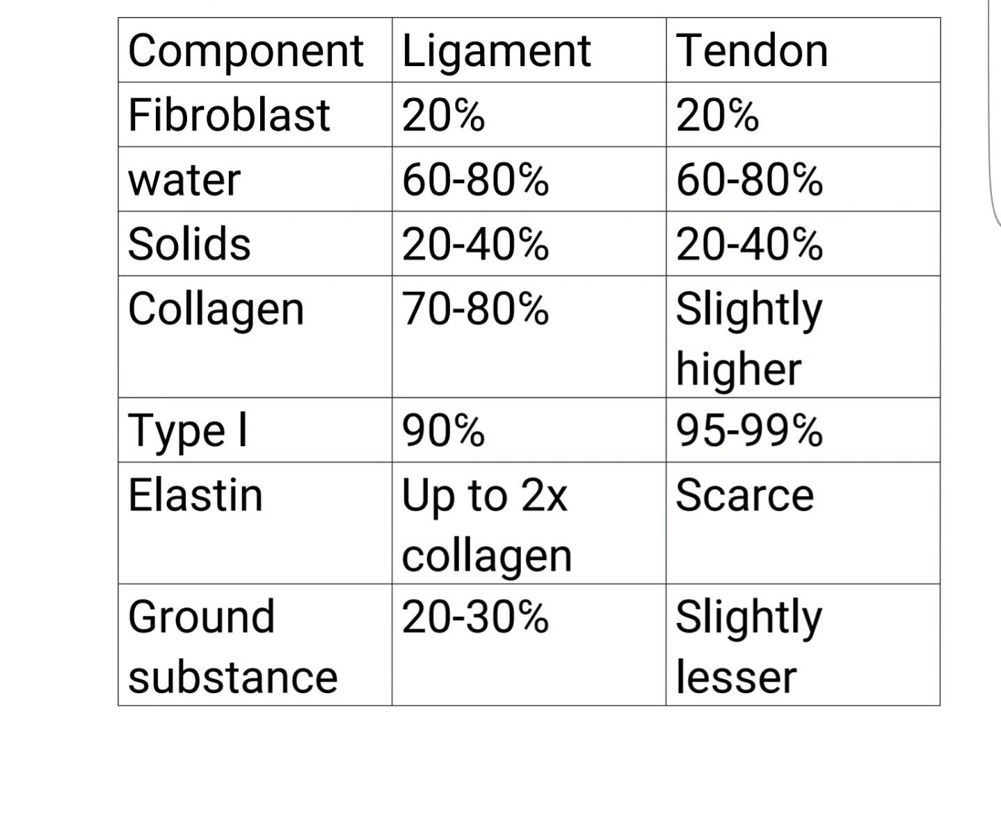
- Composition:
Functions:
- Tendon:
- Tendon carry tensile forces from muscles to bone.
- They facilitates skeletal muscle movement (movement in joints).
- They carry compressive forces when wrapped around bone like a pulley.
- Secondary function storage of energy.

- Ligaments:
- Ligaments corrects bone and joint geometry.
- Ligaments + associated joint capsule combinely functions as passive joint stabilizer.
- Secondary function, proprioception.

- Injuries in ligaments and tendons;
- Most common injuries of tendon and ligament occur by over use and high load /stress .
- The Tendons which suffers high chances of Injuries are ;
- 1) Rotator cuff tendons (shoulder).
- 2) Achilles tendon (leg)
- 3) flexor tendon (hand).

*The ligaments which suffers high chances of injuries are;
- Anterior cruciate ligament (knee)
- Ankle ligaments (calcaneofibolar, anterior talofibular,Deltoid )

- Factors that affect the biomechanical properties of ligaments and tendons:

- Aging
- Diabetes mellitus
- Renal diseases
- Connective tissue disorder
- Pharmacologic agents (steroids,floroquinolones,NSAIDs).

******************************

