Name: Muhammad Huzaifa
DPT 2nd Semester
ID No # 16455
Assignment: Biomechanics & Ergonomics
Submitted To: Dr.Shahzeb

Q1: Explain “Biomechanics of Articular cartilage”.
Answer:
Biomechanics of Articular cartilage:

Introduction:
- Articular cartilage is found in synovial joints.
- Articular cartilage functions:
- It increases the load distribution area.
- It allow movement while reducing friction and wear.

Articular cartilage Composition:
- Articular cartilage is multiphasic.
- Matrix of collagen and proteoglycan (25%).
- Free interstitial fluid (75%).
- Ion phase.

Biomechanical Behaviour Of Articular Cartilage:

- Cartilage treated as a biphasic material with
- Interstitial fluid phase.
- Porous-permeable solid phase.
- Cartilage is highly stressed material.
- To understand cartilage response to stress
- Intrinsic mechanical properties must be determined.
- Compression,tension and shear are considered.
- Intrinsic material properties and resistance to flow of solid matrix define interstitial fluid pressurization.
- Interstitial fluid pressurization influences
- Load bearing capacity.
- Lubrication capacity.

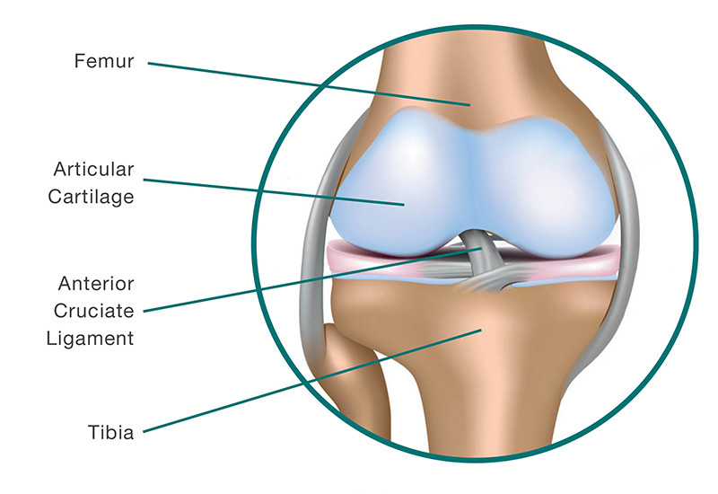

Q2: Explain “Biomechanics of Tendon and Ligament”
Answer:
Biomechanics Of Ligaments:
- Ligaments are viscoelastic structures with unique mechanical properties.
- The ligaments are plaint and flexible.
- Allowing natural movements of bones to which they attach, but are strong and in-extensible so as to offer suitable resistance to applied forces.
- Sustain chiefly tensile load during normal and excessive load.
- When injury happens, the degree of damage is related to the rate of loading as well as the amount of load.

Factor That Effect The Biomechanical Properties Of Ligaments And Tendons:

- Maturation and aging .
- Pregnancy.
- Mobilization and immobilization.
- Diabetes mellitus .
- Non steroidal anti – inflammatory drugs .
- Comorbidities .

Biomechanics of Tendon :
- Tendon is a highly organized connective tissue joining muscle to bone, capable of resisting high tensile forces while transmitting forces from muscle to bone.
- The dense, regularly arranged collagenous tissue is made up of fibers, cells of various shapes and ground substance.
- The mechanical and physiological characteristics of collagen (nearly 85% of the dry weight of tendon) dictate the qualities of tendon.
- In addition, tendon is flexible so that it can bend at joints, as well as acting as a damping tissue to absorb shock and limit potential damage to muscle.
- Tendon also shows a degree of flexibility. If the strain used to stretch a tendon could be recovered, a beneficial elastic effect would be achieved. Muscles lengthen and shorten in a cyclical manner. During the lengthening period, elastic energy can be stored and used as elastic recoil.
- For example:
- The Achilles tendon is stretched late in the stance phase as the triceps surae muscles contract and the ankle dorsiflexes.
- Prior to plantarflexion, muscle activation ceases and stored energy helps to initiate planter flexion.

Biomechanical Effects:
- Exercise strengthens tendons.
- Immobilisation has detrimental effects.
- Tensile strength decrease with age.
- Strength varies with hydration,PH & temperature.

