Grand Assignment

Course Title: Biomechanics And Ergonomics I
DPT 2nd semester section B
Instructor: Dr. M .Shahzeb khan (PT)
Marks: 20 NAME # SHAMA , ID # 16714

Note:
INTERNAL ASSESSMENT MARKS WILL BE GIVEN ON BASIS OF GRAND ASSIGNMENT

Q1: Explain “Biomechanics of Articular cartilage”

Q2: Explain “Biomechanics of Tendon and Ligament”

ALL THE STUDENTS ARE REQUESTED TO UPLOAD YOUR ASSINGMENT BEFORE FINAL TERM EXAM.

QUESTION # 1 ANSWER
BIOMECHANICS OF ARTICULAR CARTILAGE#
IMPORTANCE #
> Structure and mechanical properties of normal cartilage.
> Manner by which biomechanical and structural factors
Contribute to the material properties of cartilage.
> Manner by which changes in tissue composition affect the
Mechanical properties of cartilage.

FUNCTION OF ARTICULAR CARTILAGE#
> Distribute join loads over a wide area, decreasing the stresses
Sustained by the contacting joint surface.
> Allow relative movement of the opposing joint surface with
minimal friction and wear.
> Minimize peak stess on subchondral bone.
> Surface roll or slide during moton.
> Provide a friction co efficient of 0.0025.
> Function within a contact pressure range of 2.11Mpa
> Despite comman belief doesn't serve as a " shock absorber "
* Very thin.
* Capacity negligible composed to muscle and bone.

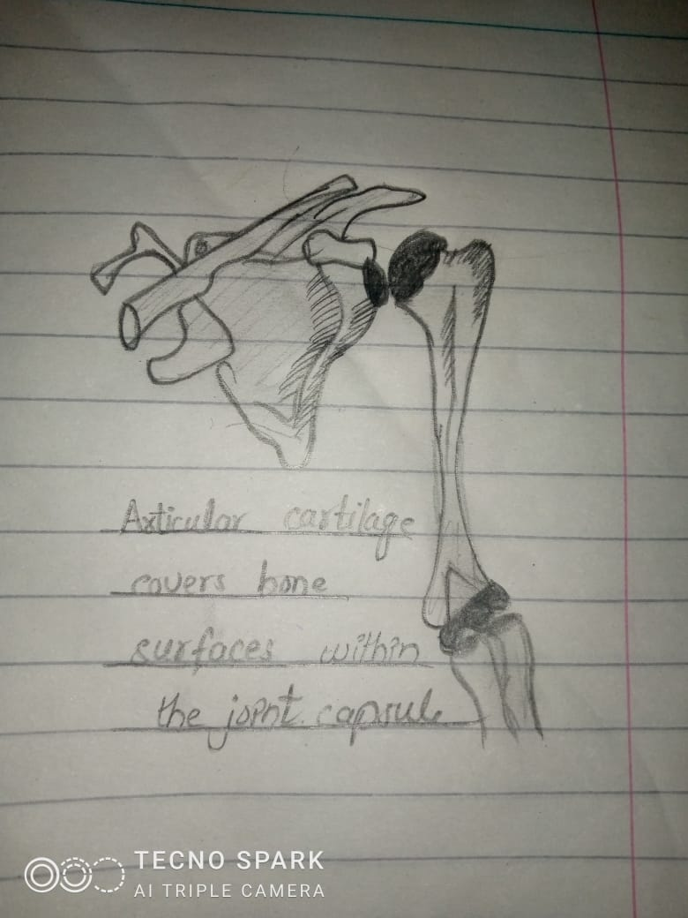

NORMAL CARTILAGE #
*. Avascular
* Alymphatic
* Aneural tissue

TYPE OF CARTILAGE #
1.HYALINE #
Appearance # Glassy , smooth
Location # be cover long bone , growth plates.
2 FIBRO #
Appearance # Dence
Location. # lnterverteberal disk , mensicus .
3. ElASTIC #
Appearance # yellow , opaque
Location #. Epiglottis , eustachian tube.

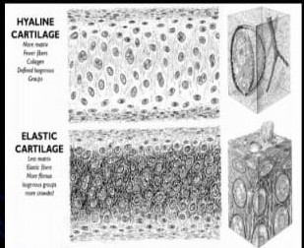

THICKNESS OF ARTICULAR CARTILAGE #
> Varies with the particulars joint ,and the location within the
joint.
> Range from 0.5 mm (rabbit knee ) to 10.0 mm ( pf groove of
bovine knee) .
> Human over ends of femur and tibia ( range 2_4 mm ).
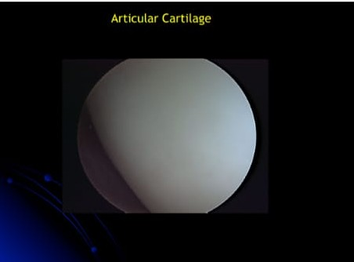

COMPOSITION AND STRUCTURE OF ARTICULAR CARTILAGE #
> CHONDROCYTES # 10%
> COLLAGEN # ( fibrous ultrastructure , procollagen
Pollypeptide ) , 10 - 30 % .
> PROTEOGLYCAN # large protein polysaccharide molecules
( In form of monomer and aggregates 3 - 10%
> WATER # inorganic salts , glycoproteins, lipids , za 60- 87%.

.

QUESTION # 2 ANSWER

BIOMECHANICS OF TENDONS AND LIGAMENTS #
INTRODUCTION #
TENDONS #
Tendon connect muscle to bone.
> Tendon consists of bundle of collagenous fibers arrange in parallel . They
are arranged this way to form cords which have great tensile strength .
> Origins at muscles , crosses at least one joint and insert in bone.

LIGAMENT #
" Ligament connect bone to bone "
> Ligaments consists mostly of bundles of elastic molecules formed into
elastic fiber with some bundle of collagen.
> Origins and insert in bone .
> More elastic and flexible than tendon .
> Offer less tensile strength.

COMPOSITION #

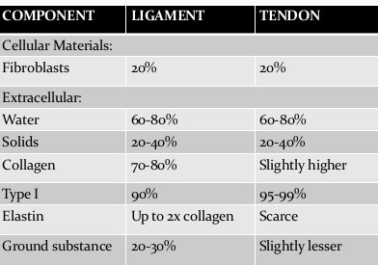

ANATOMICAL POSITION OF TENDONS #
> TENDONS #
* ANATOMY :
1 . Tendons contain collagen fibrils ( type 1 )
2. Tendon contain a proteoglycan matrix .
3. Tendons contain fibroblasts ( biological cell ) that are arranged
In parallel brows.
TYPE 1 COLLAGEN #
1 . - 86% of tendon dry weight .
2 . Glycine ( - 33% ) .
3. Proline ( - 15% ) .
4 . Hydroxyproline ( - 15% ) almost unique to
collagen , often used to identify.

ANATOMICAL POSITION OF LIGAMENTS
LIGAMENT #
> ANATOMY #
1. Similar to tendon in hierarchical structure .
2. Collagen fibrils are slightly less in volume fraction and organization than tendon

3. Higher percentage of proteoglycan matrix than tendon.
4. Fibroblasts.
FUNCTIONS #
> TENDON#
* Tendon carry tensile force from muscle to bone.
* They carry compressive forces when wrapped around bone like
a pulley.
* They facilitate skeletal muscle movement but
* Proprioception .
*. Secondary function : storage of energy .
> LIGAMENT #
* It's maintain correct bone and joint geometry .
* Ligament + associated joint capsule combine
Passive joint stabilizer.
* Secondary function : Proprioception.
MECHANICALLY MEDIATED LIGAMENT AND TENDON #
# In ligaments and tendons there is less likely to occur change in
Mechanical stiffness because of low vascular supply .
# But the im mobilization of a joint for a long time leads to severe change in the characteristics of ligament band tendons.
# For this an experiment on the rabbits knee was carried out to check the effects.
INJURIES IN TENDONS AND LIGAMENTS #
* Most common tendon and ligaments injuries occur by over use and high loads/ stress given to the tendons .
* The tendon which suffer high chances of injuries are :
1. Rotator cuff tendons ( shoulder )
2. Achilles tendon ( leg)
3. Flexor tendons ( hand )
* The ligament which suffer high chances of injuries are :
1. Anterior cruciate ligament ( knee)
2 . Ankle ligament ( calcaneofibolar , Anterior talofibular , Deltoid.)

MECHANICAL AFFECTS ON HEALING TENDON/ LIGAMENT #
# ligament and repair are very critical area of orthopedic surgery , especially
In the sports medicine.
# In case of tendon , which glide within a sheath the introduction of passive
Motion for healing and repaired tendons is believed to be important
Because it prevents the adhesion between the sheath and tendons that
Restrict motion .
#. In case of ligament the relation between the mobilization and repair is not
Positive.
# Type of hyaline cartilage covers the bone ends and makes smooth movements possible .

# It's distribute the load across joint , minimizing the peak stess on subchondral bone.

THE END🙂

.

