Subject: Discrete Structure
Instructor: Saifullah Jan
___________________________MAJOR Assignment Spring 2019________________________
Note: Attempt this assignment on a paper clearing mentioning your Name, ID NO, Class timing (Monday / Wednesday) at the top of answer sheet. Once complete than take a picture of your answer sheet, convert pictures to pdf. (Make one pdf file) and upload it to sic.

Q 1: What is a Recurrence Relation? And explain Repeated Substitution Method with the help of an example.
Q 2: Consider
Premises: If there was a ball game, then traveling was difficult. If they arrived on time, then traveling was not difficult. They arrived on time.
Conclusion: There was no ball game.
Determine whether the conclusion follows logically from the premises. Explain by representing the statements symbolically and using rules of inference.
Q 3: Consider
Premises: If Claghorn has wide support, then he'll be asked to run for the senate. If Claghorn yells “Eureka" in Iowa, he will not be asked to run for the senate. Claghorn yells “Eureka" in Iowa.
Conclusion: Claghorn does not have wide support.
Determine whether the conclusion follows logically from the premises. Explain by representing the statements symbolically and using rules of inference.
Q 4: Write a detail note on Pigeon hole principle. Give an example
Q 5: The lights in a classroom are controlled by two switches: one at the back and one at the front of the room. Moving either switch to the opposite position turns the lights off if they are on and on if they are off. Assume the lights have been installed so that when both switches are in the down position, the lights are off. Design a circuit to control the switches.
Q 6: An alarm system has three different control panels in three different locations. To enable the system, switches in at least two of the panels must be in the on position. If fewer than two are in the on position, the system is disabled. Design a circuit to control the switches.
Q 7: Give the output signals for the circuit.
- 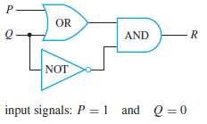 (ii) 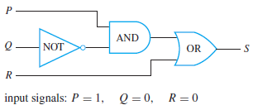

- 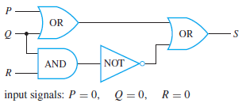

Q 8: A number of relations are defined on the set A = {0, 1, 2, 3}. For each relation:
a. Draw the directed graph.
b. Determine whether the relation is reflexive.
c. Determine whether the relation is symmetric.
d. Determine whether the relation is transitive.
Give a counterexample in each case in which the relation does not satisfy one of the properties.
1. R1 = {(0, 0), (0, 1), (0, 3), (1, 1), (1, 0), (2, 3), (3, 3)}
2. R2 = {(0, 0), (0, 1), (1, 1), (1, 2), (2, 2), (2, 3)}
3. R3 = {(2, 3), (3, 2)}
4. R4 = {(1, 2), (2, 1), (1, 3), (3, 1)}
5. R5 = {(0, 0), (0, 1), (0, 2), (1, 2)}
6. R6 = {(0, 1), (0, 2)}
7. R7 = {(0, 3), (2, 3)}
8. R8 = {(0, 0), (1, 1)}
Q 9: Find which of the following graphs are bipartite. Redraw the bipartite graphs so that their bipartite nature is evident.
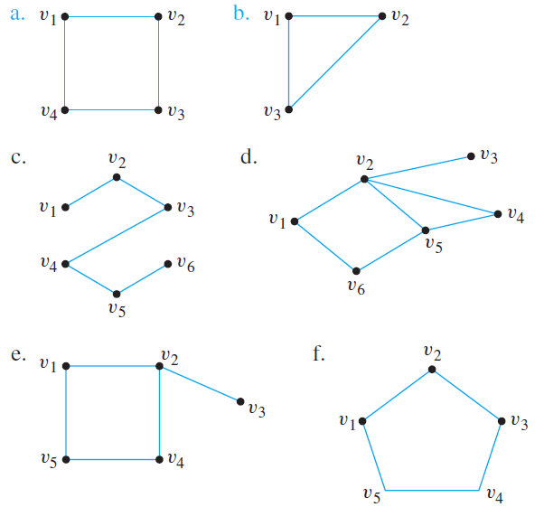
Q 10: In this exercise a graph is used to help solve a scheduling problem. Twelve faculty members in a mathematics department serve on the following committees:
Undergraduate Education: Tenner, Peterson, Kashina, Cohen
Graduate Education: Gatto, Yang, Cohen, Catoiu
Colloquium: Sahin, McMurry, Ash
Library: Cortzen, Tenner, Sahin
Hiring: Gatto, McMurry, Yang, Peterson
Personnel: Yang, Wang, Cortzen
The committees must all meet during the first week of classes, but there are only three time slots available. Find a schedule that will allow all faculty members to attend the meetings of all committees on which they serve. To do this, represent each committee as the vertex of a graph, and draw an edge between two vertices if the two committees have a common member. Find a way to color the vertices using only three colors so that no two committees have the same color, and explain how to use the result to schedule the meetings.

